|  |  |
| --- | --- |
|  | **MINISTRY OF EDUCATION AND TRAINING** |

**FPT UNIVERSITY**

|  |  |
| --- | --- |
| Capstone Project Document | |
| **Surgery Management System** | |
| **Group 12 - IS** | |
| **Group members** | Võ Thanh Tung – SE62315 (Leader)  Trần Quang Phúc – SE62300  Văn Chí Vĩnh – SE61854  Nguyễn Đàm Hiển Linh – SE61828 |
| **Supervisor** | Kiều Trọng Khánh |
| **Ext. Supervisor** | N/A |
| **Project Code** | eBSMS |

– **Ho Chi Minh City, January 07, 2019** –

**Table of Contents**

**Table of Contents** 2

**List of Tables** 8

**List of Figures** 8

**A.** **Introduction** 10

**1.** **Project Information** 10

**2.** **Introduction** 10

**3.** **Current Situation** 10

**4.** **Problem Definition** 11

**5.** **Proposed Solution** 11

**5.1.** **Feature functions** 12

**5.2.** **Values and Challenges** 13

**6.** **Functional Requirements** 13

**7.** **Role and Responsibility** 13

**B.** **Software Project Management Plan** 15

**1.** **Problem Definition** 15

**1.1.** **Name of this Capstone Project** 15

**1.2.** **Problem Abstract** 15

**1.3.** **Project Overview** 15

**1.3.1.** **Current Situation** 15

**1.3.2.** **The Proposed System** 16

**1.3.3.** **Boundaries of the System** 18

**1.3.4.** **Future Plans** 18

**1.3.5.** **Development enviroment** 19

**2.** **Project Organization** 19

**2.1. Software Process Model** 19

**2.2.** **Roles and Responsibilities** 21

**2.3.** **Tools and Techniques** 22

**3.** **Project Management Plan** 22

**3.1.** **Product Backlog** 22

**3.2.** **Sprint Backlog** 23

**3.3.** **All Meeting Minutes** 23

**4.** **Coding Convention** 23

**C.** **Software Requirement Specification** 24

**1.** **User Requirement Specification** 24

**1.1.** **Unauthorized Requirement** 24

**1.2.** **Staff Requirement** 24

**1.3.** **Handler Requirement** 25

**2.** **System Requirement Specification** 25

**2.1.** **External User Requirement** 25

**2.1.1.** **User Interface** 25

**2.1.2.** **Software Interface** 26

**2.1.3.** **Hardware Interface** 26

**2.1.4.** **Communication Protocol** 26

**2.2.** **System Overview User Case** 26

**2.3.** **List of Use Case** 27

**2.3.1.** **<Unauthorized User> Overview Use Case** 27

**2.3.1.1.** **<Unanthorized User> Login (U01)** 28

**2.3.3.** **<Authorized User> Overview Use Case** 30

**2.3.3.1.** **<Authorized User> Logout (A01)** 30

**2.3.3.** **<Medical Supply Staff> Overview Use Case** 32

**2.3.3.1.** **<Medical Supply Staff > Get medical supply** 32

**2.3.3.2.** **<Medical Supply Staff > Get medical supply detail** 33

**2.3.3.3.** **<Medical Supply Staff > Confirm medical supply** 34

**2.3.2.** **<Hospital Staff> Overview Use Case** 36

**2.3.2.1.** **<Hospital Staff> Get surgery profile (HS01)** 36

**2.3.2.2.** **<Hospital Staff> Get surgery profile detail (HS02)** 38

**2.3.2.3.** **<Hospital Staff> Import surgery report (HS03)** 40

**2.3.5.** **<Technical Staff, Chief Nurse> Overview Use Case** 41

**2.3.5.1.** **<Technical Staff, Chief Nurse> Get surgery schedule (TS01)** 42

**2.3.5.2.** **<Technical Staff, Chief Nurse> Get surgery shift detail** 43

**2.3.5.3.** **<Technical Staff, Chief Nurse> Update status of surgery shift** 44

**2.3.5.4.** **<Technical Staff, Chief Nurse> Update surgery information** 45

**2.3.5.5.** **<Technical Staff, Chief Nurse> Export surgery report** 47

**2.3.7.** **<Chief Nurse> Overview Use Case** 49

**2.3.7.1.** **<Chief Nurse> Manage surgery schedule** 50

**2.3.7.1.1.** **<Chief Nurse> Add emergency schedule (C01)** 51

**2.3.7.1.2.** **<Chief Nurse> Swap surgery schedule (C02)** 53

**2.3.7.1.3.** **<Chief Nurse> Change surgery slot room (C03)** 54

**2.3.7.2.** **<Chief Nurse> Get treatment** 55

**2.3.7.3.** **<Chief Nurse> Assign nurse** 57

**2.3.7.4.** **<Chief Nurse> Manage treatment** 58

**2.3.7.4.1.** **<Chief Nurse> Add treatment** 59

**2.3.7.4.1.** **<Chief Nurse> Edit treatment** 61

**2.3.7.4.1.** **<Chief Nurse> Delete treatment** 63

**2.3.7.5.** **<Chief Nurse> Get health care report** 65

**2.3.8.** **<Nurse> Overview Use Case** 67

**2.3.8.1.** **<Nurse> Search postoperative surgery shift (N01)** 67

**2.3.8.3.** **<Nurse> Get postoperative surgery shift** 70

**2.3.8.4.** **<Nurse> Get postoperative surgery shift detail** 72

**2.3.8.2.** **<Nurse> Manage health care report of patient** 74

**2.3.8.2.1.** **<Nurse> Insert health care report (N02)** 74

**2.3.8.2.2.** **<Nurse> Edit health care report (N03)** 77

**2.3.9.** **<Handler> Overview Use Case** 80

**2.3.9.1.** **<Handler> Scheduling surgery (H01)** 80

**2.3.9.2.** **<Handler> Send medical supply request (H02)** 82

**2.3.9.3.** **<Handler> Send notification (H03)** 84

**3.** **Software System Attribute** 85

**3.1.** **Usability** 85

**3.2.** **Reliability** 86

**3.3.** **Availability** 86

**3.4.** **Security** 86

**3.5.** **Maintainability** 86

**3.6.** **Portability** 86

**3.7.** **Performance** 87

**D.** **Software Design Description** 88

**1.** **Design Overview** 88

**2.** **System Architectural Design** 89

**3.** **Component Diagram** 89

**4.** **Detailed Description** 89

**4.1.** **Class Diagram** 89

**4.2.** **Class Diagram Explanation** 90

**4.2.1.**  **Account** 90

**4.2.2.** **Role** 91

**4.2.3.** **SurgeryShift** 91

**4.2.4.** **SurgeryRoom** 92

**4.2.5.** **SlotRoom** 92

**4.2.6.** **Ekip** 92

**4.2.7.** **MemberOfEkip** 92

**4.2.8.** **Surgeon** 92

**4.2.9.** **MedicalSupply** 92

**4.2.10.** **MedicalSupplyItem** 92

**4.2.11.** **TreatmentReport** 93

**4.2.12.** **Patient** 93

**4.2.13.** **SurgeryCatalog** 93

**4.2.14.** **Speciality** 93

**4.2.15.** **HealthCareReport** 93

**4.2.16.** **Status** 93

**4.2.17.** **HealthCareReportDetail** 93

**4.3.** **Interaction Diagram** 94

**4.3.1.** **Search postoperative surgery shift activity diagram** 95

**4.3.2.** **Insert health care report** 95

**4.3.3.** **Get postoperate surgery shift** 96

**4.3.4.** **Get recovery surgery shift detail** 97

**4.3.5.** **Get recovery surgery shift** 97

**5.** **User Interface Design** 97

**5.1.** **Web Interface Design** 97

**5.1.1.** **Login** 97

**5.1.2.** **Import Page** 98

**5.1.3.** **Import Detail Modal** 99

**5.1.4.** **Confirm Medical Supply Page** 100

**5.1.5.** **Medical Supply Detail Modal** 102

**5.1.6.** **Schedule Page** 102

**5.1.6.1.** **Schedule Page 1** 102

**5.1.6.2.** **Schedule Page 2** 104

**5.1.7.** **Schedule Detail Page** 105

**5.1.7.1.** **Information of Surgery Shift View** 105

**5.1.7.2.** **Information Detail of Surgery Shift View** 107

**5.1.7.3.** **Treatment Report View** 108

**5.1.7.4.** **Healthcare Report View** 109

**6.** **Database Design** 110

**6.1.** **Entity Relationship Diagram (ERD)** 110

**6.2.** **Data Dictionary** 110

**7.** **Algorithms** 111

**7.1.** **Scheduling surgery** 111

**7.2.** **Add emergency shift** 111

**7.2.** **Swap Shifts** 111

**7.3.** **Swap room** 112

**E.** **System Implementation & Test** 113

**1.** **Introduction** 113

**1.1.** **System Overview** 113

**1.2.** **Test Approach** 113

**2.** **Database relationship diagram** 113

**2.1.** **Physical diagram** 113

**2.2.** **Data dictionary** 113

**3.** **Test Plan** 115

**3.1.** **Features to be tested** 115

**3.2.** **Features not to be tested** 116

**4.** **System Testing Test Case** 116

**4.1.** **Hospital Staff Test Case** 116

**4.2.** **Medical Supply staff Test Case** 116

**4.3.** **Chief Nurse Test Case** 116

**4.4.** **Nurse Test Case** 116

**4.5.** **Handler System Test Case** 116

**F.** **Software User’s Manual** 117

**G.** **Appendix** 118

# **List of Tables**

Table A–1.1: *Role and Responsibility* 12

Table B–1.1: *Hardware requirements* 17

Table B–1.2: *Software requirements* 17

Table C–2.1: *<Unauthorized User> Login* 26

Table C–2.2: *<Hospital Staff> Import medical report file of patient* 29

Table C–2.3: *<Staff> Get surgery schedule* 30

Table C–2.4: *<Authorized User> Logout* 32

Table C–2.5: *<Medical Supply Staff> Confirm medical supply* 35

Table C–2.6: *<Technical Staff> <Chief Nurse> Export surgery report* 37

Table C–2.7: *<Technical Staff> Update status of surgery shift* 38

Table C–2.8: *<Technical Staff> Update surgery information* 39

Table C–2.9: *<Chief Nurse> Update surgery schedule* 41

Table C–2.10: *<Chief Nurse> Update surgery schedule* 42

Table C–2.11: *<Nurse> Search finished surgery shift* 45

Table C–2.11: *<Nurse> Insert care report* 48

Table C–2.12: *<Nurse> Update care report* 51

Table C–2.13: *<Handler> Scheduling surgery* 53

Table C–2.14: *<Handler> Send medical supply request* 55

Table C–2.15: *<Handler> Send notification* 57

# **List of Figures**

Figure B–2.1: *Scrum Framework* 18

Figure B–2.2: *The Scrum Process* 19

Figure C–2.1: *Use Case Diagram* 24

Figure C–2.2: *<Unauthorized User> Overview Use Case* 25

Figure C–2.3: *<Unauthorized User> Login* 25

Figure C–2.4: *<Hospital Staff> Overview Use Case* 27

Figure C–2.5: *<Hospital Staff> Import medical report file of patient* 27

Figure C–2.6: *<Staff> Overview Use Case* 29

Figure C–2.7: *<Staff> Get surgery schedule* 29

Figure C–2.8: *<Staff> Logout* 31

Figure C–2.9: *<Medical Supply Staff> Overview Use Case* 33

Figure C–2.10: *<Medical Supply Staff> Confirm medical supply* 33

Figure C–2.11: *<Technical Staff> <Chief Nurse> Overview Use Case* 36

Figure C–2.12: *<Technical Staff> <Chief Nurse> Export surgery report* 36

Figure C–2.13: *<Technical Staff> Overview Use Case* 38

Figure C–2.14: *<Technical Staff> Update status of surgery shift* 38

Figure C–2.15: *<Technical Staff> Update surgery information* 39

Figure C–2.16: *<Chief Nurse> Overview Use Case* 39

Figure C–2.17: *<Chief Nurse> Manage surgery schedule* 39

Figure C–2.18: *<Chief Nurse> Update surgery schedule* 40

Figure C–2.19: *<Chief Nurse> Cancel surgery schedule* 41

Figure C–2.20: *<Nurse> Overview Use Case* 43

Figure C–2.21: *<Nurse> Search finished surgery shift* 43

Figure C–2.22: *<Nurse> Manage health care report of patient* 46

Figure C–2.23: *<Nurse> Insert care report* 46

Figure C–2.24: *<Nurse> Update care report* 49

Figure C–2.25: *<Handler> Overview Use Case* 51

Figure C–2.25: *<Handler> Scheduling surgery* 52

Figure C–2.26: *<Handler> Send medical supply request* 54

Figure C–2.27: *<Handler> Send notification* 56

1. **Introduction**
2. **Project Information**
   * + Project Name: **Surgery Management System**
     + Project Code: **eBSMS**
     + Project Type: **Website Application, Android Mobile Application**
     + Start Date: **January 07, 2019**
     + End Date: **April 27, 2019**
3. **Introduction**

In this document, we introduce a solution for improving surgery management of the current hospitals. Specifically, we focus on analyzing the problems related to process of surgery from preoperative to postoperative period and then we propose a solution for this current inefficient process.

We build a system, which optimizes the operation of patient records from preoperative to postoperative period, support automatic surgery schedule arrangement, provide application for nurse, to monitor and update health status of patient in postoperative period. Besides, we also provide a function for medical supply staff who confirm availability of medical supply and equipment of surgery shift.

**3. Current Situation**

In the current hospitals in Viet Nam, the surgery process is still manually managed by hardcopy or hard paper, sometimes the excel file is used. The surgery schedule is created manually and it is added into excel file to serve observation. The profiles related to the patient’s health status are hardcopies or hard papers. Therefore, if there is a large number of patients, the hospital will have to manage the equivalent large amount of profiles.

In other situations, when a patient is appointed to surgery, the surgeon will request the surgery department to make a surgery schedule arrangement. The schedule is based on confirmation from 3 sides: available surgeon, available surgery room and medical supply. The wait time for physical confirmations from such many sides can lead to long response. Thus, it will be very complex if there is a large amount of request for schedule arrangement.

1. **Problem Definition**

Below are limitations of current situation:

* **Time consuming in arranging surgery schedule:** The manual schedule arrangement requires the confirmations from many sides. Therefore, receiving all confirmations will take long time and if one of the confirmations is rejected, the scheduling will be delayed or restart from the beginning.
* **Inefficient way to manage postoperative health record of the patient**: Every postoperative health record is hard copies, papers or files. Therefore, the records will become numerous through time. Also, this will take the nurses more time to lookup certain information in those numerous documents. As a result, this is not the efficient way to take care of the patient by doing those work manually by hand.
* **Difficult to store physical profiles**: hard copy can be affected by environmental conditions as humidity, termites, etc.

1. **Proposed Solution**

Our proposed solution is to build a Surgery Management System (eBSMS) to provide the effective management from preoperative to postoperative period. eBSMS helps surgery process in the current hospitals to operate faster and more effective. It also helps the nurse reduce complication, redundancy in taking note in postoperative period.

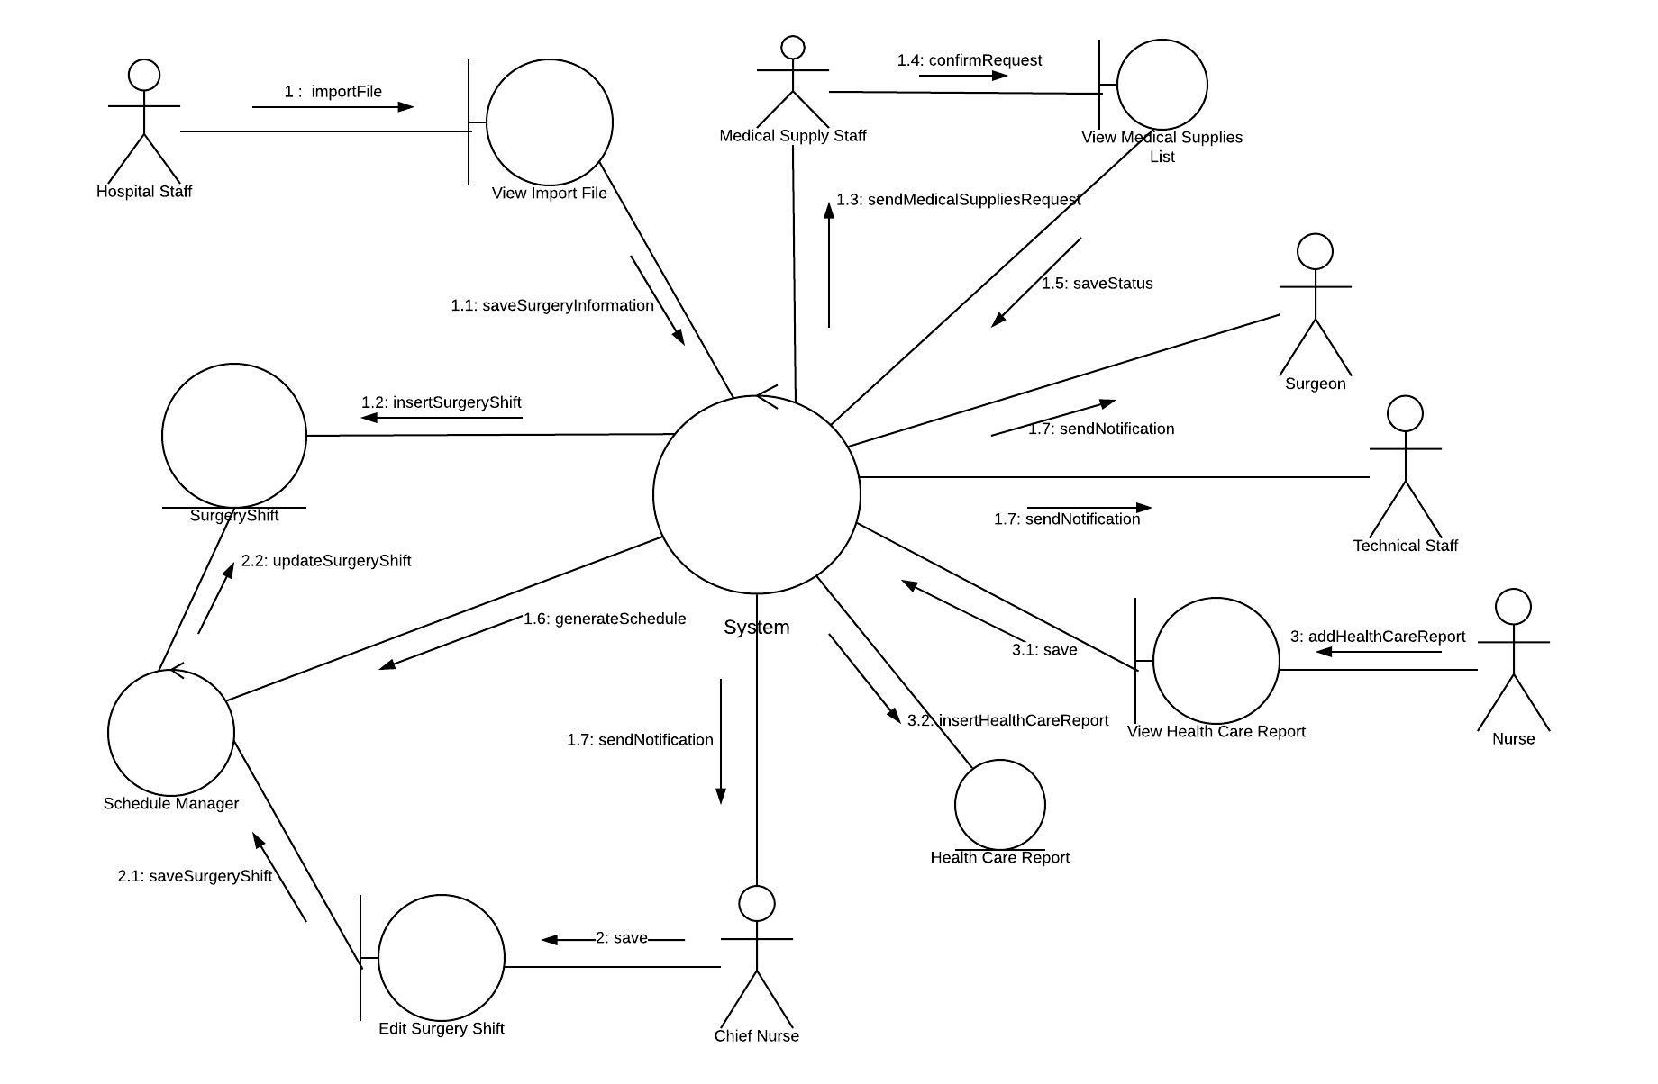

***Figure A-5.1:*** *Communication Diagram*

eBSMS includes a web application and a mobile application with following functions:

**5.1. Feature functions**

* **Scheduling surgery automatically:** When there is a the surgical document sent to surgery department, the system will receive that document and schedule the estimated time and room for that patient to have surgery. Estimated time will be automatically schedule base on surgeon’s working hours and patient’s health condition.
* **Confirm medical supply request from surgery department:** The system can send medical supply list for each surgery shift to medical supply staff to request confirm the availability of them.
* **Manage surgery schedule:** When there are exception conditions outside the system that affect the surgery schedule,theChief Nurse can modify them to resolve that problem timely.
* **Manage health record of patient in postoperative period:** The nurse can take note, update health status of the patient after every surgery by care template on mobile application. It brings new experience and easy-to-use interface for nurse.

**5.2. Values and Challenges**

**– Values:**

* Save time and money for surgery department.
* Automatically and flexibly reschedule any emergency shift transferred to hospital.
* Efficiently manage postoperative health record of patient.

**– Challenges:**

* Many conflicts in scheduling cases need to be solved.
* Many import templates are needed.

1. **Functional Requirements**

Functional requirements of the system are listed as bellow:

**– Surgery Component**

* View surgery schedule.
* Manage surgery information.
* Create surgery schedule
* Notify to Surgeon, Medical Supply staff and Technical staff.

**– Supply Department Component**

* Confirm sending surgery equipment according to each surgery shift.

**– Postoperative Component**

* Manage patient’s postoperative information

1. **Role and Responsibility**

|  |  |  |  |  |
| --- | --- | --- | --- | --- |
| **No** | **Full Name** | **Role** | **Position** | **Contact** |
| 1 | Hồ Hoàn Kiếm |  | Idea owner | [kiemhh@fpt.edu.vn](mailto:kiemhh@fpt.edu.vn) |
| 2 | Kiều Trọng Khánh | Project Manager | Supervisor | [khanhkt@fpt.edu.vn](mailto:khanhkt@fpt.edu.vn) |
| 2 | Võ Thanh Tung | BA | Leader | [tungvtse62315@fpt.edu.vn](mailto:tungvtse62315@fpt.edu.vn) |
| 3 | Trần Quang Phúc | BA | Member | [phuctqse62300@fpt.edu.vn](mailto:phuctqse62300@fpt.edu.vn) |
| 4 | Văn Chí Vĩnh | BA | Member | [vinhvcse61854@fpt.edu.vn](mailto:vinhvcse61854@fpt.edu.vn) |
| 5 | Nguyễn Đàm Hiển Linh | BA | Member | [linhndhse61828@fpt.edu.vn](mailto:linhndhse61828@fpt.edu.vn) |

Table A–1.1: *Role and Responsibility*

1. **Software Project Management Plan**
2. **Problem Definition**
   1. **Name of this Capstone Project**
      * + Official name: **Surgery Management System**
        + Vietnamese: **Hệ thống quản lý phẫu thuật**
        + Abbreviation: **eBSMS**
   2. **Problem Abstract**

Surgery is one of the most popular treatments. In fact, the need for surgery is increasing dramatically. This leads to manual scheduling that is inefficient and time-consuming. For this reason, our project is concern about automatic surgery scheduling. However, our team has no experience in studying about this field so that we need to take an extraordinary amount of time and expertise to perform. We need to collect information of the hospitals, especially the process of surgery from many different sources.

Our team come from people that are different about programming language and technology. Besides, researching language programming and technology suitable for the project is an important part of this project.

* 1. **Project Overview**
     1. **Current Situation**

Below are the problems encountered in this project:

* **Lack of surgery knowledge:** None of the team member has information or knowledge about surgery procedure.
* **Do not get clear the requirements:** There are many points in requirements that we do not get clear.
* **Limit time and human resource:** Team has only 4 members and time for all project is about 13 weeks for writing a document, implementing the products and testing.
* **Absenceof team member:** Team members can have sick or work schedule, etc.
* **Technical knowledge of team members:** some members are new to techniques and frameworks have chosen in this project. The team needs an amount of time to get familiar with those techniques
* **Lack of UI, UX design skill:** Our team members do not have UI, UX design experience. Especially, UI and UX used in hospital. This can lead to misunderstand or hard for staff to use.
  + 1. **The Proposed System**

Surgery is entire new field for us. Thus, we have to do research and study about surgery to understand it clearly. Specially, we have done collect information about the procedure of surgery in at least two hospitals. Besides, we read a lot of documentation about it. Our team members have to argue a lot to make clear the requirement and we have also training sessions for members are new to frameworks have chosen in project.

We assign responsibility in vertical to make sure if any member in this problem cannot continue to work in our team there will be the least harmful to the project processes.

By the study and research of the surgery, we propose a system called eBSMS. The end users of this system include hospital staff, and nurse department. It will help the hospital to schedule surgery automatically. Beside make the schedule for surgery, the system also provide surgery management service allows hospital to manage all the information about the surgery.

Our system includes three sub systems:

* Web services for handling data and response data for the mobile application, web application.
* Web application for Staff including Hospital Staff, Medical Supply Staff, Technical Staff and Chief Nurse.
  + - * Mobile application for nurse to manage information about health status of patient.

**1. Web services:**

* The service system takes responsibility to respond to all the requests and also manages and processes data.
* Provide API for Mobile Application and Web Application.

**2. Website application:**

*For hospital staff:*

* **Input medical reports:**  Hospital staff can input all the medical reports of patient for the surgery.

*For Chief Nurse (CN):*

* **Manage the surgery schedule:** CN can modify the surgery schedule, confirm the schedule.
* **Manage the surgery:** CN can manipulate the information about the surgery.
* **Export documentation about the surgery:** Chief Nurse can export all the documentation about the surgery for next period.

*For technical staff (TS):*

* + - * **Update status of surgery shift:** TS will update status of surgery shift when the surgeon completed the surgery shift.
      * **Update skills used in the surgery:** TS will track and update information about surgery shift as the skills that surgeon performs during surgery.

*For medical supply staff:*

* **Confirm the requested medical supply for surgery case:** Supply staff can confirm medical supply list that requested for surgery case.

**3. Mobile Application:**

This mobile application is used by Nurse to update healthy status of patients after surgery and during recovery.

* + 1. **Boundaries of the System**

*The system should do:*

* Scheduling surgery automatically.
* Manage the surgery schedule.
* Manage surgery information.
* Input the medical report.
* Update the healthy status of patient.
* Export the documentation about the surgery.
* Notify Medical Supply Staff, Surgeon, Technical Staff, Chief Nurse.

*The system has not support:*

* Manage human resources.
* Manage medical supply storage.
* Manage disease.
* Manage medical record of patient.
* Calculate hospital fee.
* Manage pharmacy.
  + 1. **Future Plans**

Our current system only supports the surgery management. With further research and development, the system can apply these advanced features:

* System is designed to easily scale and integrate with other features such as manage medical report, etc.
  + 1. **Development environment**
       1. **Hardware requirements**

|  |  |  |
| --- | --- | --- |
| **PC** | **Minimum Requirements** | **Recommended** |
| **Internet Connection** | **Cable 100Mbps** | **Cable 100Mbps or more** |
| **Operating System** | **Window Server 2012 Standard** | **Window Server 2016 Standard** |
| **Computer Processor** | **Intel® Xeon E3 1.4GHz** | **Intel® Xeon E5 2.51GHz** |
| **Computer Memory** | **2GB RAM** | **4GB RAM or more** |
| **Web Browser** | **Chromes (v70 or higher)** | **Chrome latest stable version** |

Table B–1.1: *Hardware requirements*

* + - 1. **Software requirement**

|  |  |  |
| --- | --- | --- |
| **Software** | **Name / Version** | **Description** |
| **Modeling tool** | **Lucidchart, StarUML** | **Used to design diagram** |
| **IDE** | **Visual Studio 2017, Android Studio 3.2.1,**  **Visual Studio Code** | **Programming tools** |
| **DBMS** | **SQL Server 2016** | **Used to create & manage the database for system** |
| **Source control** | **Github** | **Used for source control** |

Table B–1.2: *Software requirements*

1. **Project Organization**

**2.1. Software Process Model**

This project is developed based on Scrum model. We choose this model for the following reasons:

* Our project needs a large information about requirements and collecting all this requirement document in the same time is too long. With the Scrum, we can be flexible to start our project based on just enough requirements. In that time, if there is any feedback or new information comes up from outside, we can update requirement document again and work to adapt this document.
* As the Scrum, our project will be divided into sprints which each is a series of repeating processes as completed slices of functionality and is completed within one or two weeks. It is easy for our team to focus together to complete each sprint in short time so that the level of completion of our project is guaranteed.
* 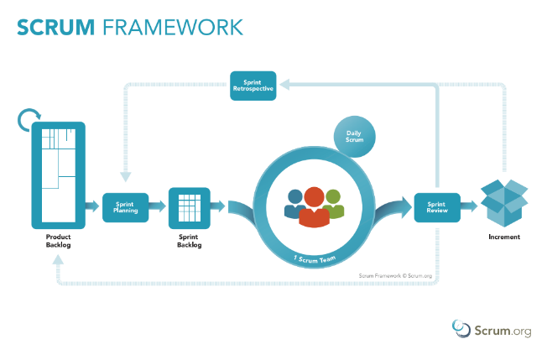Our team only have 4 members and perform the project during 4 months. Scrum model will help us reduce time management and increase time development.

Figure B–2.1: *Scrum Framework*

Reference: <https://www.scrum.org/resources/what-is-scrum>

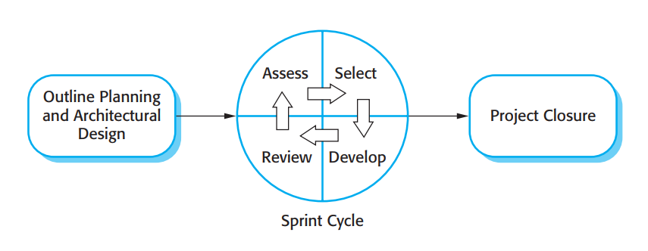

Figure B–2.2: *The Scrum Process*

Reference: Page 73, Chapter 03, Agile software development, Software Engineer 9­thEdition, by Ian Sommerville

**2.2. Roles and Responsibilities**

|  |  |  |  |
| --- | --- | --- | --- |
| **No** | **Full name** | **Role in Group** | **Responsibilities** |
| **1** | Kiều Trọng Khánh | Product Owner | * Specify user requirement * Control the development process * Give out technique and business analysis support |
| **2** | Võ Thanh Tung | Scrum Master | * Managing process * Designing database * Clarifying requirements * Prepare documents * GUI Design * Create test plan * Coding * Testing * Arrange Meeting * Risk Management |
| **3** | Trần Quang Phúc | Scrum team member | * Designing database * Clarifying requirements * Prepare documents * GUI Design * Create test plan * Coding * Testing |
| **4** | Văn Chí Vĩnh | Scrum team member | * Designing database * Clarifying requirements * Prepare documents * GUI Design * Create test plan * Coding * Testing |
| **5** | Nguyễn Đàm Hiển Linh | Scrum team member | * Clarifying requirements * Prepare documents * GUI Design * Create test plan * Coding * Testing |

**2.3. Tools and Techniques**

|  |  |
| --- | --- |
| **Tool/Technique** | **Name** |
| Front-end | HTML, CSS, JavaScript, jQuery, Angular |
| Back-end | ASP.NET, Entity Framework, Java |
| IDE | Visual Studio 2017, Android Studio 3.2.1 |
| DBMS | SQL Server |
| Source Control | Github 2.14 |
| Modelling tool | Lucidchart, StarUML |

1. **Project Management Plan**

**3.1. Product Backlog**

Refer to “ProductBacklog” file.

Reference: https://trello.com/b/GRgZsYme/surgery-management

**3.2. Sprint Backlog**

Refer to “SprintBacklog” file.

Reference: https://trello.com/b/GRgZsYme/surgery-management

**3.3. All Meeting Minutes**

Refer to “MeetingMinutes” file.

1. **Coding Convention**

This project is applied some coding convention rules of C# language as listed below:

**– Naming Conventions**

* Use PascalCasing for class name and method name.
* Use camelCasing for method arguments and local variables.
* Use meaningful name for variables, avoid using abbreviation.

**– Commenting Conventions:**

* Place the comment on a separate line.
* Begin comment text with an uppercase letter and end with a period.

– **Layout Conventions**

* Write only one statement or one declaration per line

Reference:

– <https://docs.microsoft.com/en-us/dotnet/csharp/programming-guide/inside-a-program/coding-conventions>

– https://github.com/ktaranov/naming-convention/blob/master/C%23%20Coding%20Standards%20and%20Naming%20Conventions.md

1. **Software Requirement Specification**
   * + 1. **User Requirement Specification**
   1. **Unauthorized Requirement**

*Unauthorized user (UAU) cannot access to system. To become a member of the system and use the functions in the system, UAU need to* ***login*** *to the system.*

* 1. **Staff Requirement**

*Staff is a member of the system. There are different staff roles with the following different corresponding functions:*

– **Hospital Staff:**

* Get surgery profile
* Get surgery profile detail
* Import surgery profile of patient

– **Medical Supply Staff:**

* Get medical supply
* Get medical supply detail
* Confirm medical supply for each surgery shift

– **Technical Staff:**

* Update status of surgery shift
* Update surgery information
* Export surgery report
* Get surgery schedule
* Get surgery shift detail

– **Nurse:**

* Manage health care report of patient
* Search postoperative surgery shift
* Get postoperative surgery shift
* Get postoperative surgery shift detail

**– Chief Nurse:**

* Manage the surgery schedule
* Get the surgery schedule
* Get surgery shift detail
* Export surgery report
* Update status of surgery shift
* Management treatment in postoperative
* Get treatment in postoperative
* Get health care report in postoperative
* Assign nurse in postoperative
  1. **Handler Requirement**

*Handler is the name of the system, which handles the processes run background to keep the system always working. Handler have the following functions:*

* Send notification to Surgeon, Technical Staff, Chief Nurse
* Send medical supply request to Medical Supply Staff
* Scheduling surgery
  + - 1. **System Requirement Specification**

**2.1. External User Requirement**

**2.1.1. User Interface**

**–** The user interface uses English for both the web application and mobile application.

**–** *The web application user interface will provide the following components:*

* User login page.
* A page for importing file and show surgery profile list.
* A page for showing surgery profile detail.
* A page for confirming medical supply list.
* A page for show surgery schedule by time line and surgery room
* An area for update surgery information of surgery shift
* An area for manage treatment in postoperative
* An area for show health care report in postoperative

**–** *The mobile application user interface will provide the following components:*

* User login page
* A page for observing finished surgery shift
* A page for managing care report of patient in specific surgery shift

**2.1.2. Software Interface**

− The web services are provided in JSON format.  
− Web application works with Google Chrome (version 69) and Firefox (version 52)

**2.1.3. Hardware Interface**

– N/A

**2.1.4. Communication Protocol**

– Use HTTP protocol (version 1.1) for communication between web services and web application or mobile device application that consumes the services.

**2.2. System Overview User Case**

Figure C–2.1: *Use Case Diagram*

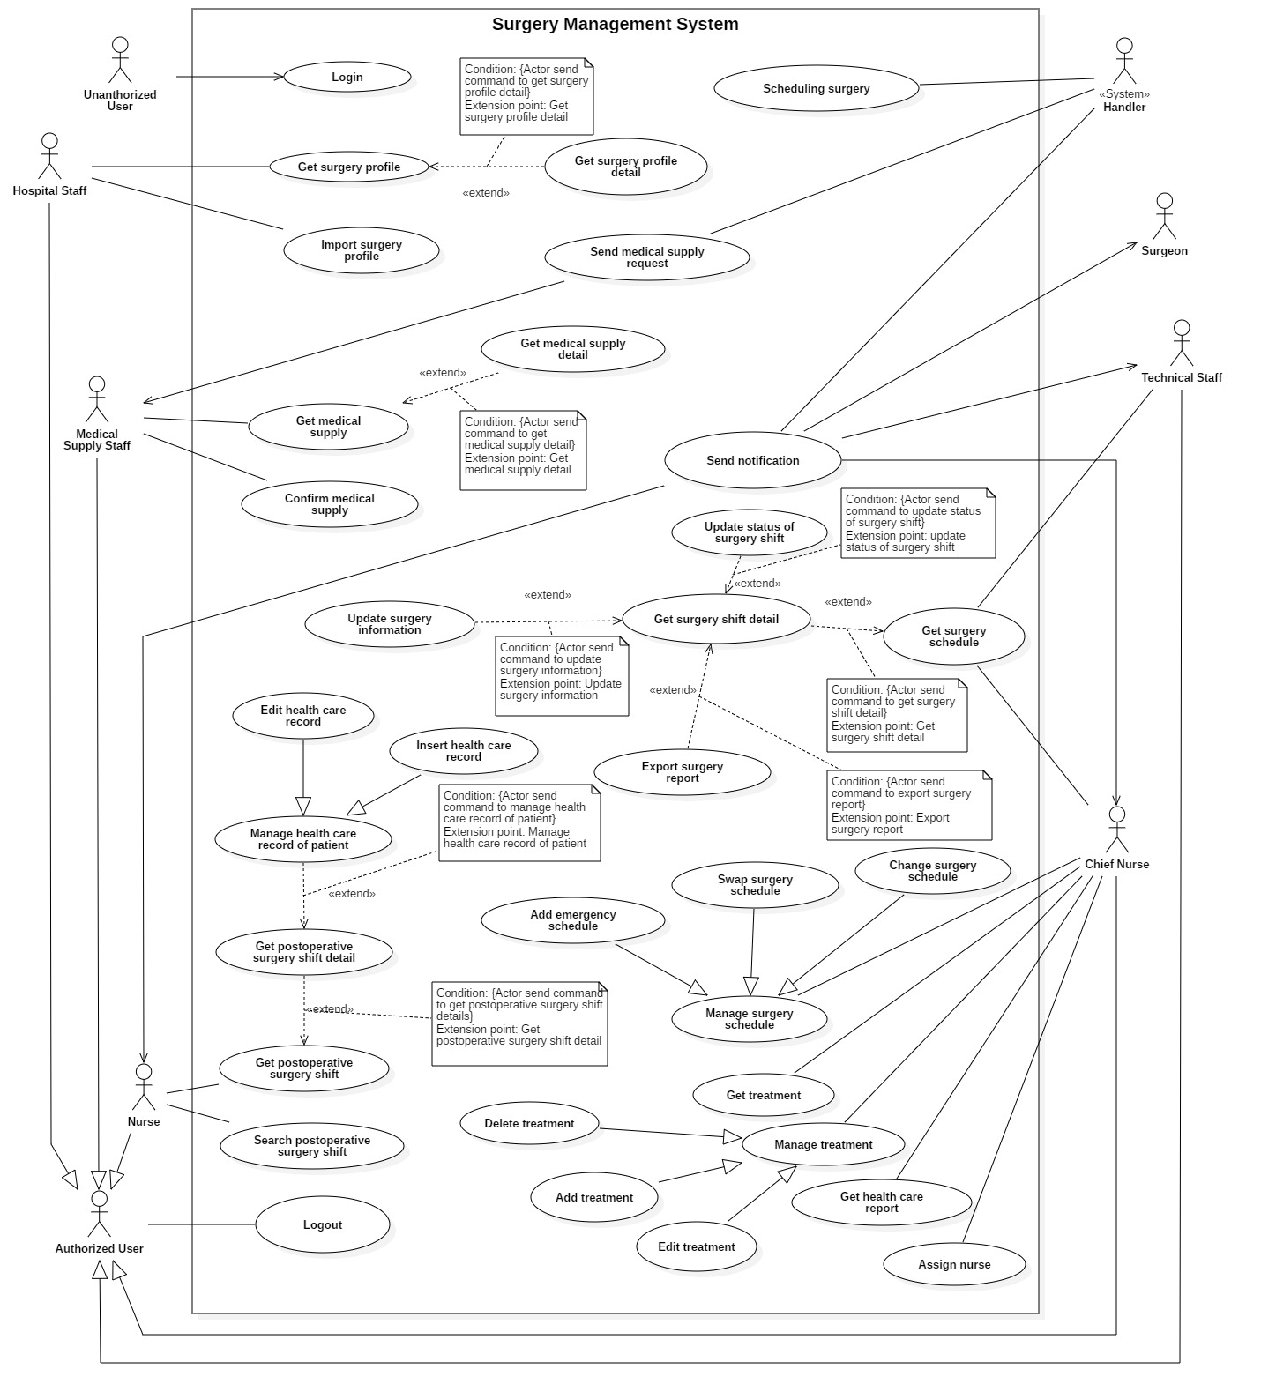**2.3. List of Use Case**

**2.3.1. <Unauthorized User> Overview Use Case**

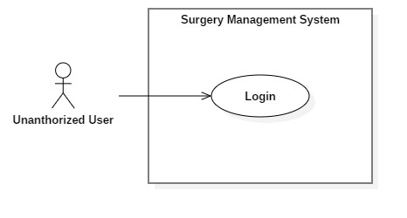

Figure C–2.2: *<Unauthorized User> Overview Use Case*

**2.3.1.1. <Unauthorized User> Login (U01)**

Figure C–2.3: *<Unauthorized User> Login*

|  |  |  |  |
| --- | --- | --- | --- |
| **USE CASE – U01** | | | |
| **Use Case No.** | U01 | **Use Case Version** | 2.0 |
| **Use Case Name** | Login | | |
| **Author** | LinhNDH | | |
| **Date** | 10/02/2019 | **Priority** | Normal |
| **Actor**:  – Unauthorized User  **Summary**:  – This use case allows Unauthorized User to login into the system  **Goal**:  – Unauthorized user becomes a member of the system and uses the functions based on the role.  **Triggers**:  – Unauthorized user sends login command to the system  **Preconditions**: N/A  **Post** **Conditions**:  – Success:   * Actors in the system include: * Hospital Staff * Medical Supply Staff * Technical Staff * Chief Nurse * Nurse * System shows welcome message to actors and redirect actor to appropriate view.   – Fail: System shows error message.  **Main** **Success** **Scenario**:   |  |  |  | | --- | --- | --- | | Step | Actor Action | System Response | | 1 | Actor goes to login view | System requires actor input authenticated information:  – Username: text input  – Password: text input | | 2 | Actor inputs information  [Alternative 1] | System shows the input information of actor. | | 3 | Actor sends login command | Actor will login into system with specific role.  [Exception 1]  [Exception 2] |   **Alternative** **Scenario**: N/A  **Exception:**  [Exception 1]   |  |  |  | | --- | --- | --- | | No | Cause | System Response | | 1 | Actor sends login command  without username or  password | System shows error message: “Username or Password can be blank!”. |   [Exception 2]   |  |  |  | | --- | --- | --- | | No | Cause | System Response | | 1 | Actor inputs incorrect credential information | System shows error message: “Invalid username or password!”. |   **Relationships**: N/A  **Business** **Rules**:   * Password are encrypted before being sent to server * After login to system, user will be redirected to specific view based on their role on the system:   + If role is “Hospital Staff”, system displays import surgery profile view   + If role is “Medical Supply Staff”, system displays medical supply request list view   + If role is “Chief Nurse”, system displays Chief Nurse view   + If role is “Nurse”, system displays patient’s health care report management view | | | |

Table C–2.1: *<Unauthorized User> Login*

**2.3.3. <Authorized User> Overview Use Case**

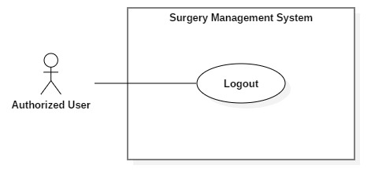

Figure C–2.6: *<Staff> Overview Use Case*

**2.3.3.1. <Authorized User> Logout (A01)**

Figure C–2.8: *<Authorized User> Logout*

|  |  |  |  |
| --- | --- | --- | --- |
| **USE CASE – S02** | | | |
| **Use Case No.** | S02 | **Use Case Version** | 2.0 |
| **Use Case Name** | Logout | | |
| **Author** | LinhNDH | | |
| **Date** | 10/02/2019 | **Priority** | Normal |
| **Actor**:   * Authorized User   **Summary**:   * This use case allows actor to logout from the system   **Goal**:   * Staff stops accessing the system * User’s session is removed from the system   **Triggers**:   * Staff send logout command   **Preconditions**:   * User must be an Authorized User * Authorized user’s session must be available in system   **Post** **Conditions**:   * Success: System redirects actor to login view * Fail: N/A   **Main** **Success** **Scenario**:   |  |  |  | | --- | --- | --- | | Step | Actor Action | System Response | | 1 | Authorized user clicks sign out link | System clear user’s session from session storage.  [Exception 1] | | 2 |  | System redirects actor to login view |   **Alternative** **Scenario**: **N/A**  **Exception:**   |  |  |  | | --- | --- | --- | | No | Cause | System Response | | 1 | System cannot connect to  session storage | System redirects actor to login view |   **Relationships**: N/A  **Business** **Rules**:   * Actor does not do anything in 30 minutes, system remove session and require actor re-login. | | | |

Table C–2.4: *<Authorized User> Logout*

**2.3.4. <Medical Supply Staff> Overview Use Case**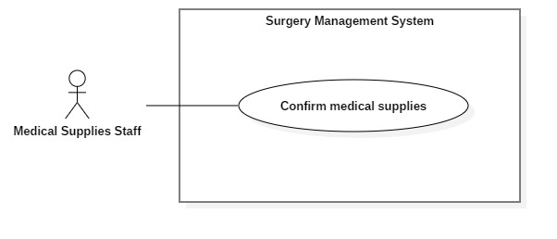

Figure C–2.9: *<Medical Supply Staff> Overview Use Case*

**2.3.3. <Medical Supply Staff> Overview Use Case**

**2.3.3.1. <Medical Supply Staff > Get medical supply**

|  |  |  |  |
| --- | --- | --- | --- |
| **USE CASE – M02** | | | |
| **Use Case No.** | M02 | **Use Case Version** | 2.0 |
| **Use Case Name** | Get medical supplies | | |
| **Author** | LinhNDH | | |
| **Date** | 24/03/2019 | **Priority** | Normal |
| **Actor**:   * Authorized User: Medical supply staff   **Summary**:   * This use case allows Medical Staff to get all medical supply request need to be confirmed for the surgery.   **Goal**:   * To get list of all medical confirm request needed to be confirmed.   **Triggers**:   * Medical Supplies Staff sends get all medical request command to system.   **Preconditions**:   * User must login with Medical Supplies Staff role. * Medical supplies confirming list must be existed and received by Medical Supplies Staff   **Post** **Conditions**:   * Success: Display list of requests * Fail: System display error message.   **Main** **Success** **Scenario**:   |  |  |  | | --- | --- | --- | | Step | Actor Action | System Response | | 1 | Actor send get all medical supply request command to the system. | System get all surgery shift profile needed confirm medical supply requests. | | 2 |  | System display list of surgery profile needed confirm. |   **Alternative** **Scenario**: N/A  **Exception:** N/A  **Relationships**: N/A  **Business** **Rules**:   * Medical supply staff sends get all medical supply request command to system. * System find all surgery profile which surgery shift’s medical supplies confirm status is “not approved”. * System display short surgery profile information in view table:  |  |  |  | | --- | --- | --- | | Patient Name | Surgery name | Date created | | | | |

**2.3.3.2. <Medical Supply Staff > Get medical supply detail**

|  |  |  |  |
| --- | --- | --- | --- |
| **USE CASE – M03** | | | |
| **Use Case No.** | M03 | **Use Case Version** | 2.0 |
| **Use Case Name** | Get medical supply detail | | |
| **Author** | LinhNDH | | |
| **Date** | 24/03/2019 | **Priority** | Normal |
| **Actor**:   * Authorized User: Medical supply staff   **Summary**:   * This use case allows Medical Staff to get all medical supply request need to be confirmed for the surgery.   **Goal**:   * To get all medical supplies in a needed confirm medical supply request.   **Triggers**:   * Medical Supplies Staff sends get all medical request detail command to system.   **Preconditions**:   * User must login with Medical Supplies Staff role. * Medical supplies confirming list must be existed and received by Medical Supplies Staff   **Post** **Conditions**:   * Success: Display list of medical supplies need in the request. * Fail: System display error message.   **Main** **Success** **Scenario**:   |  |  |  | | --- | --- | --- | | Step | Actor Action | System Response | | 1 | Actor send get all medical supply request detail command to the system. | System get all medical supplies need in the medical supply request.  [Exception 1] | | 2 |  | System display list of medical supplies need in the medical supply request. |   **Alternative** **Scenario**: N/A  **Exception:** N/A  **Relationships**: M02 – Get Medical supply   |  |  |  | | --- | --- | --- | | Step | Cause | System Response | | 1 | Actor send get all medical supply request detail command to the system.  [Exception 1] | System display error message. |   **Business** **Rules**:   * Medical supplier send get medical supply request detail of a surgery profile command to system. * System find all medical supply need in surgery profile. * System display medical supply information in view table:  |  |  |  | | --- | --- | --- | | No | Name | Quantity | | | | |

**2.3.3.3. <Medical Supply Staff > Confirm medical supply**

|  |  |  |  |
| --- | --- | --- | --- |
| **USE CASE – M01** | | | |
| **Use Case No.** | M01 | **Use Case Version** | 2.0 |
| **Use Case Name** | Confirm medical supply | | |
| **Author** | LinhNDH | | |
| **Date** | 10/02/2019 | **Priority** | Normal |
| **Actor**:   * Authorized User: Medical supply staff   **Summary**:   * This use case allows Medical Staff to confirm a medical supply request for surgery shift   **Goal**:   * To confirm a medical supply request for surgery shift   **Triggers**:   * Medical Supply Staff sends confirm medical supply request to system   **Preconditions**:   * User must login with Medical Supply Staff role. * Medical supply list must be existed and received by Medical Supply Staff   **Post** **Conditions**:   * Success: Confirm medical supply is sent to system * Fail: System shows error message.   **Main** **Success** **Scenario**:   |  |  |  | | --- | --- | --- | | Step | Actor Action | System Response | | 1 | Actor get confirm medical supply request from notification | System show confirm medical supply request include a medical supply list for surgery shift  Each record in list has the following information:  – Code  – Medical supply’s name | | 2 | Actor checks fully available medical supply  [Alternative 1] | System enable confirm request | | 3 | Actor send confirm request | System changes medical supply’s status of surgery shift is “approved” and redirect actor to medical supply request list view |   **Alternative** **Scenario**:   |  |  |  | | --- | --- | --- | | No | Actor Action | System Response | | 1 | Actor checks no fully medical supply | System disable confirm request |   **Exception:** N/A  **Relationships**: N/A  **Business** **Rules**:   * Medical supply request is created along with a surgery profile created by import an excel file. * Get all detail of a request before approve the request * The approved medical supply request will be trigger for surgery scheduling * The unapproved medical supply request will be saved into waiting list and wait until medical supply are available, the requests will be approved. * Surgery shift only can be scheduled if medical supply is available | | | |

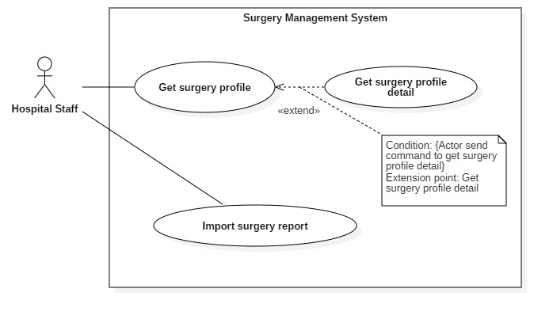**2.3.2. <Hospital Staff> Overview Use Case**

Figure C–2.4: *<Hospital Staff> Overview Use Case*

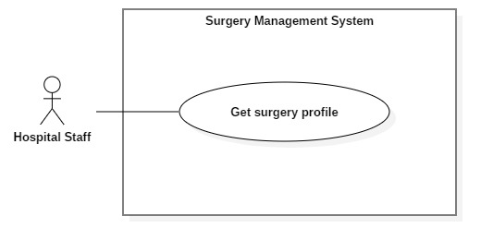**2.3.2.1. <Hospital Staff> Get surgery profile (HS01)**

Figure C–2.5: *<Hospital Staff> Get surgery profile*

|  |  |  |  |
| --- | --- | --- | --- |
| **USE CASE – M02** | | | |
| **Use Case No.** | M02 | **Use Case Version** | 2.0 |
| **Use Case Name** | Get surgery profile | | |
| **Author** | LinhNDH | | |
| **Date** | 24/03/2019 | **Priority** | Normal |
| **Actor**:   * Authorized User: Medical surgery profile   **Summary**:   * This use case allows Medical Staff to get all medical supply request need to be confirmed for the surgery.   **Goal**:   * To get list of all medical confirm request needed to be confirmed.   **Triggers**:   * Medical Supplies Staff sends get all medical request command to system.   **Preconditions**:   * User must login with Medical Supplies Staff role. * Medical supplies confirming list must be existed and received by Medical Supplies Staff   **Post** **Conditions**:   * Success: Display list of requests * Fail: System display error message.   **Main** **Success** **Scenario**:   |  |  |  | | --- | --- | --- | | Step | Actor Action | System Response | | 1 | Actor send get all medical supply request command to the system. | System get all surgery shift profile needed confirm medical supply requests. | | 2 |  | System display list of surgery profile needed confirm. |   **Alternative** **Scenario**: N/A  **Exception:** N/A  **Relationships**: N/A  **Business** **Rules**:   * System find all surgery profile which surgery shift’s medical supplies confirm status is “not approved”. * System display short surgery profile information in view table:  |  |  |  | | --- | --- | --- | | Patient Name | Surgery name | Date created | | | | |

Figure C–2.6: *<Hospital Staff> Get surgery profile*

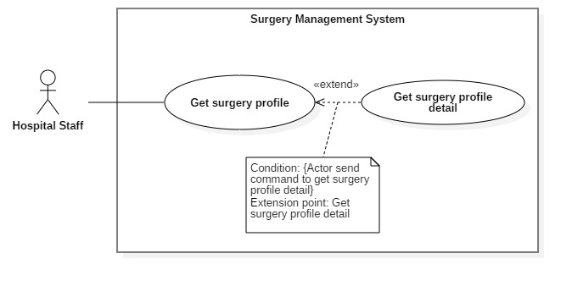**2.3.2.2. <Hospital Staff> Get surgery profile detail (HS02)**

Figure C–2.6: *<Hospital Staff> Get surgery profile detail*

|  |  |  |  |
| --- | --- | --- | --- |
| **USE CASE – M03** | | | |
| **Use Case No.** | M03 | **Use Case Version** | 2.0 |
| **Use Case Name** | Get medical supply detail | | |
| **Author** | LinhNDH | | |
| **Date** | 24/03/2019 | **Priority** | Normal |
| **Actor**:   * Authorized User: Medical supply staff   **Summary**:   * This use case allows Medical Staff to get all medical supply request need to be confirmed for the surgery.   **Goal**:   * To get all medical supplies in a needed confirm medical supply request.   **Triggers**:   * Medical Supplies Staff sends get all medical request detail command to system.   **Preconditions**:   * User must login with Medical Supplies Staff role. * Medical supplies confirming list must be existed and received by Medical Supplies Staff   **Post** **Conditions**:   * Success: Display list of medical supplies need in the request. * Fail: System display error message.   **Main** **Success** **Scenario**:   |  |  |  | | --- | --- | --- | | Step | Actor Action | System Response | | 1 | Actor send get all medical supply request detail command to the system. | System get all medical supplies need in the medical supply request.  [Exception 1] | | 2 |  | System display list of medical supplies need in the medical supply request. |   **Alternative** **Scenario**: N/A  **Exception:** N/A  **Relationships**: M02 – Get Medical supply   |  |  |  | | --- | --- | --- | | Step | Cause | System Response | | 1 | Actor send get all medical supply request detail command to the system.  [Exception 1] | System display error message. |   **Business** **Rules**:   * System find all medical supply need in surgery profile. * System display medical supply information in view table:  |  |  |  | | --- | --- | --- | | No | Name | Quantity | | | | |

**2.3.2.3. <Hospital Staff> Import surgery report (HS03)**

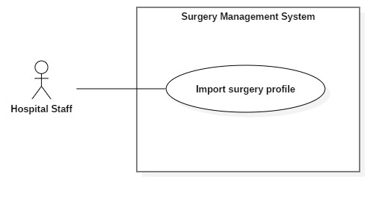

Figure C–2.5: *<Hospital Staff> Import medical report file of patient*

|  |  |  |  |
| --- | --- | --- | --- |
| **USE CASE – HS01** | | | |
| **Use Case No.** | HS01 | **Use Case Version** | 2.0 |
| **Use Case Name** | Import surgery report | | |
| **Author** | LinhNDH | | |
| **Date** | 10/02/2019 | **Priority** | Normal |
| **Actor**:   * Hospital Staff   **Summary**:   * This use case allows Hospital Staff to save surgery profile for preparing surgery schedule.   **Goal**:   * To save information of surgery profile to the system   **Triggers**:   * Actor sends import file command   **Preconditions**:   * User must login with Hospital Staff role.   **Post** **Conditions**:   * Success: System gets information of surgery profile and save to database successfully. * Fail: System show error message.   **Main** **Success** **Scenario**:   |  |  |  | | --- | --- | --- | | Step | Actor Action | System Response | | 1 | Actor choose surgery profiles and send import file command | System save profiles to database. | | 2 | Actor sends “save surgery profile” command  [Alternative 1] | System display success message. |   **Alternative** **Scenario**: N/A  **Exception: N/A**  **Relationships**: N/A  **Business** **Rules**:  – This is the first step to create a surgery schedule, create surgery shift to make schedule.  - Hospital Staff confirms and choose which profile should be import to the system.  Hospital staff sends Import command and chosen profiles will be saved to the system. | | | |

Table C–2.2: *<Hospital Staff> Import medical report file of patient*

#### **2.3.5. <Technical Staff, Chief Nurse> Overview Use Case**

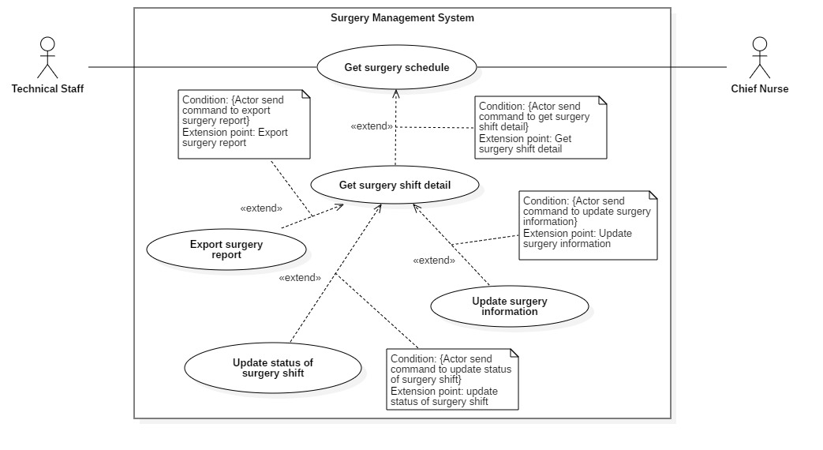

Figure C–2.11: *<Technical Staff> <Chief Nurse> Overview Use Case*

**2.3.5.1. <Technical Staff, Chief Nurse> Get surgery schedule (TS01)**

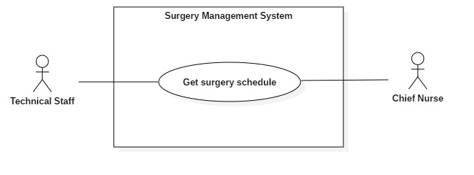

Figure C–2.12: *<Technical Staff> <Chief Nurse> Export surgery report*

|  |  |  |  |
| --- | --- | --- | --- |
| **USE CASE – S01** | | | |
| **Use Case No.** | S01 | **Use Case Version** | 2.0 |
| **Use Case Name** | Get surgery schedule | | |
| **Author** | Võ Thanh Tung | | |
| **Date** | 10/02/2018 | **Priority** | Normal |
| **Actor:**   * Staff   **Summary:**   * This use case allow actor to get surgery schedule.   **Goal:**   * To monitor surgery schedule.   **Triggers:**   * Actor sends request to get surgery schedule.   **Preconditions:**  - Unauthorized user must login with Chief Nurse, Technical Staff role  **Post conditions:**   * Success: Unauthorized user accesses to the system with specific role and can view surgery schedule. * Fail: System shows error messages.   **Main Success Scenario:**   |  |  |  | | --- | --- | --- | | **Step** | **Actor Action** | **System Response** | | 1 | Actor sends request for getting surgery schedule | - System show surgery schedule in table with   * Vertical denotes the surgery room * Horizontal denotes the surgery time * Each surgery shift in surgery schedule will be displayed with following information: * Room number * Surgeon’s name * Patient’s name * Surgery’s name * Start time of surgery shift * End time of surgery shift   [Exception 1] |   **Alternative Scenario:** N/A  **Exceptions:**   |  |  |  | | --- | --- | --- | | **No** | **Cause** | **System Response** | | 1 | System returns an empty list of surgery shift | System show surgery rooms and there is no surgery shift |   **Relationships:** N/A  **Business Rules:**  – Surgery schedule will be loaded by surgery room and date and be updated automatically everyday:  + Get all surgery room  + Each surgery room will get all scheduled surgery shift based on day  – Surgery schedule present scheduled surgery shifts with the status: “Not yet started”, “Proceeding” or “Completed” | | | |

Table C–2.6: *<Technical Staff> <Chief Nurse> Export surgery report*

**2.3.5.2.** **<Technical Staff, Chief Nurse> Get surgery shift detail**



**2.3.5.3.** **<Technical Staff, Chief Nurse> Update status of surgery shift**



|  |  |  |  |
| --- | --- | --- | --- |
| **USE CASE – T01** | | | |
| **Use Case No.** | T01 | **Use Case Version** | 2.0 |
| **Use case Name** | Update status of a surgery shift | | |
| **Author** | PhucTQ | | |
| **Date** | 10/02/2019 | **Priority** | Normal |
| **Actor**:   * Technical Staff   **Summary**:   * Change the status of a surgery shift   **Goal**:   * Surgery shift status successfully changed   **Triggers**:   * An update status command is sent   **Preconditions**:   * + User must login with Technical Staff role.   + Surgery shift must be performed (Intraoperation status)   **Post** **Conditions**:   * Success: System shows success popup message, the surgery shift status changed * Fail: System shows error message.   **Main** **Success** **Scenario**:   |  |  |  | | --- | --- | --- | | Step | Actor Action | System Response | | 1 | Actor sends “set Postoperation status for a surgery shift” command | System will change surgery shift’s status from “Intraoperation” to “Postoperative” |   **Alternative** **Scenario**: N/A  **Relationships**: N/A  **Business** **Rules**:   * Only Technical Staff can status of surgery shift from Intraoperation to Post Operation. * Status of a surgery shift:   + Preoperative   + Intraoperative   + Postoperative   + Recovery   + Finish * Surgery Shift Status cannot be reverted. | | | |

**2.3.5.4.** **<Technical Staff, Chief Nurse> Update surgery information**



|  |  |  |  |
| --- | --- | --- | --- |
| **USE CASE – T02** | | | |
| **Use Case No.** | T02 | **Use Case Version** | 2.0 |
| **Use Case Name** | Update surgery information | | |
| **Author** | PhucTQ | | |
| **Date** | 10/02/2019 | **Priority** | Normal |
| **Actor**:   * Technical Staff   **Summary**:   * Update surgery information   **Goal**:   * Surgery information is updated   **Triggers**:   * An updated surgery information command is sent   **Preconditions**:   * + User must login with Technical Staff role.   **Post** **Conditions**:   * Success: System shows success popup message. * Fail: System shows error message.   **Main** **Success** **Scenario**:   |  |  |  | | --- | --- | --- | | Step | Actor Action | System Response | | 1 | Actor send “get information of a update surgery shift” command | System will show information of surgery shift and the following editable information:  - Surgery Ekip  - Surgical procedure | | 2 | Actor edit information of surgery shift | System show input edited information | | 3 | Actor send “update information of surgery shift” command to system | System show “update successfully” message. |   **Alternative** **Scenario**: **N/A**  **Relationships**: N/A  **Business** **Rules**:   * Technical Staff can only update information of surgery shift that she/he which is present. * Surgery Shift Information can be change only while it’s status is in Preoperative or Intraoperative. | | | |

**2.3.5.5.** **<Technical Staff, Chief Nurse> Export surgery report**



|  |  |  |  |
| --- | --- | --- | --- |
| **USE CASE – TS01** | | | |
| **Use Case No.** | TS01 | **Use Case Version** | 2.0 |
| **Use Case Name** | Export surgery report | | |
| **Author** | Võ Thanh Tung | | |
| **Date** | 10/02/2018 | **Priority** | Normal |
| **Actor:**   * Technical Staff, Chief Nurse   **Summary:**   * This use case allows Actor to export surgery report to file excel.   **Goal:**   * To export information of surgery report into file excel.   **Triggers:**   * Actor sends request to export surgery report.   **Preconditions:**   * User must login with Technical Staff or Chief Nurse role   **Post conditions:**   * Success: System shows success popup message and let the actor choose where to save the file * Fail: System shows error messages.   **Main Success Scenario:**   |  |  |  | | --- | --- | --- | | **Step** | **Actor Action** | **System Response** | | 1 | Actor send request to preview the surgery report. | System show surgery report with following information:  - Information of patient  Information of surgery shift  - Information of Surgery Ekip: Member’s name, member’s role  - Surgical procedure | | 1 | Actor sends export surgery report command to the system. | System show “Export surgery report successfully.” message |   **Alternative Scenario:** N/A  **Exceptions:** N/A  **Relationships:** N/A  **Business Rules:**   * Technical Staff can only export surgery report of the surgery shift that he/she is present * The surgery shift status must be “Post-Operation” in order to export the report. * The report must follow the pre-defined template. * Chief Nurse can export surgery report of all surgery shift. | | | |

**2.3.7. <Chief Nurse> Overview Use Case**

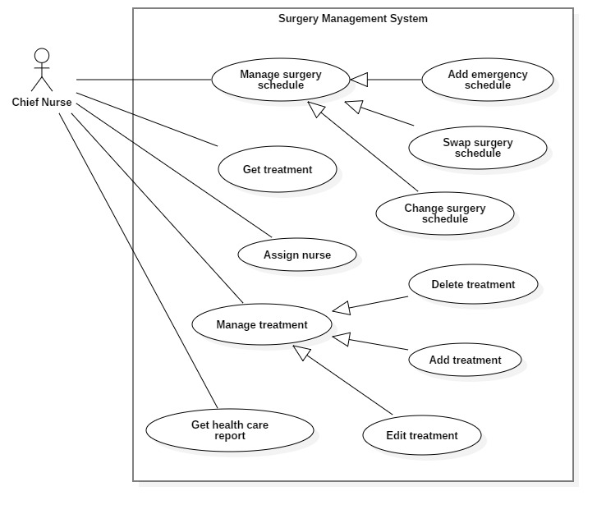

Figure C–2.16: *<Chief Nurse> Overview Use Case*

**2.3.7.1. <Chief Nurse> Manage surgery schedule**

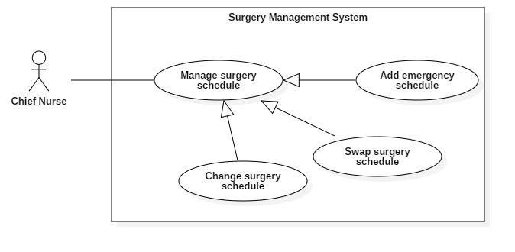

Figure C–2.17: *<Chief Nurse> Manage surgery schedule*

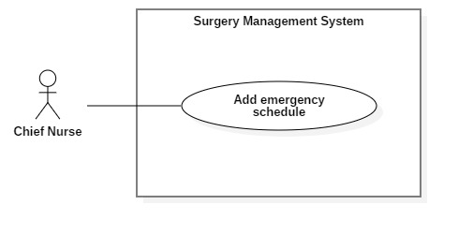**2.3.7.1.1. <Chief Nurse> Add emergency schedule (C01)**

Figure C–2.18: *<Chief Nurse> Add emergency schedule*

|  |  |  |  |
| --- | --- | --- | --- |
| **USE CASE – C01** | | | |
| **Use Case No.** | C01 | **Use Case Version** | 2.0 |
| **Use Case Name** | Add emergency shift | | |
| **Author** | Võ Thanh Tung | | |
| **Date** | 24/03/2019 | **Priority** | Normal |
| **Actor:**  – Chief Nurse  **Summary:**  – This use case allows Chief Nurse to add emergency shift.  **Goal:**  – To add emergency shift into surgery schedule.  **Triggers:**  – Chief Nurse sends command to add emergency shift  **Preconditions:**  – Unauthorized user must login with Chief Nurse role.  **Post conditions:**   * Success: * Surgery schedule is updated successfully. * Success message is displayed.   - Fail: Error message is displayed.  **Main Success Scenario:**   |  |  |  | | --- | --- | --- | | **Step** | **Actor Action** | **System Response** | | 1 | Actor goes to “Add emergency shift” view | System shows the following input information:  - Start time  - Expected surgery duration | | 2 | Actor inputs information |  | | 3 | Actor sends “Add emergency shift” command to the system | System shows message: “Add emergency successfully!”. |   **Alternative Scenario:** N/A  **Exceptions:**   |  |  |  | | --- | --- | --- | | **No** | **Cause** | **System Response** | | 1 | System cannot search alternative surgeon or new surgery time | Update request is disable |   **Relationships:** N/A  **Business Rules:**  – Adding emergency shift have 2 options:  + If emergency shift is added normally, the system will find available slot room add it into surgery schedule or not, adding emergency shift is fail  + If adding emergency shift is obligatory, the shift will be added into any slot room with proposed time and the affected shift will move time after emergency shift  – Emergency shift can’t insert into proceeding shift  – When emergency shift is added, the notifications will be sent to related Staff.  **–** In the beginning, emergency shift often hasn’t full surgery profile include patient’s information, available medical supply, doctor and the surgery profile will be updated later | | | |

Table C–2.9: *<Chief Nurse> Update surgery schedule*

**2.3.7.1.2. <Chief Nurse> Swap surgery schedule (C02)**

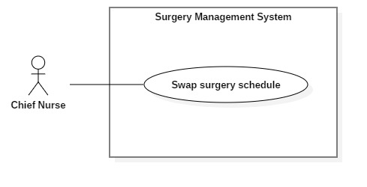

Figure C–2.19: *<Chief Nurse> Swap surgery schedule*

|  |  |  |  |
| --- | --- | --- | --- |
| **USE CASE – TS01** | | | |
| **Use Case No.** | TS01 | **Use Case Version** | 2.0 |
| **Use Case Name** | Swap Surgery Schedules | | |
| **Author** | Trần Quang Phúc | | |
| **Date** | 10/02/2019 | **Priority** | Normal |
| **Actor:**   * Technical Staff, Chief Nurse   **Summary:**   * This use case allows Actor to swap schedule   **Goal:**   * To swap two schedules with each other   **Triggers:**   * Actor sends swap command.   **Preconditions:**   * User must login with Technical Staff or Chief Nurse role   **Post conditions:**   * Success: System shows success popup. * Fail: System shows error messages.   **Main Success Scenario:**   |  |  |  | | --- | --- | --- | | **Step** | **Actor Action** | **System Response** | | 1 | Actor choose two Shift to swap |  | | 1 | Actor send Swap command | System show “Swap Successfully.” Popup message. |   **Alternative Scenario:** N/A  **Exceptions:** N/A  **Relationships:** N/A  **Business Rules:**   * Technical Staff can only swap cases under his/her control. * Chief Nurse can swap every shift. * Can only swap Preoperative schedules. * Actor have to click enable swap button, then choose schedules to swap. * Affected Schedules will be changed to other room slot, if can’t, their schedule will be changed. | | | |

Table C–2.10: *<Chief Nurse> Cancel surgery schedule*

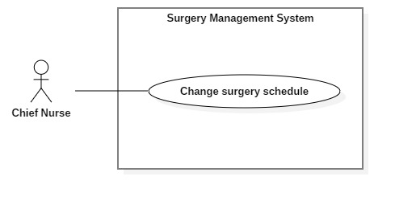**2.3.7.1.3. <Chief Nurse> Change surgery slot room (C03)**

|  |  |  |  |
| --- | --- | --- | --- |
| **USE CASE – TS01** | | | |
| **Use Case No.** | TS01 | **Use Case Version** | 2.0 |
| **Use Case Name** | Change Room Slot | | |
| **Author** | Trần Quang Phúc | | |
| **Date** | 10/02/2019 | **Priority** | Normal |
| **Actor:**   * Technical Staff, Chief Nurse   **Summary:**   * This use case allows Actor to change Room Slot   **Goal:**   * To change Room Slot with each other   **Triggers:**   * Actor sends change room slot command.   **Preconditions:**   * User must login with Technical Staff or Chief Nurse role   **Post conditions:**   * Success: System shows success popup. * Fail: System shows error messages.   **Main Success Scenario:**   |  |  |  | | --- | --- | --- | | **Step** | **Actor Action** | **System Response** | | 1 | Actor choose a schedule and drag and drop to another slot |  | | 1 | Actor send change room slot command | System show “Change Successfully.” Popup message. |   **Alternative Scenario:** N/A  **Exceptions:** N/A  **Relationships:** N/A  **Business Rules:**   * Technical Staff can only change cases under his/her control. * Chief Nurse can change every surgery shift. * Can only change Preoperative Room Slots. * Affected Schedules will be changed to other room slot, if can’t, their Schedule time will be changed. | | | |

**2.3.7.2. <Chief Nurse> Get treatment**

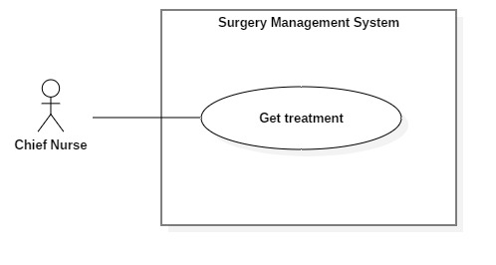

|  |  |  |  |
| --- | --- | --- | --- |
| **USE CASE – < UC-SD06>** | | | |
| **Use Case No.** | **UC- SD06** | **Use Case Version** | 2.0 |
| **Use Case Name** | Get treatment | | |
| **Author** | Văn Chí Vĩnh | | |
| **Date** | 28/09/2018 | **Priority** | Normal |
| **Actor:**  -        Chief nurse.  **Summary:**  -        This use case allows user to get treatment  **Goal:**  -        Nurse can get treatment.  **Triggers:**  -        Nurse sends command to “get treatment”.  **Preconditions:**  -        User must login into the system with role Chief Nurse.  **Post Conditions:**  -        Success: Treatment reports will be displayed.  -        Fail: Show error message.  **Main Success Scenario:**     |  |  |  | | --- | --- | --- | | Step | Actor Action | System Response | | 1 | Chief nurse open treatment tab. |  | | 2 | Chief nurse sends Get treatment command | Treatment will be displayed with information:   * Date created * Progressive disease * Medical requirement   [Alternative 1]  [Exception 1] |     **Alternative Scenario:**   |  |  |  | | --- | --- | --- | | No | Actor Action | System Response | | 1 | Chief nurse send expand medical requirement | Medical requirement will be show with information:   * Drug name * Unit * Quantity for each time (morning, afternoon, evening, night) |   **Exception:**     |  |  |  | | --- | --- | --- | | No | Cause | System Response | | 1 | When the connection to the server is lost | System show error message |     **Relationships:** None.  **Business Rules:**   * + Get treatments base on surgery shift   + List of treatment will be ordered by date created.   + Treatment will contain information:     - Date created     - Progressive disease     - Medical requirement contains:       * Drug name       * Unit       * Quantity for each time (morning, afternoon, evening, night) | | | |

**2.3.7.3. <Chief Nurse> Assign nurse**

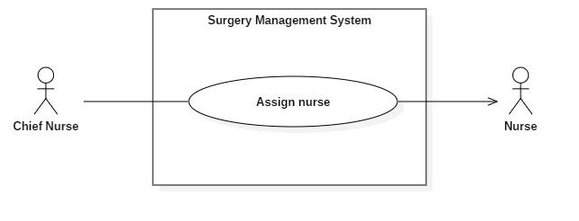

**2.3.7.4. <Chief Nurse> Manage treatment**

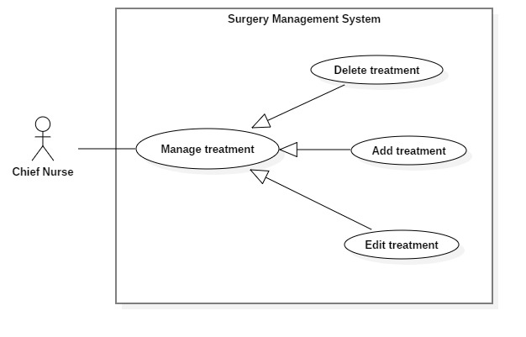

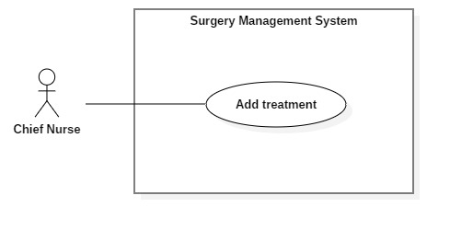**2.3.7.4.1. <Chief Nurse> Add treatment**

|  |  |  |  |
| --- | --- | --- | --- |
| **USE CASE – SD03** | | | |
| **Use Case No.** | **SD03** | **Use Case Version** | 2.0 |
| **Use Case Name** | Add treatment | | |
| **Author** | Văn Chí Vĩnh | | |
| **Date** | 28/09/2018 | **Priority** | Normal |
| **Actor:**  -        Chief nurse.  **Summary:**  -        This use case allows chief nurse to add treatment.  **Goal:**  -        New treatment will be added in system.  **Triggers:**  -        Chief nurse sends command to “Add treatment”.  **Preconditions:**  -        Login into the system with role chief nurse.  **Post Conditions:**  -        Success: Treatment success added to surgery shift in system.  -        Fail: Show error message.  **Main Success Scenario:**     |  |  |  | | --- | --- | --- | | Step | Actor Action | System Response | | 1 | Chief nurse goes to add treatment view. | System show view and requires some information from nurse:   * Progressive disease: condition of patient and doctors requirement; required; length [1; 1000]. * Medical requirement: doctors medical requirement contains:   + Drug   + Quantity for each time (morning, afternoon, evening, night) | | 2 | User input information |  | | 3 | User sends command to add treatment to system. | System validates treatment  [Exception 1]  Add the treatment to the system and update view.  [Exception2] |     **Alternative Scenario:** N/A  **Exception:**     |  |  |  | | --- | --- | --- | | No | Cause | System Response | | 1 | Information that user input not valid. | Show message to ask user to re-input. | | 2 | Server fail to add treatment | Show error message |   **Relationships:** N/A  **Business Rules:**   * System will record inputted information include:   + Drugs along with quantity for each time slot (morning, afternoon, evening, night).   + Progressive disease. | | | |

**2.3.7.4.1. <Chief Nurse> Edit treatment**

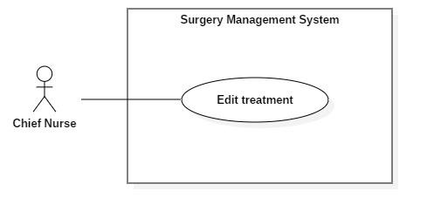

|  |  |  |  |
| --- | --- | --- | --- |
| **USE CASE – SD04** | | | |
| **Use Case No.** | **SD04** | **Use Case Version** | 2.0 |
| **Use Case Name** | Edit treatment | | |
| **Author** | Văn Chí Vĩnh | | |
| **Date** | 28/09/2018 | **Priority** | Normal |
| **Actor:**  -        Chief nurse.  **Summary:**  -        This use case allows chief nurse to edit treatment.  **Goal:**  -        Treatment will be edited in system.  **Triggers:**  -        Chief nurse sends command to “Edit treatment”.  **Preconditions:**  -        Login into the system with role chief nurse.  **Post Conditions:**  -        Success: Treatment is successfully edited to surgery shift in system.  -        Fail: Show error message.  **Main Success Scenario:**     |  |  |  | | --- | --- | --- | | Step | Actor Action | System Response | | 1 | Chief nurse goes to edit treatment view. | System show view and requires some information from nurse:   * Progressive disease: condition of patient and doctors requirement; required; length [1; 1000]. * Medical requirement: doctors medical requirement contains:   + Drug   + Quantity for each time (morning, afternoon, evening, night) | | 2 | User input information |  | | 3 | User sends command to edit treatment to system. | System validates treatment  [Exception 1]  Edit the treatment to the system and update view.  [Exception2] |     **Alternative Scenario:** N/A  **Exception:**     |  |  |  | | --- | --- | --- | | No | Cause | System Response | | 1 | Information that user input not valid. | Show message to ask user to re-input. | | 2 | Server fail to edit treatment | Show error message |   **Relationships:** N/A  **Business Rules:**   * + Treatment reports have status “IsUsed” cannot edit.   + Check if drug in treatment is existed, new information will be edited. On the other hand, new drug will be added to treatment. | | | |

**2.3.7.4.1. <Chief Nurse> Delete treatment**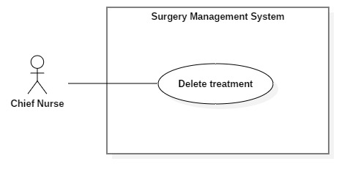

|  |  |  |  |
| --- | --- | --- | --- |
| **USE CASE – SD05** | | | |
| **Use Case No.** | **SD05** | **Use Case Version** | 2.0 |
| **Use Case Name** | Delete treatment | | |
| **Author** | Văn Chí Vĩnh | | |
| **Date** | 28/09/2018 | **Priority** | Normal |
| **Actor:**  -        Chief nurse.  **Summary:**  -        This use case allows chief nurse to delete treatment.  **Goal:**  -        Treatment will be no longer visible to user.  **Triggers:**  -        Chief nurse sends command to “Delete treatment”.  **Preconditions:**  -        Login into the system with role chief nurse.  **Post Conditions:**  -        Success: Treatment will be successfully deleted from system.  -        Fail: Show error message.  **Main Success Scenario:**     |  |  |  | | --- | --- | --- | | Step | Actor Action | System Response | | 1 | Chief nurse sends get treatment reports command. | System show information:   * Progressive disease: condition of patient and doctors requirement; required; length [1; 1000]. * Medical requirement: doctors medical requirement contains:   + Drug: (dropdown list)   + Quantity for each time (morning, afternoon, evening, night); number | | 2 | User sends command to delete treatment to system. | System will deactivate vehicle.  [Exception1] |     **Alternative Scenario:** N/A  **Exception:**     |  |  |  | | --- | --- | --- | | No | Cause | System Response | | 1 | Server fail to delete treatment | Show error message |   **Relationships:** N/A  **Business Rules:**   * + Treatment reports have status “IsUsed” cannot delete.   + Deleted treatments are no longer visible to user. | | | |

**2.3.7.5. <Chief Nurse> Get health care report**

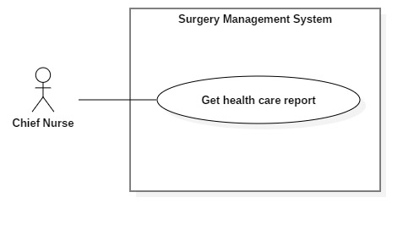

|  |  |  |  |
| --- | --- | --- | --- |
| **USE CASE – < UC-SD07>** | | | |
| **Use Case No.** | **UC- SD07** | **Use Case Version** | 2.0 |
| **Use Case Name** | Get healthcare report | | |
| **Author** | Văn Chí Vĩnh | | |
| **Date** | 28/09/2018 | **Priority** | Normal |
| **Actor:**  -        Chief nurse.  **Summary:**  -        This use case allows user to get healthcare report  **Goal:**  -        Nurse can get healthcare report.  **Triggers:**  -        Nurse sends command to “get healthcare report”.  **Preconditions:**  -        User must login into the system with role Chief Nurse.  **Post Conditions:**  -        Success: Healthcare reports will be displayed.  -        Fail: Show error message.  **Main Success Scenario:**     |  |  |  | | --- | --- | --- | | Step | Actor Action | System Response | | 1 | Chief nurse open healthcare tab. |  | | 2 | Chief nurse sends get healthcare reports command | Healthcare reports will be displayed with information:   * Wound condition * Event content * Care content * Nurse name   [Exception 1] |     **Alternative Scenario: N/A**  **Exception:**     |  |  |  | | --- | --- | --- | | No | Cause | System Response | | 1 | When the connection to the server is lost | System show error message |     **Relationships:** None.  **Business Rules:**   * + Get healthcare reports base on surgery shift   + List of treatment will be ordered by date created.   + Treatment will contain information:     - Wound condition     - Event content     - Care content     - Nurse name | | | |

**2.3.8. <Nurse> Overview Use Case**

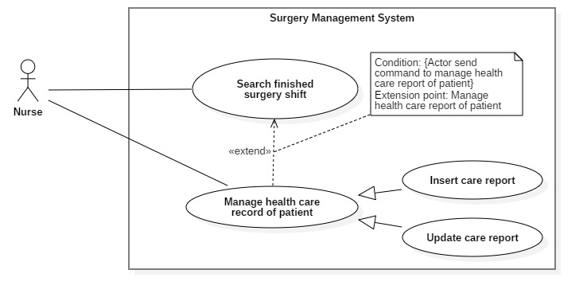

Figure C–2.20: *<Nurse> Overview Use Case*

**2.3.8.1. <Nurse> Search postoperative surgery shift (N01)**

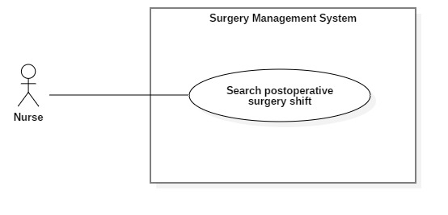

Figure C–2.21: *<Nurse> Search finished surgery shift*

|  |  |  |  |
| --- | --- | --- | --- |
| **USE CASE – N01** | | | |
| **Use Case No.** | **N01** | **Use Case Version** | 2.0 |
| **Use Case Name** | Search postoperative surgery shift | | |
| **Author** | Văn Chí Vĩnh | | |
| **Date** | 28/09/2018 | **Priority** | Normal |
| **Actor:**  – Nurse.  **Summary:**  – This use case allows user to search postoperative surgery shift.  – This use case applied for mobile application.  **Goal:**  – Nurse would be found surgery shifts in system  **Triggers:**  – Nurse enters keyword and sends command to “Search postoperative surgery shift”.  **Preconditions:**  – Login into the system with role Nurse.  – A surgery shift list have “Postoperative” status must be existed.  **Post Conditions:**  – Success: A list of surgery shift which have patient’s name matching with keyword will be displayed  – Fail: Show error message.  **Main Success Scenario:**   |  |  |  | | --- | --- | --- | | Step | Actor Action | System Response | | 1 | Nurse clicks search view. | System requires keyword from Nurse. Keyword can be:   * Patients name * Surgery shift Id * Doctor name | | 2 | Nurse inputs information. |  | | 3 | Nurse sends command to search to system. | System response search result with matched items.  [Exception 1] |   **Alternative Scenario:** N/A  **Exception:**   |  |  |  | | --- | --- | --- | | No | Cause | System Response | | 1 | User enters keyword which do not match any items and send search command. | System show empty data message |   **Relationships:** Extension point of health care record of patient  **Business Rules:**  – System gets all surgery shift that match keyword  – The surgery shift search result list is sorted in descending order by date created  – Nurse can only search postoperative/recovery surgery shift that assigned for him/her.  – Surgery shift item will contain:   * Patient name * Surgery Shift ID * Bed | | | |

Table C–2.11: *<Nurse> Search finished surgery shift*

**2.3.8.3. <Nurse> Get postoperative surgery shift**

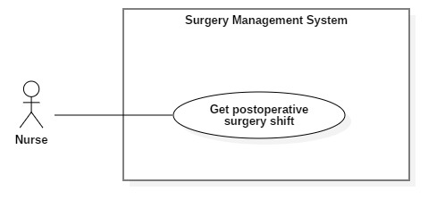

|  |  |  |  |
| --- | --- | --- | --- |
| **USE CASE – < UC-N04>** | | | |
| **Use Case No.** | **UC- N04** | **Use Case Version** | 2.0 |
| **Use Case Name** | Get postoperative surgery shifts | | |
| **Author** | Văn Chí Vĩnh | | |
| **Date** | 28/09/2018 | **Priority** | Normal |
| **Actor:**  -        Nurse.  **Summary:**  -        This use case allows user to get postoperative surgery shifts  - This use case applied for mobile application.  **Goal:**  -        Nurse can get postoperative surgery shifts.  **Triggers:**  -        Nurse sends command to “Get postoperative surgery shifts”.  **Preconditions:**  -        User must login into the system with role Nurse.  **Post Conditions:**  -        Success: Postoperative Surgery Shift will be displayed.  -        Fail: Show error message.  **Main Success Scenario:**     |  |  |  | | --- | --- | --- | | Step | Actor Action | System Response | | 1 | Nurse open postoperative surgery shifts view |  | | 2 | Nurse sends Get postoperative surgery shifts command | Show user postoperative surgery shift. Information will be displayed:   * Patients name. * Surgery shift ID. * Bed.   [Exception 1] |     **Alternative Scenario: N/A**  **Exception:**     |  |  |  | | --- | --- | --- | | No | Actor Action | System Response | | 1 | When the connection to the server is lost | System show error message |     **Relationships:** None.  **Business Rules:**   * + Get surgery shifts have status “postoperative “or “recovery” and this list is ordered by date created.   + Nurse can only get list surgery shift that assigned for him/her. | | | |

**2.3.8.4. <Nurse> Get postoperative surgery shift detail**

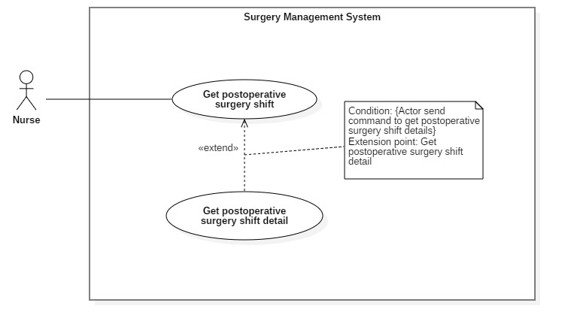

|  |  |  |  |
| --- | --- | --- | --- |
| **USE CASE – < UC-N05>** | | | |
| **Use Case No.** | **UC- N05** | **Use Case Version** | 2.0 |
| **Use Case Name** | Get postoperative surgery detail | | |
| **Author** | Văn Chí Vĩnh | | |
| **Date** | 28/09/2018 | **Priority** | Normal |
| **Actor:**  -        Nurse.  **Summary:**  -        This use case allows user to get postoperative surgery detail  - This use case applied for mobile application.  **Goal:**  -        Nurse can get surgery shift detail.  **Triggers:**  -        Nurse sends command to “Get postoperative surgery detail”.  **Preconditions:**  -        User must login into the system with role Nurse.  **Post Conditions:**  -        Success: Surgery Shift Detail will be displayed.  -        Fail: Show error message.  **Main Success Scenario:**     |  |  |  | | --- | --- | --- | | Step | Actor Action | System Response | | 1 | Nurse goes to surgery shift detail view. |  | | 2 | Nurse sends Get postoperative surgery detail command | Information will be displayed:   * Patient’s information. * Medical requirement. * Health care records. |     **Alternative Scenario: N/A**  **Exception:**     |  |  |  | | --- | --- | --- | | No | Actor Action | System Response | | 1 | Get postoperative surgery detail fail | System show error message |     **Relationships:** Extend by get postoperative surgery shift.  **Business Rules:**   * + Check the required surgery shift exists in system.   + Get patient information:     - Patient name, age, gender     - Surgery catalog name     - Post-Op Room, Bed   + Get medical requirement is lasted created and by time of server. This contains:     - Drug name, unit and quantity   + Get health care records sort by date created. This contains:     - Date created, visit reason. | | | |

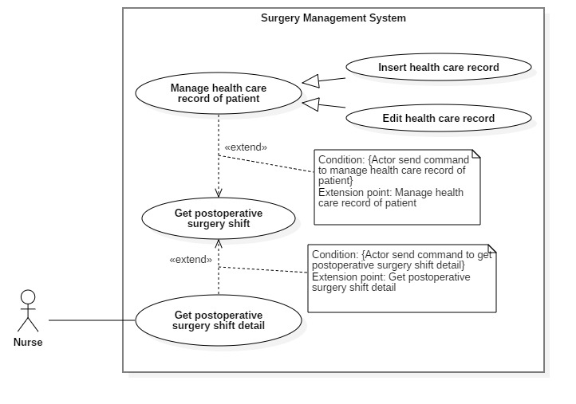**2.3.8.2. <Nurse> Manage health care report of patient**

Figure C–2.22: *<Nurse> Manage health care report of patient*

**2.3.8.2.1. <Nurse> Insert health care report (N02)**

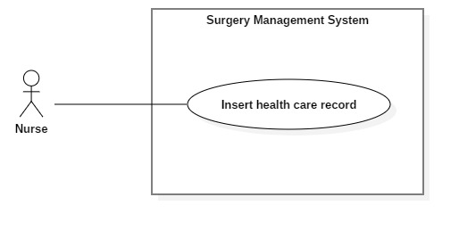

Figure C–2.23: *<Nurse> Insert health care report*

|  |  |  |  |
| --- | --- | --- | --- |
| **USE CASE – N02** | | | |
| **Use Case No.** | **N02** | **Use Case Version** | 2.0 |
| **Use Case Name** | Insert health care record | | |
| **Author** | Văn Chí Vĩnh | | |
| **Date** | 28/09/2018 | **Priority** | Normal |
| **Actor:**  -        Nurse.  **Summary:**  -        This use case allows nurse to insert health care record  - This use case applied for mobile application.  **Goal:**  -        Nurse inserted healthcare record to patient in system.  **Triggers:**  -        Nurse sends command to “Insert health care record”.  **Preconditions:**  -        Login into the system with role Nurse.  **Post Conditions:**  -        Success: Health care record success insert to surgery shift’s health care records in system.  -        Fail: Show error message.  **Main Success Scenario:**     |  |  |  | | --- | --- | --- | | Step | Actor Action | System Response | | 1 | Nurse goes to insert health care record view. | System requires information from nurse:   * Wound condition: wound condition of patient; required; Boolean. * Event content: developments or abnormal conditions, complain and petition of patient; required, length[1;1000] * Care content: things that nurse has taken health care; required; length[1;1000] | | 2 | Nurse input information |  | | 3 | Nurse sends command to insert health record to system.  [Alternative 1] | System validating health care record  [Exception 1]  Add the health care record to the system and navigate to surgery detail view.  [Exception2] |     **Alternative Scenario:**  [Alternative 1]     |  |  |  | | --- | --- | --- | | Step | Actor Action | System Response | | 1 | Nurse send go back command | Return to previous view. |     **Exception:**     |  |  |  | | --- | --- | --- | | No | Cause | System Response | | 1 | Missing required fields. | Show message to ask user to fill in the needed information. | | 2 | Server fail to insert healthcare record | Show error message |   **Relationships:** N/A  **Business Rules:**   * Identify the nurse who insert the healthcare record and the treatment record is lasted created. * The treatment record is used by health care record will change status “Is Used” * Health care record will be inserted along with the inputted information. | | | |

Table C–2.11: *<Nurse> Insert care report*

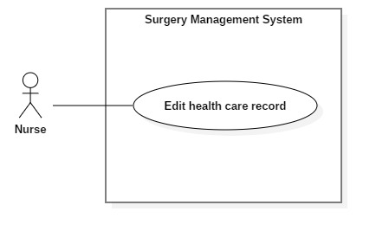**2.3.8.2.2. <Nurse> Edit health care report (N03)**

Figure C–2.24: *<Nurse> Edit health care report*

|  |  |  |  |
| --- | --- | --- | --- |
| **USE CASE – N03** | | | |
| **Use Case No.** | **N03** | **Use Case Version** | 2.0 |
| **Use Case Name** | Edit health care record | | |
| **Author** | Văn Chí Vĩnh | | |
| **Date** | 28/09/2018 | **Priority** | Normal |
| **Actor:**  -        Nurse.  **Summary:**  -        This use case allows nurse to Edit health care record  - This use case applied for mobile application.  **Goal:**  -        Healthcare record will be edited in system.  **Triggers:**  -        Nurse sends command to “Edit health care record”.  **Preconditions:**  -        Login into the system with role Nurse.  -        Health care record must be added in system.  **Post Conditions:**  -        Success: Health care record success edit to surgery shift’s health care records in system.  -        Fail: Show error message.  **Main Success Scenario:**     |  |  |  | | --- | --- | --- | | Step | Actor Action | System Response | | 1 | Nurse goes to edit health care record view. | System show view and requires some information from user:   * Wound condition: wound condition of patient; required; Boolean. * Event content: developments or abnormal conditions, complain and petition of patient; required, length[1;1000] * Care content: things that nurse has taken health care; required; length[1;1000] | | 2 | Nurse input new information |  | | 3 | User sends command to edit health record to system. [Alternative 1] | System validating health care record  [Exception 1]  Edit the health care record to the system and navigate to surgery detail view. |     **Alternative Scenario:**   * 1. [Alternative 1]      |  |  |  | | --- | --- | --- | | Step | Actor Action | System Response | | 1 | Nurse send go back command | Return to previous view. |     **Exception:**     |  |  |  | | --- | --- | --- | | No | Actor Action | System Response | | 1 | Missing required fields. | Show message to ask user to fill in the needed information. | | 2 | Server fail to edit healthcare record | Show error message |   **Relationships:** N/A  **Business Rules:**   * Identify the nurse who edit healthcare record and only who created the healthcare record can edit it. * Check the edit healthcare record exists in the system. * The “date updated” will be update base on time of server. * Healthcare record will be edited along with inputted information. | | | |

Table C–2.12: *<Nurse> Edit health care report*

**2.3.9. <Handler> Overview Use Case**

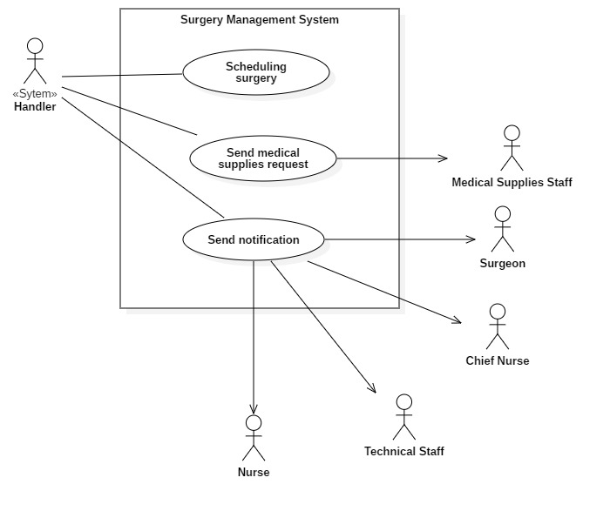

Figure C–2.25: *<Handler> Overview Use Case*

**2.3.9.1. <Handler> Scheduling surgery (H01)**

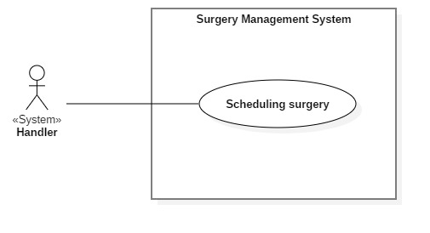

Figure C–2.25: *<Handler> Scheduling surgery*

|  |  |  |  |
| --- | --- | --- | --- |
| **USE CASE – H01** | | | |
| **Use Case No.** | H01 | **Use Case Version** | 2.0 |
| **Use Case Name** | Scheduling surgery | | |
| **Author** | Vo Thanh Tung | | |
| **Date** | 10/02/2019 | **Priority** | High |
| **Actor**:   * System Handler   **Summary**:   * Create a schedule for a surgery shift.   **Goal**:   * Create a schedule which does not conflict with any other schedules.   **Triggers**:   * A Create Schedule command is sent to the system.   **Preconditions**: N/A  **Post** **Conditions**:   * Success: System shows success popup message. * Fail: System shows error message.   **Main** **Success** **Scenario**:   |  |  |  | | --- | --- | --- | | Step | Actor Action | System Response | | 1 | Hospital staff import medical record | System requires actor to import required files. | | 2 | Medical Supply Staff confirm supply requirement |  | | 3 | “Make Schedule” command is sent to the system | Success popup message will be shown up |   **Alternative** **Scenario**: **N/A**   |  |  |  | | --- | --- | --- | | No | Cause | System Response | | 1 |  |  |   **Relationships**: N/A  **Business** **Rules**:   * Get surgery shifts that are confirmed available medical supply to add into unscheduled surgery shift list * The unscheduled surgery shift list is arranged based on:   – Scheduling date: surgery profile that is confirmed sooner will be scheduled first.  – Priority of surgery: the lower priority number, the higher the weight of surgery.  – Surgery shift has proposed time: surgery shifts have the same scheduling day, surgery shifts that have proposed time are preferred.   * The arranged list will be scheduling based on available slot room * If proposed time of surgery shifts is unavailable in slot room, the surgery shift will be scheduling normally based duration time   – Example: *Surgery shift has proposed time: 7:00 – 9:00 22/03/2019, if not available, the system will find slot room that has duration time is 2 hours.*   * Proposed time depends on surgeon’s available time and is set before scheduling. * If surgery room is full slot, the unscheduled surgery shift will be created automatically in next day. * After scheduling surgery, the system will notify to Chief Nurse and Technical Staff. | | | |

Table C–2.13: *<Handler> Scheduling surgery*

**2.3.9.2. <Handler> Send medical supply request (H02)**

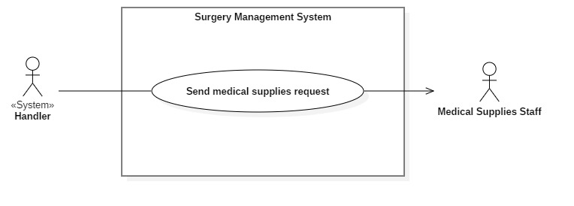

Figure C–2.26: *<Handler> Send medical supply request*

|  |  |  |  |
| --- | --- | --- | --- |
| **USE CASE – H02** | | | |
| **Use Case No.** | H02 | **Use Case Version** | 2.0 |
| **Use Case Name** | Send medical supply request | | |
| **Author** | PhucTQ | | |
| **Date** | 10/02/2019 | **Priority** | Normal |
| **Actor**:   * System Handler   **Summary**:   * Send a supply request to medical supply staff.   **Goal**:   * Supply staff receive medical request.   **Triggers**:   * After hospital staff import medical record files, a Send Supply Request command will be sent to the system   **Preconditions**: N/A  **Post** **Conditions**:   * Success: Supply staff receive the medical request * Fail: System shows error message.   **Main** **Success** **Scenario**:   |  |  |  | | --- | --- | --- | | Step | Actor Action | System Response | | 1 | Hospital staff import medical record | System requires actor to import required files. | | 2 | Send Supply Request command is sent to the system |  |   **Alternative** **Scenario**: **N/A**  **Relationships**: N/A  **Business** **Rules**:   * Hospital Staff must import correct medical record template. * Supply Request can only be sent after all medical record templates are saved. * Supply Request is saved to database. | | | |

Table C–2.14: *<Handler> Send medical supply request*

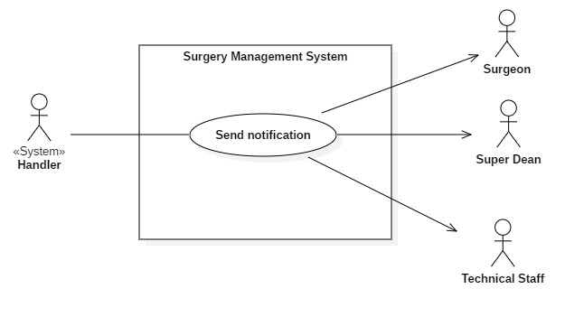**2.3.9.3. <Handler> Send notification (H03)**

Figure C–2.27: *<Handler> Send notification*

|  |  |  |  |
| --- | --- | --- | --- |
| **USE CASE – H03** | | | |
| **Use Case No.** | H03 | **Use Case Version** | 2.0 |
| **Use Case Name** | Send notification | | |
| **Author** | PhucTQ | | |
| **Date** | 10/02/2019 | **Priority** | Normal |
| **Actor**:   * System Handler   **Summary**:   * Send Notification to Surgeon, Chief Nurse, Technical Staff   **Goal**:   * Actors receive notification successfully.   **Triggers**:   * Send Notification command is sent to the system after schedule is created, updated or canceled.   **Preconditions**: N/A  **Post** **Conditions**:   * Success: Actors receive notification successfully * Fail: System shows error message.   **Main** **Success** **Scenario**:   |  |  |  | | --- | --- | --- | | Step | Actor Action | System Response | |  |  |  | |  |  |  |   **Alternative** **Scenario**: N/A  **Relationships**: N/A  **Business** **Rules**:   * Surgeon email must exist | | | |

Table C–2.15: *<Handler> Send notification*

* + - 1. **Software System Attribute**

### **3.1. Usability**

– UI website is fit for each browser in each device:

* + - * Font size: 13-18px
      * Font style: Roboto, sans-serif font
      * Color: black
      * Background: green

– UI mobile application mobile is scalable with each monitor of smart phone or tablet:

* Font size: follow Google Material design guideline for typography.
* Font style: sans-serif font
* Color: black
* Background: green

– Staffs can be trained one week to use all system functions.

### **3.2. Reliability**

– Scheduling system can run 24/7 and with accuracy of 99%.

### **3.3. Availability**

– System replies in maximum 5 seconds/ 8Mbps.

– System with 95% durability and backup plan for system failure.

### **3.4. Security**

– Each role of user has a specific permission to interact with the system.

– System always checks for authorization and authentication before doing anything.

### **3.5. Maintainability**

– The system is divided into separated modules for easy maintain.

### **3.6. Portability**

– User can use the mobile application on devices running Android 5.0 or later.

– Web application can be run on Chrome browser version 42 or later.

### **3.7. Performance**

– The system can handle 100 requests at a time.

* + - 1. **Conceptual Diagram**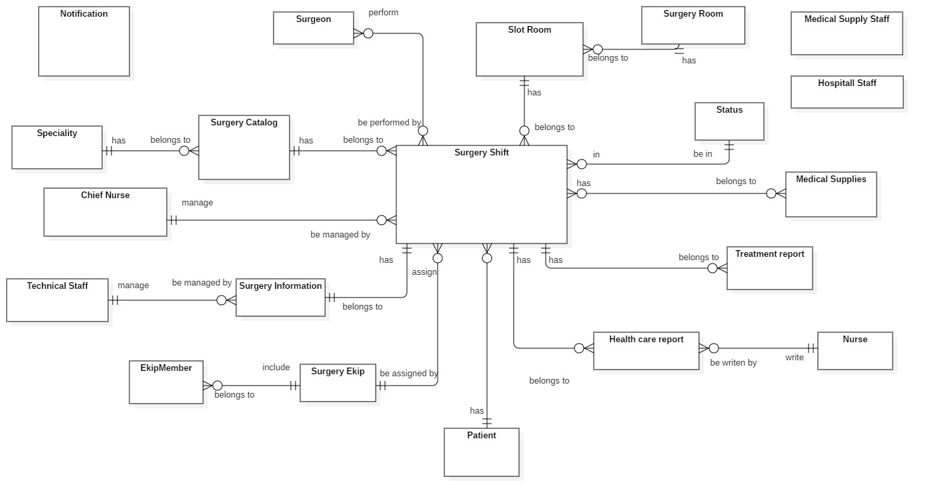

***Figure C-4.1:*** *Conceptual Diagram*

|  |  |  |
| --- | --- | --- |
| **Entity Data Dictionary: describe all content of all entities** | | |
| **No.** | **Entity Name** | **Description** |
| 1 | Hospital Staff | Contain the Hospital Staff information |
| 2 | Chief Nurse | Contain the Chief Nurse information |
| 3 | Technical Staff | Contain the Technical Staff information |
| 4 | Medical Supply Staff | Contain the Medical Supply Staff information |
| 5 | Nurse | Contain the Nurse information |
| 6 | Surgeon | Contain the Surgeon information |
| 7 | Medical Supply | Contain Medical Supply Catalog |
| 8 | Surgery Report | Contain the Surgery Report information |
| 9 | Surgery Shift | Contain the Surgery Shift information |
| 10 | Surgery Room | Contain the Surgery Room information |
| 11 | Notification | Contain the Notification information |
| 12 | Health Care Report | Contain the Health Care Report information |

1. **Software Design Description**
   * + - 1. **Design Overview**

– This document describes the technical and user interface design of eBSMS. It includes the architectural design, the detailed design of common functions and business functions and the design of database model.

– The architectural design describes the overall architecture of the system and the architecture of each main component and subsystem.

– The detailed design describes static and dynamic structure for each component and functions. It includes class diagrams, class explanations and sequence diagrams for each use cases.

– The database design describes the relationships between entities and details of each entity.

– Document overview:

* Section 2: gives an overall description of the system architecture design.
* Section 3: gives component diagrams that describe the connection and integration of the system.
* Section 4: gives the detail design description which includes class diagram, class explanation, and sequence diagram to details the application functions.
* Section 5: describe screens design.
* Section 6: describe a fully attributed ERD.
* Section 7: describe algorithms**.**
  + - * 1. 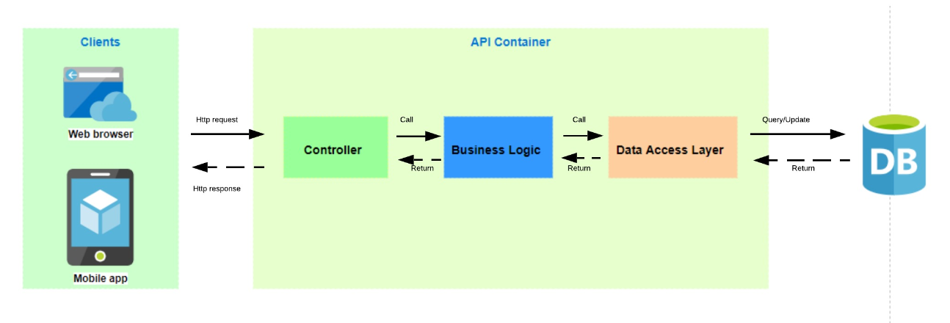**System Architectural Design**
        2. **Component Diagram**
        3. **Detailed Description**
  1. **Class Diagram**

|  |  |  |  |
| --- | --- | --- | --- |
| **Class dictionary: Describe Class** | | | |
| **Class Name** | **Mapping with Conceptual diagram** | **Mapping with Entity diagram** | **Description** |
| SurgeryShift | x |  | Contain the surgery shift information |
| SurgeryRoom | x |  | Contain the Surgery Room name |
| SlotRoom | x |  | Contain the slot room information |
| Ekip | x |  | Contain the ekip name |
| MemberOfEkip | x |  | Contain the member information of a ekip |
| Surgeon | x |  | Contain the Surgeon information |
| MedicalSupply | x |  | Contain the Medical Supplies information |
| MedicalSupplyItem | N/A |  | Contain the Medical Supplies detail information |
| TreatmentReport | x |  | Contain the Treatment Report information |
| Patient | x |  | Contain the Patient information |
| SurgeryCatalog | x |  | Contain the surgery catalog information |
| Specialty | x |  | Contain the Specialty information |
| HealthCareReport | x |  | Contain the Health Care Report information |
| Status | x |  | Contain the statuses of a surgery. Has types: preoperative, inoperative, postoperative |
| HealthCareReportDetail | x |  | Contain detail information of a health care report |
| Account | x |  | Contain the account information |
| Role | x |  | Contain the role information. Has 4 types: hospital staff, supplier, chief nurse, nurse |

* 1. **Class Diagram Explanation**

#### **4.2.1. Account**

**Attributes**

|  |  |  |  |
| --- | --- | --- | --- |
| **Attribute** | **Type** | **Visibility** | **Description** |
| id | int | private | Unique identity key of an account |
| username | String | private | Unique username of an account uses to login into specific system. |
| password | String | private | Password of an account uses to login into specific system. |
| fullName | String | private | Name of the user using account |
| phoneNumber | String | private | Phone number of the user using account |
| email | String | private | Email of the user using account |

#### **4.2.2. Role**

**Attributes**

|  |  |  |  |
| --- | --- | --- | --- |
| **Attribute** | **Type** | **Visibility** | **Description** |
| id | int | private | Unique identifier of a role. |
| name | String | private | Name of a role. |

**4.2.3. SurgeryShift**

**Attributes**

|  |  |  |  |
| --- | --- | --- | --- |
| **Attribute** | **Type** | **Visibility** | **Description** |
| id | int | private | Unique identifier of a surgery shift. |
| actualStartDatetime | Datetime | private | Actual start date time of a surgery |
| actualEndDatetime | Datetime | private | Actual end date time of a surgery |
| estimatedStartDatetime | Datetime | private | Propose start date time of a surgery |
| estimatedEndDatetime | Datetime | private | Propose end date time of a surgery |
| isNormalSurgeryTime | Bool | private |  |
| confirmDate | Datetime | private | Medical supply request confirmed date |
| scheduleDate | Datetime | private |  |
| expectedSurgeryDuration | int | private | Expected duration of the surgery |
| usedProcedure | String | private | Procedure used in the surgery |
| usedAnesthesiaMethod | String | private | Anesthesia method used in the surgery |
| priorityNumber | int | private | Priority of the surgery |

**4.2.4. SurgeryRoom**

**Attributes**

|  |  |  |  |
| --- | --- | --- | --- |
| **Attribute** | **Type** | **Visibility** | **Description** |
| id | int | private | Unique identifier of a surgery room. |
| name | String | private | Name of the surgery room. |

**4.2.5. SlotRoom**

**Attributes**

|  |  |  |  |
| --- | --- | --- | --- |
| **Attribute** | **Type** | **Visibility** | **Description** |
| id | int | private | Unique identifier of a surgery slot. |
| name | String | private | Name of the surgery slot. |

**4.2.6. Ekip**

**Attributes**

|  |  |  |  |
| --- | --- | --- | --- |
| **Attribute** | **Type** | **Visibility** | **Description** |
| id | int | private | Unique identifier of an ekip. |

**4.2.7. MemberOfEkip**

**Attributes**

|  |  |  |  |
| --- | --- | --- | --- |
| **Attribute** | **Type** | **Visibility** | **Description** |
| id | int | private | Unique identifier of an ekip member. |
| name | String | private | Name of the surgery ekip member. |
| role | String | private | Role name of a member in surgery ekip |

**4.2.8. Surgeon**

**Attributes**

|  |  |  |  |
| --- | --- | --- | --- |
| **Attribute** | **Type** | **Visibility** | **Description** |
| id | int | private | Unique identifier of a patient. |
| fullName | String | private | Name of the surgeon. |
| phoneNumber | String | private | Surgeon phone number |
| email | String | private | Surgeon email |

**4.2.9. MedicalSupply**

**Attributes**

|  |  |  |  |
| --- | --- | --- | --- |
| **Attribute** | **Type** | **Visibility** | **Description** |
| Id | int | private | Surgery shift id |
| name | String | private | Medical supply name |
| barcode | String | private | Medical supply barcode |
| origin | String | private | Medical supply origin country |
| brand | String | private | Medical supply brand |
| supplyCompany | String | private | Medical supplycompany name |
| price | double | private | Medical supply price |
| quantity | int | private | Medical supply quantity in storage |
| unit | String | private | Medical supply unit count |

**4.2.10. MedicalSupplyItem**

**Attributes**

|  |  |  |  |
| --- | --- | --- | --- |
| **Attribute** | **Type** | **Visibility** | **Description** |
| surgeryShiftId | int | private | Surgery shift id |
| medicalSupplyId | String | private | Medical supply Id use. |
| usedQuantity | int | private | Medical supply quantity |

**4.2.11. TreatmentReport**

**Attributes**

|  |  |  |  |
| --- | --- | --- | --- |
| **Attribute** | **Type** | **Visibility** | **Description** |
| id | int | private | Unique identifier of a surgery shift treatment report. |
| progressiveDisease | String | private | Progressive Disease of the progressiveDisease. |

**4.2.12. Patient**

**Attributes**

|  |  |  |  |
| --- | --- | --- | --- |
| **Attribute** | **Type** | **Visibility** | **Description** |
| id | int | private | Unique identifier of a patient. |
| fullName | String | private | Name of the patient. |
| identityNumber | String | private | Patient identity number in system |
| address | String | private | Patient address |
| gender | int | private | Patient gender |
| yob | int | private | Patient year of birth |

**4.2.13. SurgeryCatalog**

**Attributes**

|  |  |  |  |
| --- | --- | --- | --- |
| **Attribute** | **Type** | **Visibility** | **Description** |
| id | int | private | Unique identifier of a Surgery Catalog. |
| code | String | private | Code of the Surgery Catalog. |
| name | String | private | Name of the Surgery Catalog |
| type | String | private | Surgery catalog type |
| note | String | private | Note of the Surgery Catalog |
| price | double | private | Price of the Surgery Catalog |
| procedure | String | private | Procedure used in the Surgery Catalog |
| expectedSurgeryDuration | int | private | Expected duration of the Surgery Catalog |
| anesthesiaMethod | String | private | Anesthesia method in the Surgery Catalog |

**4.2.14. Speciality**

**Attributes**

|  |  |  |  |
| --- | --- | --- | --- |
| **Attribute** | **Type** | **Visibility** | **Description** |
| id | int | private | Unique identifier of a specialty. |
| name | String | private | Name of the specialty. |

**4.2.15. HealthCareReport**

**Attributes**

|  |  |  |  |
| --- | --- | --- | --- |
| **Attribute** | **Type** | **Visibility** | **Description** |
| id | int | private | Unique identifier of a surgery healthcare report. |
| postRoomNumber | String | private | Room patient stay after surgery. |
| posBedNumber | String |  | Bed patient stay after surgery. |

**4.2.16. Status**

**Attributes**

|  |  |  |  |
| --- | --- | --- | --- |
| **Attribute** | **Type** | **Visibility** | **Description** |
| id | int | private | Unique identifier of a surgery status. |
| name | String | private | Name of the surgery status. |

**4.2.17. HealthCareReportDetail**

**Attributes**

|  |  |  |  |
| --- | --- | --- | --- |
| **Attribute** | **Type** | **Visibility** | **Description** |
| id | int | private | Unique identifier of a heath care report detail. |
| datetime | datetime | private | Created day of a heath care report detail. |
| eventContent | String | private | Name of a heath care report detail. |
| careContent | String | public | Name of the heath care report detail. |
| careReason | String | private | Reason of the heath care report detail. |
| woundCondition | String | private | Surgery wound condition |
| woundConditionDescription | String | private | Detail about Surgery wound condition |
| drugAllergy | String | private | Post-surgery drug allergy |
| drugAllergyDescription | String | private | Detail about post-surgery drug allergy |

* 1. **Interaction Diagram**

**4.3.1. Get Surgery Profile**

**4.3.2. Import Surgery Profile**

**4.3.3. Get Medical Supply Request**

**4.3.4. Confirm Medical Supply Request**

**4.3.5. Make Surgery Schedule**

**4.3.6. Add Emergency Shift**

**4.3.7. Swap Surgery Shift**

**4.3.8. Change Time of Surgery Shift**

**4.3.9. Update Status of Surgery Shift**

**4.3.10. Update Status of Surgery Shift**

**4.3.11. Get Surgery Shift Detail**

**4.3.12. Update Surgery Information**

**4.3.13. Get Treatment Report**

**4.3.14. Add Treatment Report**

**4.3.15. Get Health Care Report**

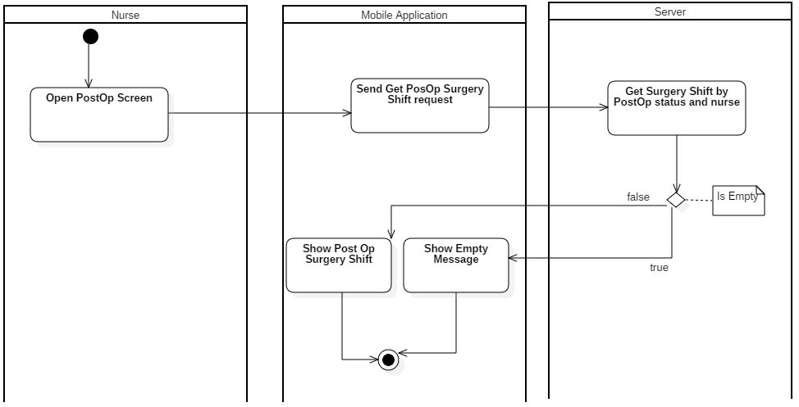**4.3.16. Get Postoperative Surgery Shift**

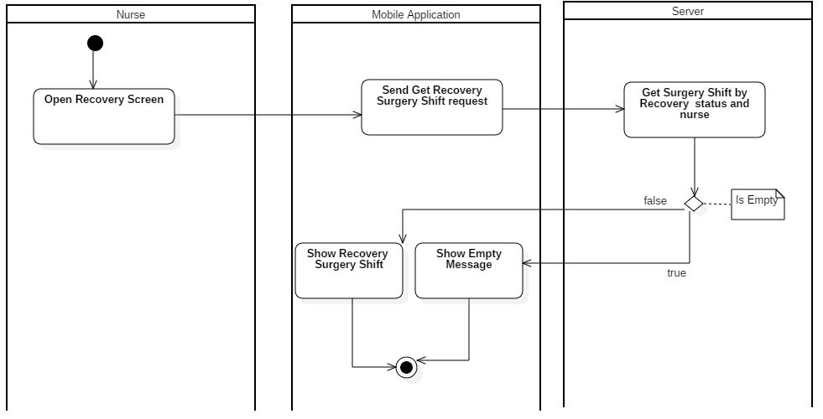**4.3.17. Get Recovery Surgery Shift**

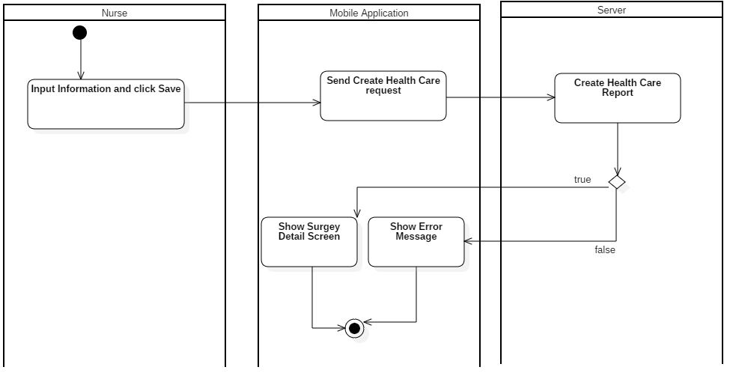**4.3.18. Add Health Care Report**

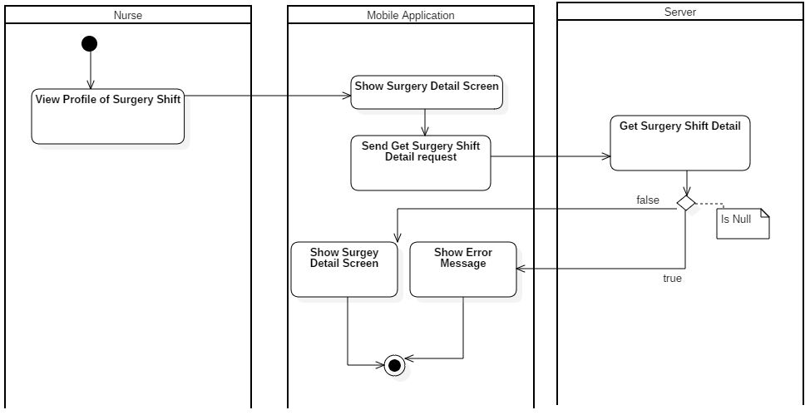**4.3.19. Get Recovery Surgery Shift Detail**

1. **User Interface Design**
   1. **Web Interface Design**
      1. **Login**

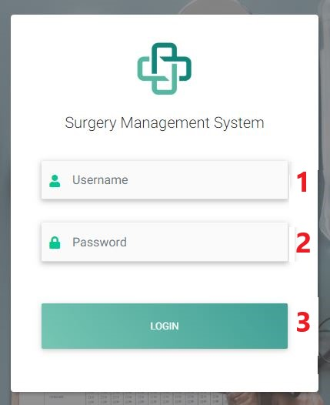

**Fields**

|  |  |  |  |  |  |  |
| --- | --- | --- | --- | --- | --- | --- |
| **No** | **Field Name** | **Description** | **Read-only** | **Mandatory** | **Control** | **Data Type** |
| 1 | Username | Username to login | No | Yes | Text Box | String |
| 2 | Password | Password to login | No | Yes | Text Box | String |

**Buttons/Hyperlinks**

|  |  |  |  |  |
| --- | --- | --- | --- | --- |
| **No.** | **Function** | **Description** | **Validation** | **Outcome** |
| 3 | Log in | Validate all field and perform log in process | Validate all fields | Success: Navigate to page for role signed in  Fail: Stay and show Login fail |

* + 1. **Import Page**

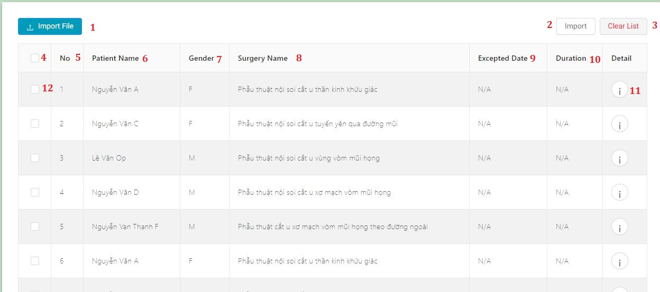

**Fields**

|  |  |  |  |  |  |  |
| --- | --- | --- | --- | --- | --- | --- |
| **No** | **Field Name** | **Description** | **Read-only** | **Mandatory** | **Control** | **Data Type** |
| 5 | No | Numerical Order | Yes | Yes | Text | String |
| 6 | Patient Name | Show name of patient | Yes | Yes | Text | String |
| 7 | Gender | Show gender of patient | Yes | Yes | Text | String |
| 8 | Surgery Name | Show surgery name that patient takes | Yes | Yes | Text | String |
| 9 | Expected Date | Show date that patient expects | Yes | Yes | Text | String |
| 10 | Duration | Show duration of surgery | Yes | Yes | Text | String |

**Buttons/Hyperlinks**

|  |  |  |  |  |
| --- | --- | --- | --- | --- |
| **No.** | **Function** | **Description** | **Validation** | **Outcome** |
| 1 | Import File | Choose excel file to import | N/A | Information from excel file will be parsed |
| 2 | Import | Import selected surgery shift | N/A | Selected shift will be imported |
| 3 | Clear list | Clear all information in table | N/A | All information in table will be cleared and show “No Data” |
| 4 | Select All | Select All record in table | N/A | All record will be “checked” |
| 11 | View Detail | View Detail of surgery shift | N/A | Open surgery shift detail modal |
| 12 | Select | Select one record in table | N/A | Record that selected will be “checked” |

* + 1. **Import Detail Modal**

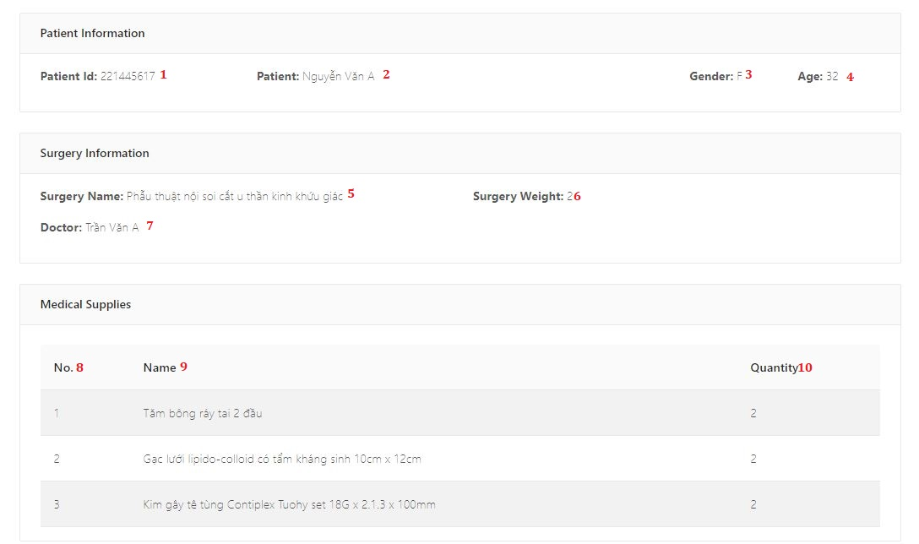

**Fields**

|  |  |  |  |  |  |  |
| --- | --- | --- | --- | --- | --- | --- |
| **No** | **Field Name** | **Description** | **Read-only** | **Mandatory** | **Control** | **Data Type** |
| 1 | Patient ID | Show id for patient | Yes | Yes | Text | String |
| 2 | Patient | Show name of patient | Yes | Yes | Text | String |
| 3 | Gender | Show gender of patient | Yes | Yes | Text | String |
| 4 | Age | Show age for patient | Yes | Yes | Text | String |
| 5 | Surgery Name | Show surgery name that patient takes | Yes | Yes | Text | String |
| 6 | Surgery Weight | Show duration of surgery | Yes | Yes | Text | String |
| 7 | Doctor | Show treatment doctors name | Yes | Yes | Text | String |
| 8 | No | Numerical order of medical supplies | Yes | Yes | Text | String |
| 9 | Name | Name of medical supply | Yes | Yes | Text | String |
| 10 | Quantity | Quantity of medical supply | Yes | Yes | Text | String |

* + 1. **Confirm Medical Supply Page**

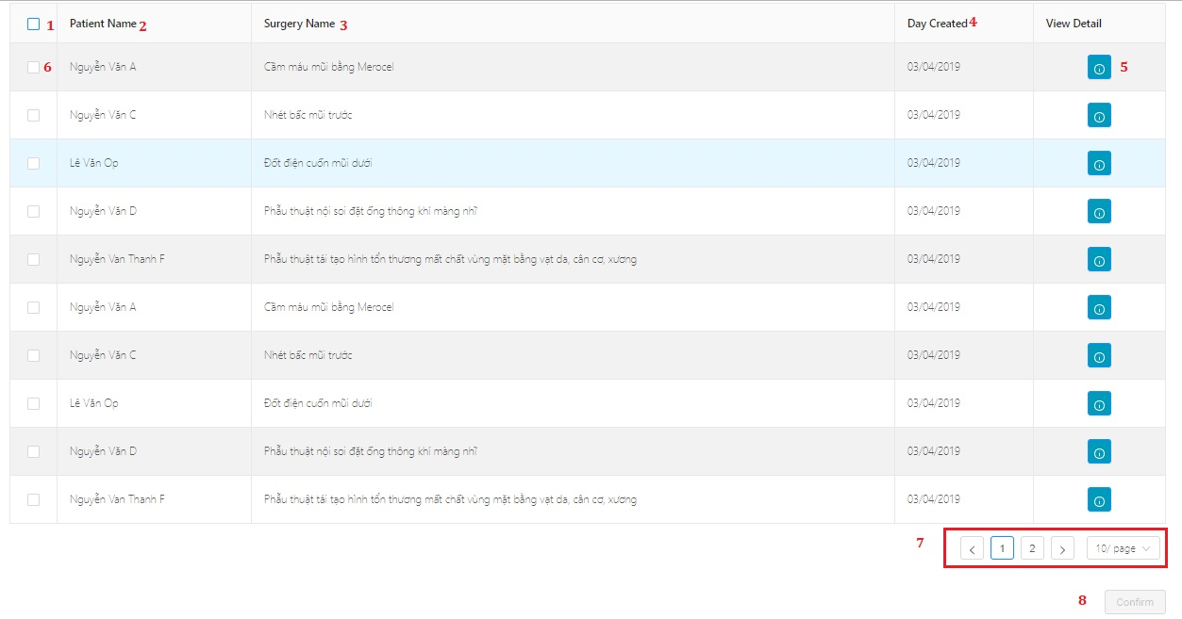

**Fields**

|  |  |  |  |  |  |  |
| --- | --- | --- | --- | --- | --- | --- |
| **No** | **Field Name** | **Description** | **Read-only** | **Mandatory** | **Control** | **Data Type** |
| 2 | Patient Name | Show name of patient | Yes | Yes | Text | String |
| 3 | Surgery Name | Show surgery name that patient takes | Yes | Yes | Text | String |
| 4 | Day Created | Show date that surgery shift created | Yes | Yes | Text | String |

**Buttons/Hyperlinks**

|  |  |  |  |  |
| --- | --- | --- | --- | --- |
| **No.** | **Function** | **Description** | **Validation** | **Outcome** |
| 1 | Select All | Select All record in table | N/A | All record will be “checked” |
| 5 | View Detail | View Detail of surgery shift | N/A | Open surgery shift supplies detail modal |
| 6 | Select | Select one record in table | N/A | Record that selected will be “checked” |
| 7 | Pagination | Paging function | N/A | Perform clicked paging function |
| 8 | Confirm | Confirm medical supplies that surgery shift request | If there are not selected record, button is “Disabled” | All selected record will be confirmed and make schedule |

* + 1. **Medical Supply Detail Modal**

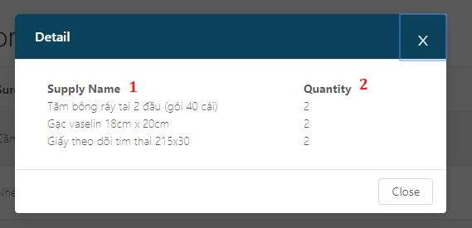

**Fields**

|  |  |  |  |  |  |  |
| --- | --- | --- | --- | --- | --- | --- |
| **No** | **Field Name** | **Description** | **Read-only** | **Mandatory** | **Control** | **Data Type** |
| 1 | Supply name | Name of medical supply | Yes | Yes | Text | String |
| 2 | Quantity | Quantity of medical supply | Yes | Yes | Text | String |

* + 1. **Schedule Page**
       1. **Schedule Page 1**

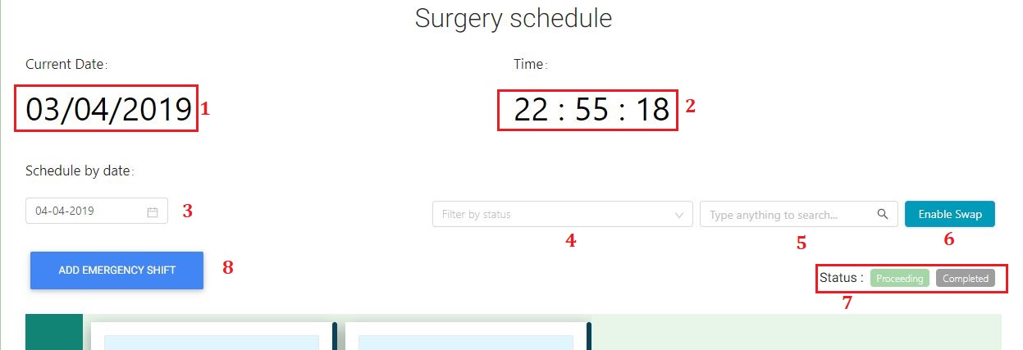

**Fields**

|  |  |  |  |  |  |  |
| --- | --- | --- | --- | --- | --- | --- |
| **No** | **Field Name** | **Description** | **Read-only** | **Mandatory** | **Control** | **Data Type** |
| 1 | Current Date | Show current date of server | Yes | Yes | Text | String |
| 2 | Current Time | Show current time of server | Yes | Yes | Text | String |
| 3 | Schedule by date | Show schedule by selected date | Yes | Yes | DatePicker | String |
| 4 | Filter by status | Filter surgery shift by status | Yes | Yes | TextBox | String |
| 5 | Search field | Search surgery shift by inputted keyword | Yes | Yes | TextBox | String |
| 7 | Status | Show information about status | Yes | Yes | Text | String |

**Buttons/Hyperlinks**

|  |  |  |  |  |
| --- | --- | --- | --- | --- |
| **No.** | **Function** | **Description** | **Validation** | **Outcome** |
| 6 | Enable swap | Enable swap function | N/A | Swap function will be ready to perform |
| 8 | Add emergency shift | Add emergency shift to schedule | N/A | Open add emergency shift modal |

* + - 1. **Schedule Page 2**

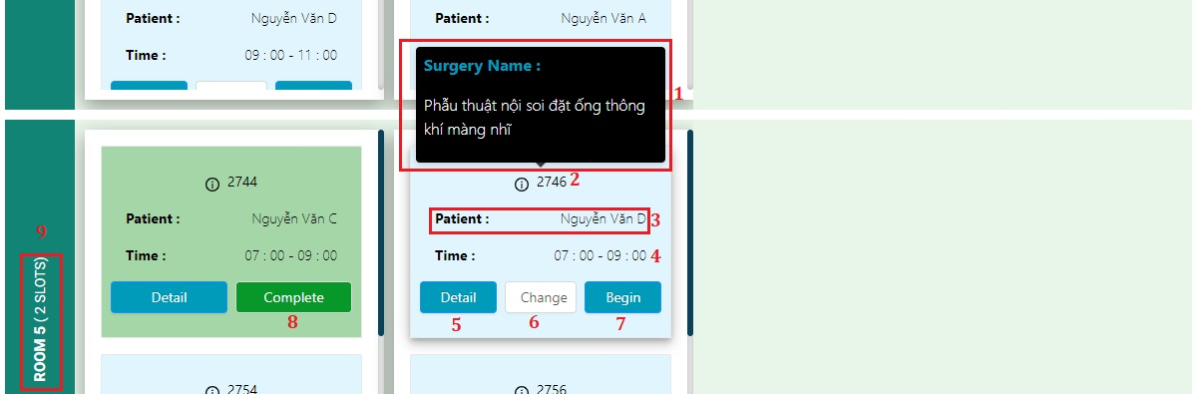

**Fields**

|  |  |  |  |  |  |  |
| --- | --- | --- | --- | --- | --- | --- |
| **No** | **Field Name** | **Description** | **Read-only** | **Mandatory** | **Control** | **Data Type** |
| 1 | Surgery Name | Show name of surgery catalog | Yes | Yes | Text | String |
| 2 | Surgery ID | Show ID of surgery shift | Yes | Yes | Text | String |
| 3 | Patient name | Show name of patient | Yes | Yes | Text | String |
| 4 | Time | Show time start – end of surgery shift | Yes | Yes | Text | String |
| 9 | Room name | Show name of room and number of slots | Yes | Yes | Text | String |

**Buttons/Hyperlinks**

|  |  |  |  |  |
| --- | --- | --- | --- | --- |
| **No.** | **Function** | **Description** | **Validation** | **Outcome** |
| 5 | Detail | Open detail page of surgery shift | N/A | Navigate to selected surgery shift detail page |
| 6 | Change | Change surgery shift | N/A | Open change surgery shift modal |
| 7 | Begin | Begin surgery shift | N/A | Open begin surgery shift modal |
| 8 | Complete | Complete surgery shift | N/A | Open complete surgery shift modal |

* + 1. **Schedule Detail Page**
       1. **Information of Surgery Shift View**

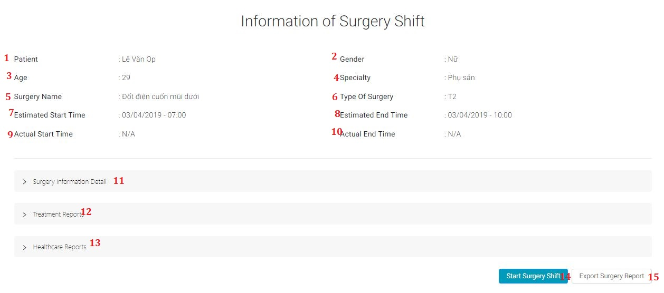

**Fields**

|  |  |  |  |  |  |  |
| --- | --- | --- | --- | --- | --- | --- |
| **No** | **Field Name** | **Description** | **Read-only** | **Mandatory** | **Control** | **Data Type** |
| 1 | Patient | Show name of patient | Yes | Yes | Text | String |
| 2 | Gender | Show gender of patient | Yes | Yes | Text | String |
| 3 | Age | Show age of patient | Yes | Yes | Text | String |
| 4 | Specialty | Show specialty of surgery shift | Yes | Yes | Text | String |
| 5 | Surgery name | Show name of surgery shift | Yes | Yes | Text | String |
| 6 | Type of surgery | Show type of surgery shift | Yes | Yes | Text | String |
| 7 | Estimated Start time | Show estimated start of surgery shift | Yes | Yes | Text | String |
| 8 | Estimated End time | Show estimated end of surgery shift | Yes | Yes | Text | String |
| 9 | Actual Start time | Show actual start of surgery shift | Yes | Yes | Text | String |
| 10 | Actual End time | Show actual end of surgery shift | Yes | Yes | Text | String |

**Buttons/Hyperlinks**

|  |  |  |  |  |
| --- | --- | --- | --- | --- |
| **No.** | **Function** | **Description** | **Validation** | **Outcome** |
| 11 | Surgery information detail | Surgery information detail view | N/A | Open surgery information detail view |
| 12 | Treatment report | Treatment report view | N/A | Open Treatment report detail view |
| 13 | Healthcare report | Healthcare report view | N/A | Open Healthcare report detail view |
| 14 | Change status | Change status modal | N/A | Open Change status modal |
| 15 | Export surgery shift | Export surgery shift function | N/A | Documentation about surgery shift will be exported (PDF file) |

* + - 1. **Information Detail of Surgery Shift View**

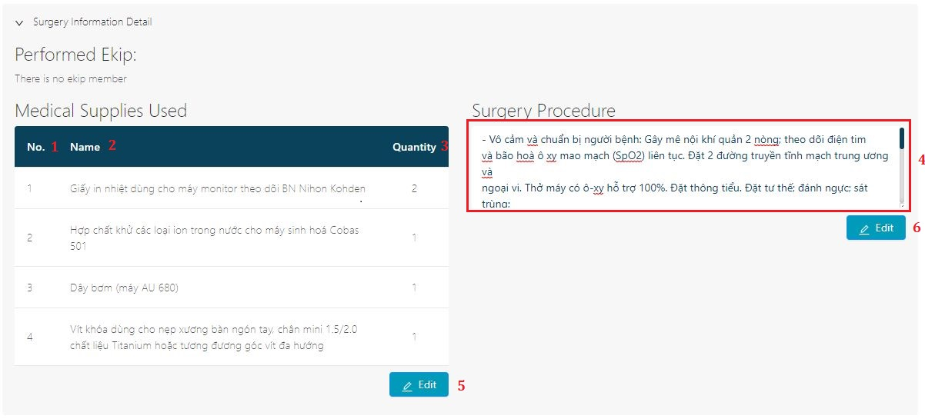

**Fields**

|  |  |  |  |  |  |  |
| --- | --- | --- | --- | --- | --- | --- |
| **No** | **Field Name** | **Description** | **Read-only** | **Mandatory** | **Control** | **Data Type** |
| 1 | No | Numerical order of medical supplies | Yes | Yes | Text | String |
| 2 | Name | Show name of medical supply | Yes | Yes | Text | String |
| 3 | Quantity | Show quantity of medical supply | Yes | Yes | Text | String |
| 4 | Surgery Procedure | Show procedure of surgery shift | Yes | Yes | TextArea | String |

**Buttons/Hyperlinks**

|  |  |  |  |  |
| --- | --- | --- | --- | --- |
| **No.** | **Function** | **Description** | **Validation** | **Outcome** |
| 5 | Edit medical supplies | Edit medical supplies | N/A | Open edit medical supplies modal |
| 6 | Edit surgery procedure | Edit surgery procedure | N/A | Enable edit mode for surgery procedure |

* + - 1. **Treatment Report View**

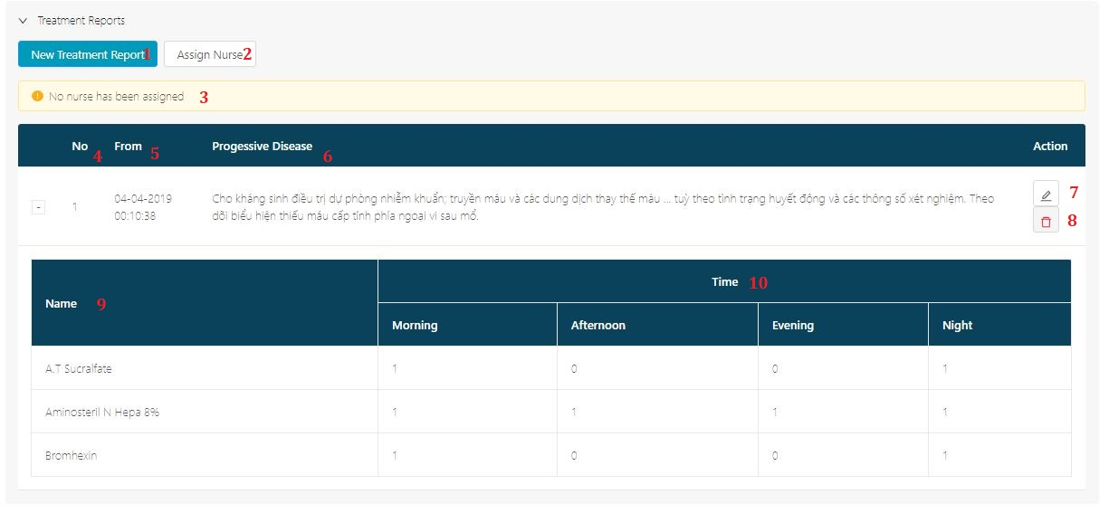

**Fields**

|  |  |  |  |  |  |  |
| --- | --- | --- | --- | --- | --- | --- |
| **No** | **Field Name** | **Description** | **Read-only** | **Mandatory** | **Control** | **Data Type** |
| 3 | Assign Nurse Warning | Show assign nurse warning | Yes | Yes | Text | String |
| 4 | No | Numerical order of treatment report | Yes | Yes | Text | String |
| 5 | From | Show created time of treatment report | Yes | Yes | Text | String |
| 6 | Progressive Disease | Show Progressive Disease of treatment report | Yes | Yes | Text | String |
| 9 | Drug name | Show name of drug | Yes | Yes | Text | String |
| 10 | Drug time | Show time of drug | Yes | Yes | Text | String |

**Buttons/Hyperlinks**

|  |  |  |  |  |
| --- | --- | --- | --- | --- |
| **No.** | **Function** | **Description** | **Validation** | **Outcome** |
| 1 | New Treatment Report | New Treatment Report | N/A | Open New Treatment Report modal |
| 2 | Assign nurse | Assign nurse | N/A | Open Assign nurse modal |
| 7 | Edit Treatment Report | Edit Treatment Report | N/A | Open Edit Treatment Report modal |
| 8 | Delete Treatment Report | Delete Treatment Report | N/A | Delete Treatment Report and refresh treatment report table |

* + - 1. **Healthcare Report View**

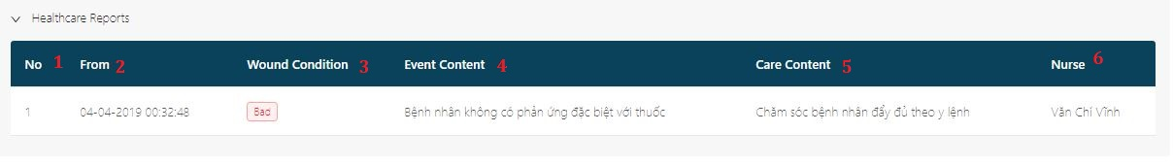

**Fields**

|  |  |  |  |  |  |  |
| --- | --- | --- | --- | --- | --- | --- |
| **No** | **Field Name** | **Description** | **Read-only** | **Mandatory** | **Control** | **Data Type** |
| 1 | No | Numerical order of healthcare report | Yes | Yes | Text | String |
| 2 | From | Show created time of healthcare report | Yes | Yes | Text | String |
| 3 | Wound condition | Show wound condition of patient | Yes | Yes | Text | String |
| 4 | Event content | Show event content of healthcare report | Yes | Yes | Text | String |
| 5 | Care content | Show care content of healthcare report | Yes | Yes | Text | String |
| 6 | Nurse | Show nurse name of healthcare report | Yes | Yes | Text | String |

**5.2. Mobile Interface Design**

Login Page

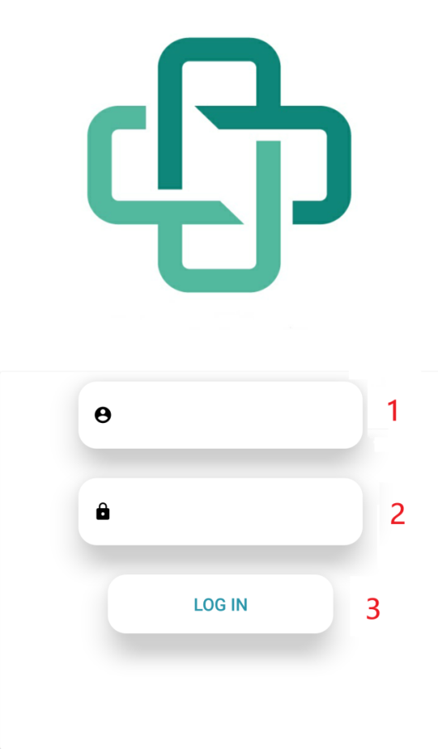

**Fields**

|  |  |  |  |  |  |  |
| --- | --- | --- | --- | --- | --- | --- |
| **No** | **Field Name** | **Description** | **Read-only** | **Mandatory** | **Control** | **Data Type** |
| 1 | Username | Username to login | No | Yes | EditText | String |
| 2 | Password | Password to login | No | Yes | EditText | String |

**Buttons/Hyperlinks**

|  |  |  |  |  |
| --- | --- | --- | --- | --- |
| **No.** | **Function** | **Description** | **Validation** | **Outcome** |
| 3 | Log in | Validate all field and perform log in process | Validate all fields | Success: Navigate Main page  Fail: Stay and show Login fail |

Main Page

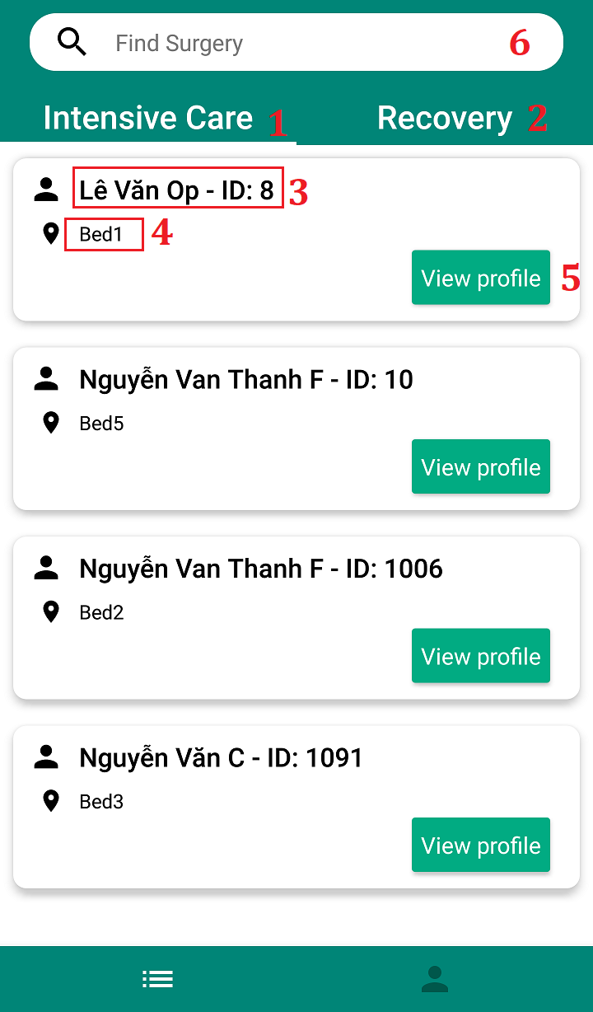

**Fields**

|  |  |  |  |  |  |  |
| --- | --- | --- | --- | --- | --- | --- |
| **No** | **Field Name** | **Description** | **Read-only** | **Mandatory** | **Control** | **Data Type** |
| 3 | Patient Name | Patient name and surgery shift ID | No | Yes | TextView | String |
| 4 | Bed | Bed position of patient | No | Yes | TextView | String |

**Buttons/Hyperlinks**

|  |  |  |  |  |
| --- | --- | --- | --- | --- |
| **No.** | **Function** | **Description** | **Validation** | **Outcome** |
| 1 | Intensive care | Intensive care tab | N/A | Open intensive care tab |
| 2 | Recovery | Recovery tab | N/A | Open recovery tab |
| 5 | View Profile | View profile of surgery shift | N/A | Open Surgery shift detail view |
| 6 | Find Surgery | Find surgery base on keyword(patient name, surgery shift ID, doctor name) | N/A | Open Find surgery view |

Surgery Detail Page

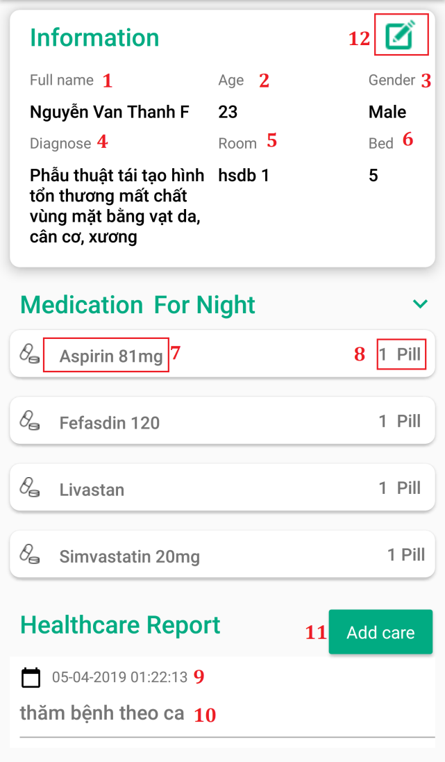

**Fields**

|  |  |  |  |  |  |  |
| --- | --- | --- | --- | --- | --- | --- |
| **No** | **Field Name** | **Description** | **Read-only** | **Mandatory** | **Control** | **Data Type** |
| 1 | Full name | Patient name | No | Yes | TextView | String |
| 2 | Age | Patient age | No | Yes | TextView | String |
| 3 | Gender | Patient gender | No | Yes | TextView | String |  |  |  |  |  |  |
| 4 | Diagnose | Surgery catalog | No | Yes | TextView | String |  |  |
| 5 | Room | Room position of patient | No | Yes | TextView | String |
| 6 | Bed | Bed position of patient | No | Yes | TextView | String |
| 7 | Drug name | Drug name | No | Yes | TextView | String |
| 8 | Drug quantity & unit | Drug quantity & unit | No | Yes | TextView | String |
| 9 | Date created care | Date created of health care report | No | Yes | TextView | String |
| 10 | Care reason | Care reason of health care report | No | Yes | TextView | String |

**Buttons/Hyperlinks**

|  |  |  |  |  |
| --- | --- | --- | --- | --- |
| **No.** | **Function** | **Description** | **Validation** | **Outcome** |
| 11 | Add care | Add healthcare button | N/A | Open Add health care view |
| 12 | Edit room bed | Edit room and bed position | N/A | Open edit room bed dialog |

Surgery Detail Page

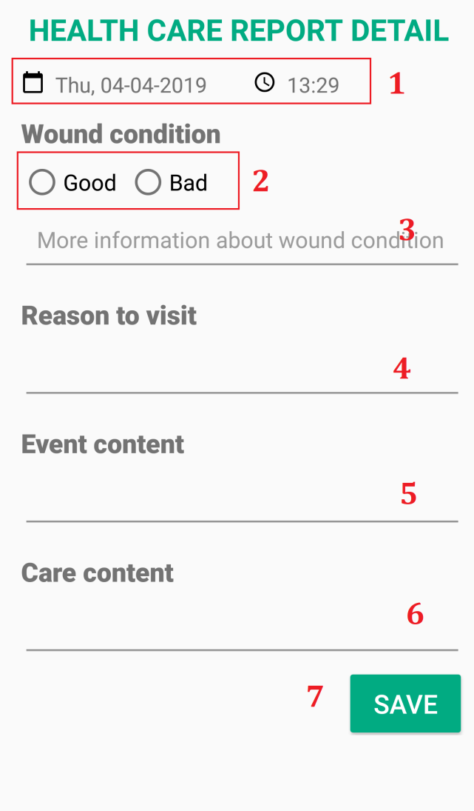

**Fields**

|  |  |  |  |  |  |  |
| --- | --- | --- | --- | --- | --- | --- |
| **No** | **Field Name** | **Description** | **Read-only** | **Mandatory** | **Control** | **Data Type** |
| 1 | Server time | Patient name | No | Yes | TextView | String |
| 3 | Wound condition desc | Wound condition description | No | Yes | TextView | String |  |  |  |  |  |  |
| 4 | Care reason | Care reason of healthcare report | No | Yes | TextView | String |  |  |
| 5 | Event content | Event content of healthcare report | No | Yes | TextView | String |
| 6 | Care content | Care content of healthcare report | No | Yes | TextView | String |

**Buttons/Hyperlinks**

|  |  |  |  |  |
| --- | --- | --- | --- | --- |
| **No.** | **Function** | **Description** | **Validation** | **Outcome** |
| 2 | Wound condition | Wound condition of patient | N/A | Wound condition will be selected |
| 7 | Save | Add healthcare button | Check all input | Success: Navigate to Surgery Detail View  Error: Show error message |

1. **Database Design**
   1. **Entity Relationship Diagram (ERD)**
   2. **Data Dictionary**

|  |  |  |
| --- | --- | --- |
| Entity Name | Mapping column with Conceptual diagram | Description |
| Role | Role | Contain the role information. Has 3 types: chief nurse, surgeon, medical supply staff, hospital staff, nurse, technical staff and patient. |
| Chief Nurse | Chief Nurse | Contain the Chief Nurse information. |
| Surgeon | Surgeon | Contain the Surgeon information. |
| Medical supply staff | Medical supply staff | Contain the Medical supply staff information. |
| Hospital staff | Hospital staff | Contain the Hospital staff information. |
| Nurse | Nurse | Contain the Nurse information. |
| Technical staff | Technical staff | Contain the technical staff information. |
| Patient | Patient | Contain the patient information. |
| Account | Account | Contain the account information. |
| Slot room | Slot room | Contain the slot room information |
| Medical Supplies | Medical Supplies | Contain medical supplies information. |
| Health care report | Health care report | Contain the health care report detail. |
| Surgery information | Surgery information | Contain detail surgery information. |

1. **Algorithms**
   1. **Scheduling surgery**
   2. **Add emergency shift**

**7.3. Swap Shifts**

#### **7.3.1. Definition**

“Swap Shifts” is the processing model of Change Shift which we use to swap the estimated start time and estimated end time of two shifts together.

#### **7.3.2. Define problem**

When actor want to swap two shifts together, we also have to resolve affected shifts base on the estimated start time and estimated end time of those shifts if there are any during the swapping process.

#### **7.3.3. Solution**

At first, we select 2 shifts, then identify them either their duration is equal or not.

– If 2 shifts have the same duration: We will swap their Estimated Start Time and Estimated End Time to each other.

– If 2 shifts don’t have the same duration: We will determine are they in the same room slot or not.

* If they are in the same room slot: We will determine are they next to each other or not.
* If they are next to each other: We will swap their Estimated Start Time and Estimated End Time to each other.
* If they are not next to each other: We will swap their Estimated Start Time and Estimated End Time to each other and disable the longer shift. After that we will search for affected shifts base on the new Estimated Start Time and Estimated End Time of the longer shift. We will resolve affected shift by 2 priority: ‘Keep the time and change the Room Slot’ and ‘Change the time to nearest as possible’. As for the first priority, we will find available room slots for that affected shift and put that shift in there. If there are not any available room slots for that shift, we will find the nearest Estimated Start Time for that shift. After affected shifts has been resolved or there are not any affected shifts, we will re-enable the longer shift we have disabled the first time.
* If they are not in the same room slot: We use the same way as they are in the same slot room but not next to each other

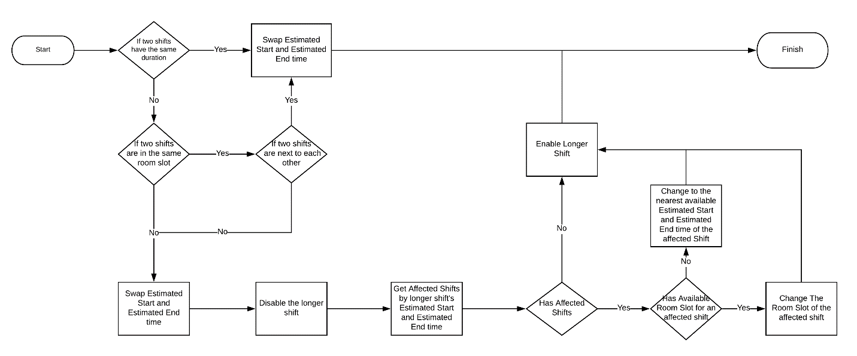

**7.4. Swap room**

#### **7.4.1. Definition**

“Swap Room Slot” is the processing model of Change Shift which we change the room slot of a shift to another room slot

#### **7.4.2. Define Problem**

When actor want to change the room slot of a shift to another room slot, we also have to resolve affected shifts base on the estimated start time and estimated end time of that shift when it is in the new room slot if there are any during the swapping process.

#### **7.4.3. Solution**

There are two options to choose: Normal Swap and Forced Swap.

– In “Normal Swap”: We will find are there any available room slots for that shift base on its Estimated Start Time and Estimated End Time. If there is available room slot, we will put it in there. If there is no available room slot, we will find the nearest Estimated Start Time and Estimated End Time available for that shift in that room slot.

– In “Forced Swap”: We will find are there any affected shifts during that shift Estimated Start Time and Estimated End Time. If there are any affected shifts, we will first change the room slot of that shift, and then disable it. Next, we will resolve affected shift by 2 priority: ‘Keep the time and change the room slot’ and ‘Change the time to nearest as possible’. As for the first priority, we will find available room slots for that affected shift and put that shift in there. If there are not any available room slots for that shift, we will find the nearest Estimated Start Time for that shift. After affected shifts has been resolved or there are not any affected shifts, we will re-enable the shift we have disabled the first time.

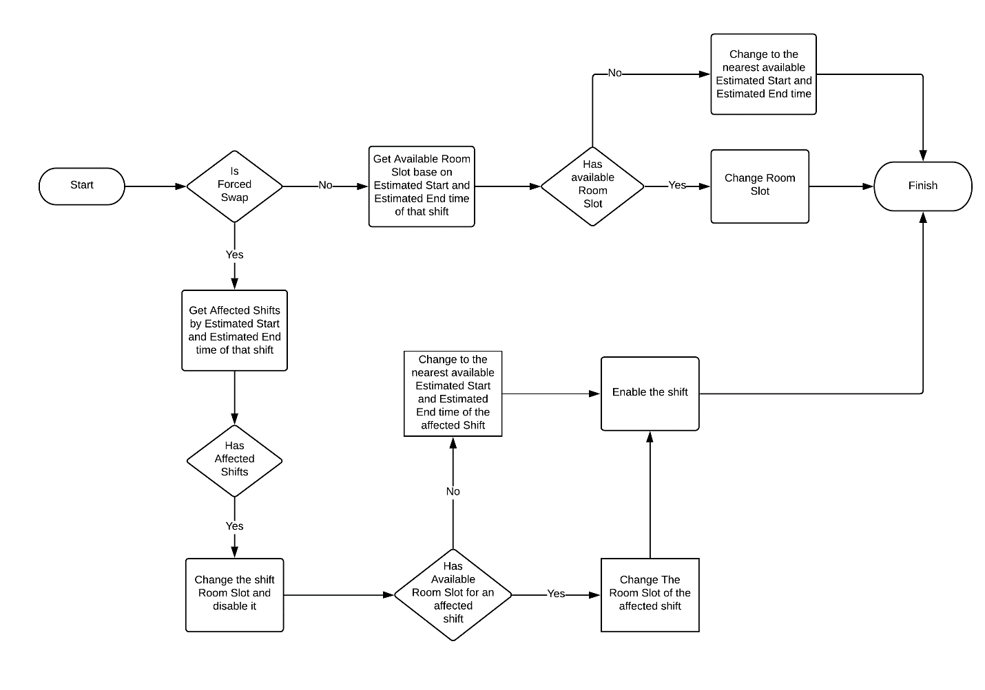

1. **System Implementation & Test**

## **Introduction**

### **1.1. System Overview**

This section describes the approach and methodologies used by group to plan, organize and manage the testing of EBMS system. It provides in the detail of all necessary information about the implementation and testing procedure of the system included test plans, test cases, test result, test environments, pass/fail criteria and risks estimations as well as a checklist to cover as much as possible cases that we can.

### **1.2. Test Approach**

– Goal: Test core features in the EBMS system based on the core flow.

– Method: black-box Testing.

– Size: System Component.

– Technique: Check list

– The testing for this project will consists of Integration System test level. Testing the program which was integrated and as a complete system to ensure that the software requirement have been met.

– System testing is focused on assessing the system’s reliability. This process is concerned with finding errors that result from unanticipated interaction between components and component interface problems.

## **Database relationship diagram**

### **2.1. Physical diagram**

### **2.2. Data dictionary**

|  |  |  |  |
| --- | --- | --- | --- |
| **Data dictionary: describe content of all tables** | | | |
| **Table Name** | **Mapping with Conceptual diagram** | **Mapping with Entity diagram** | **Description** |
| Heath care report | Heath care report | Heath care report | Contain information of Heath care report. |
| SurgeryShiftMedicalSupply | N/A | N/A | Contain detail information of a medical supply request. |
| MedicalSupplies | MedicalSupply | MedicalSupply | Contain information of a Medical Supply. |
| SurgeryShift | SurgeryShift | SurgeryShift | Contain information of Surgery Shift. |
| SurgeryCatalog | SurgeryCatalog | SurgeryCatalog | Contain Surgery Catalog detail information. |
| Specialities | Specialty | Specialty | Contain information of Specialties. |
| Status | Status | status | Contain statuses of a surgery shift. |
| SlotRoom | Slot room | Slot room | Contain information of Slot room. |
| SurgeryRooms | N/A | N/A | Contain information of Surgery room. |
| SurgeryShiftSurgeon | Surgeon | Surgeon | Contain information of Surgeon of the surgery shift. |
| Doctors | Device | Device | Contain information of Doctors. |
| EkipMembers | N/A | N/A | Contain information of a member in surgery ekip. |
| Ekip | Ekip | Ekip | Contain ekip in a surgery shift. |
| Patients | Patients | Patients | Contain information of Patients. |
| TreatmentReports | TreatmentReports | TreatmentReports | Contain information of Treatment Reports. |
| TreatmentReportDrugs | N/A | N/A | Contain drugs used in treatment. |
| UserInfo | N/A | N/A | Contain information of User Info. |

1. Data table dictionary

## **3. Test Plan**

The overall purpose of testing is to ensure EBMS system meets its entire technical, functional and business requirement. The purpose of this document is to describe the overall test plan and strategy for testing the core flow of EBMS system.

The approach described in this document provides the framework for all testing related to this application. Each test cases will be written for each version of the application that is released. This document will also be updated as required for each release.

### **3.1. Features to be tested**

We will carry out test based on core workflow of system. All main functions will be tested carefully and clearly following phases.

– Hospital staff:

* Import surgery shift
* Get surgery shift detail

– Medical Supply staff:

* Get all medical supply request
* Get medical supply request detail
* Confirm medical supply request

– Handler System:

* Scheduling surgery
* Add Emergency Shift
* Swap surgery shift
* Change surgery slot room

– Chief Nurse:

* Start a surgery shift
* Complete a surgery shift
* Create treatment
* Edit treatment
* Assign nurse
* Update quantity of used medical supplies
* Add used medical supplies

– Nurse:

1. Get drug needed for patient base on current time
2. Add heath care report

### **3.2. Features not to be tested**

– Login, Logout

## **4. System Testing Test Case**

**4.1. Hospital Staff Test Case**

|  |  |  |  |  |  |
| --- | --- | --- | --- | --- | --- |
| ID | Test Case Description | Test case procedure | Expected output | *Inter Dependence -test Case* | Result |
| *ISS_1* | Hospital staff choose a file with correct format to import. | 1. Hospital staff click “Choose file” button.  2. Hospital staff choose excel file.  3. Hospital staff click “Open file”. | System shows list of importing surgery profile in table view. | N/A | Pass |
| *ISS_2* | Hospital staff choose a file with wrong format to import. | 1. Hospital staff click “Choose file” button.  2. Hospital staff choose excel file.  3. Hospital staff click “Open file”. | System show error message | N/A | Pass |
| *GSSD_1* | Hospital staff gets a surgery shift detail | 1. Hospital staff click “i” on a row in surgery shift table. | A modal appears sand show surgery shift detail: surgery name, patient name, patient identity number, medical supply need | N/A | Pass |

**4.2. Medical Supply Staff Test Case**

|  |  |  |  |  |  |
| --- | --- | --- | --- | --- | --- |
| ID | Test Case Description | Test case procedure | Expected output | *Inter Dependence -test Case* | Result |
| *GAMS_1* | Medical supply staff get all medical supply request with no request need approving. | 1. Medical supply staff Logged in and request supplier web page | System response webpage with empty medical supply request table. | N/A | Pass |
| *GAMS _2* | Medical supply staff get all medical supply request need approving. | 1. Medical supply staff Logged in and request supplier web page | System response webpage with list of medical supply request in table. | N/A | Pass |
| *GMSD_1* | Medical supply staff get medical supply request detail | 1. Medical supply staff click “i” on a row in medical supply request table. | A modal appears and shows medical supply need in request: No, name, quantity | *GAMS _2* | Pass |
| *CMSR_1* | Medical supply staff confirm request | 1. Medical supply staff select request to approve by checking check boxes on appropriate row  2. Button “Confirm” enable  3. Medical supply staff click “Confirmed” | Show success message, reload page and confirmed request will not appear | *GAMS _2* | Pass |

**4.3. Chief Nurse Test Case**

|  |  |  |  |  |  |
| --- | --- | --- | --- | --- | --- |
| ID | Test Case Description | Test case procedure | Expected output | *Inter Dependence -test Case* | Result |
| *SSS_01* | C Nurse start processing a surgery plan on schedule | 1. C Nurse point to an on time surgery plan  2. C Nurse click “Start Surgery”  3. C Nurse input start time | Surgery change status to “Inoperative” and change color to “Processing” color | N/A | Pass |
| *CSS_01* | C Nurse complete processing a surgery plan on schedule | 1. C Nurse point to an on time surgery plan  2. C Nurse click “End Surgery”  3. C Nurse input start time | Surgery change status to “Inoperative” and change color to “Completed” color | *SSS_01* | Pass |
| *CTM_01* | C Nurse add new treatment | 1. C Nurse click “Add Treatment”  2. “Add treatment” modal appear  3. C Nurse input “Progressive Disease”  4. C Nurse add drug and quantity use  5. C Nurse click “Save” | Add treatment to surgery shift | N/A | Pass |
| *ETM_01* | C Nurse edit treatment when health care report has been apply using this treatment | N/A | Treatment “Edit” disable | N/A | Pass |
| *ETM_02* | C Nurse edit treatment when no health care report has been apply using this treatment | 1. C Nurse click “Edit Treatment”  2. A modal with current treatment plan  3. C Nurse update quantity and drug | Treatment is updated in surgery shift. | N/A | Pass |
| *AN_01* | C Nurse assign a nurse to take care of the patient | 1. C Nurse click “Assign Nurse”  2. C Nurse choose Nurse name to assign | Assigned Nurse can see patient information and treatment | N/A | Pass |
| *UMS_01* | C Nurse update quantity of used medical supply in surgery | 1. C Nurse click “Update Medical Supply”  2. C Nurse update quantity of medical supply | Medical supply used in surgery updated | N/A | Pass |
| *UMS_02* | C Nurse update quantity of used medical supply in surgery to “0” | 1. C Nurse click “Update Medical Supply”  2. C Nurse update quantity of medical supply to “0” | Medical supply used in surgery updated. Medical supply with quantity 0 is consider delete and not appear. | N/A | Pass |
| *AMS_01* | C Nurse update quantity of used medical supply in surgery | 1. C Nurse click “Add Medical Supply”  2. C Nurse choose medical supply used to add to surgery shift and input quantity | Medical supply used in surgery updated | N/A | Pass |

**4.4. Nurse Test Case**

|  |  |  |  |  |  |
| --- | --- | --- | --- | --- | --- |
| ID | Test Case Description | Test case procedure | Expected output | *Inter Dependence -test Case* | Result |
| *GD_01* | Nurse get drug treatment plan for a patient after surgery in the morning | 1. Nurse chose an assigned patient | Mobile device get detail information and drug with label “Morning” | N/A | Pass |
| *GD_02* | Nurse get drug treatment plan for a patient after surgery in the noon | 1. Nurse chose an assigned patient | Mobile device get detail information and drug with label “Noon” | N/A | Pass |
| *GD_03* | Nurse get drug treatment plan for a patient after surgery in the evening | 1. Nurse chose an assigned patient | Mobile device get detail information and drug with label “Evening” | N/A | Pass |
| *GD_04* | Nurse get drug treatment plan for a patient after surgery in the night | 1. Nurse chose an assigned patient | Mobile device get detail information and drug with label “Night” | N/A | Pass |
| *AHCR_01* | Nurse add a health care report with good wound condition | 1. Nurse chose an assigned patient  2. Nurse click “add care”  3. Nurse choose “Wound condition good”  4. Nurse click “Save” | Mobile device show patient information and added health care report below | N/A | Pass |
| *AHCR_02* | Nurse add a health care report with bad wound condition | 1. Nurse chose an assigned patient  2. Nurse click “add care”  3. Nurse choose “Wound condition bad”  4. Nurse click “Save” | Mobile device show patient information and added health care report below | N/A | Pass |

**4.5. Handler System Test Case**

|  |  |  |  |  |  |
| --- | --- | --- | --- | --- | --- |
| ID | Test Case Description | Test case procedure | Expected output | *Inter Dependence -test Case* | Result |
| *MKS_1* | System automatically make schedule for medical supply request approved but not yet schedule surgery shift. | 1. Medical supply staff Confirm Medical Supply Request, system make schedule for those shift. | Scheduled surgery shift will appear on surgery room schedule with time and room. | N/A | Pass |

1. **Software User’s Manual**
2. **Installation Guide**
   1. **Setting up enviroment at server side**
      1. **Hardware requirements**

|  |  |  |
| --- | --- | --- |
| **Server** | **Minimum Requirements** | **Recommended** |
| **Internet Connection** | Cable, Wi-Fi (8 Mbps) | Cable, Wi-Fi (50 Mbps or more) |
| **Operating System** | Window XP, Vista, 7, 10, Window Server 2008 | Window 10, Window Server 2008 |
| **Computer Processor** | Intel® Xeon ® 1.4GHz | Intel® Xeon ® Quad Core (12M Cache, 2.50 GHz) |
| **Computer Memory** | 4GB RAM | 32GB or more |
| **Storage space** | 1GB | 5GB or more |

Table 140 - Hardware requirement for server

* + 1. **Software requirements**

|  |  |  |
| --- | --- | --- |
| **Name** | **Name/Version** | **Description** |
| **Environment** | .Net 2.0, .Net 2.1, .Net 2.1,Node v10,npm v6 | Specification for developing web application |
| **Operating System** | Window 10 | Operating system and platform for development |
| **Modeling tool** | LucidChart, StarUML | Used to design diagram |
| **IDE** | Visual Studio 2017, Visual Studio Code,Android Studio | Programming tools |
| **DBMS** | SQL Server | Used to create & manage the database for system |
| **Web server** | IIS Express | Deployment environment |
| **Web browser** | Chrome 69 or above. | Testing browser |

Table 141 - Software requirement for server

* 1. **Deployment at server side**

**1.2.1 Prepare deployement package**

**Step 1:** Download and Install .Net 2.0, 2.1, 2.2

Link download:

<https://dotnet.microsoft.com/download/thank-you/dotnet-sdk-2.1.202-windows-x64-installer>

<https://dotnet.microsoft.com/download/thank-you/dotnet-sdk-2.1.602-windows-x64-installer>

<https://dotnet.microsoft.com/download/thank-you/dotnet-sdk-2.2.202-windows-x64-installer>

**Step 2:** Download and setup Visual Studio Code

Link download: <https://code.visualstudio.com/>

**Step 3:** Download and Install Nodejs

Link download: https://nodejs.org/en/download/

**Step 4:** Download and Install Visual Studio 2017

Link download: <https://visualstudio.microsoft.com/downloads/>

**Step 5:** Download and Install IIS server

Link download: <https://www.microsoft.com/en-us/download/details.aspx?id=48264>

**Step 6:** Download, Install and configure Microsoft SQL Server

Link download: <https://www.microsoft.com/en-us/sql-server/sql-server-downloads>

**1.2.2 Configure server before deploy**

Step 1:

Step 2:

Step 3:

Step 4:

* 1. **Setting up enviroment at client side**

The client devices should have one of the following browsers to access the website:

* + - Google Chrome

Link download: <https://www.google.com/chrome/>

* + - Firefox

Link download: <https://www.mozilla.org/vi/firefox/channel/desktop/>

## **2. User Guide**

* 1. **Import Profile**

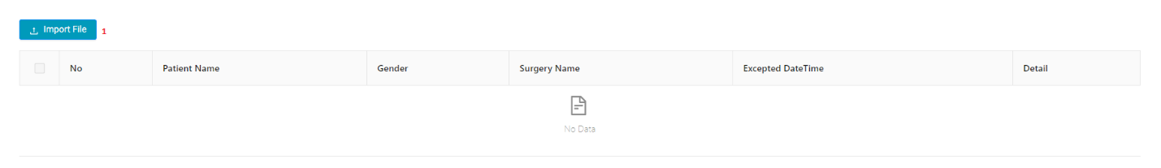

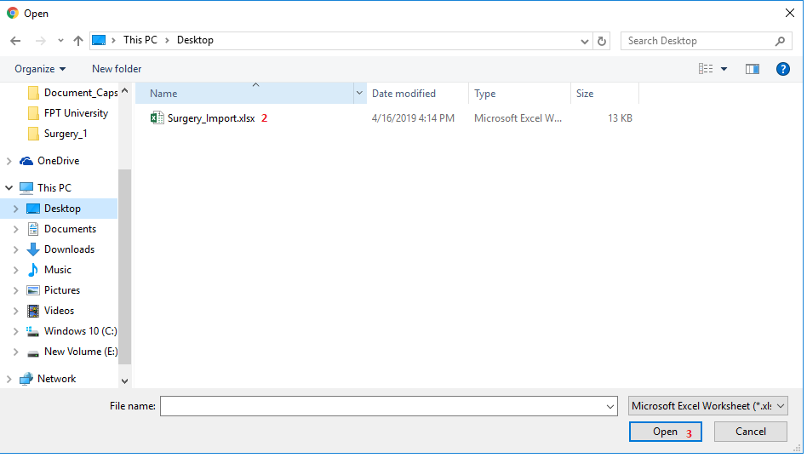

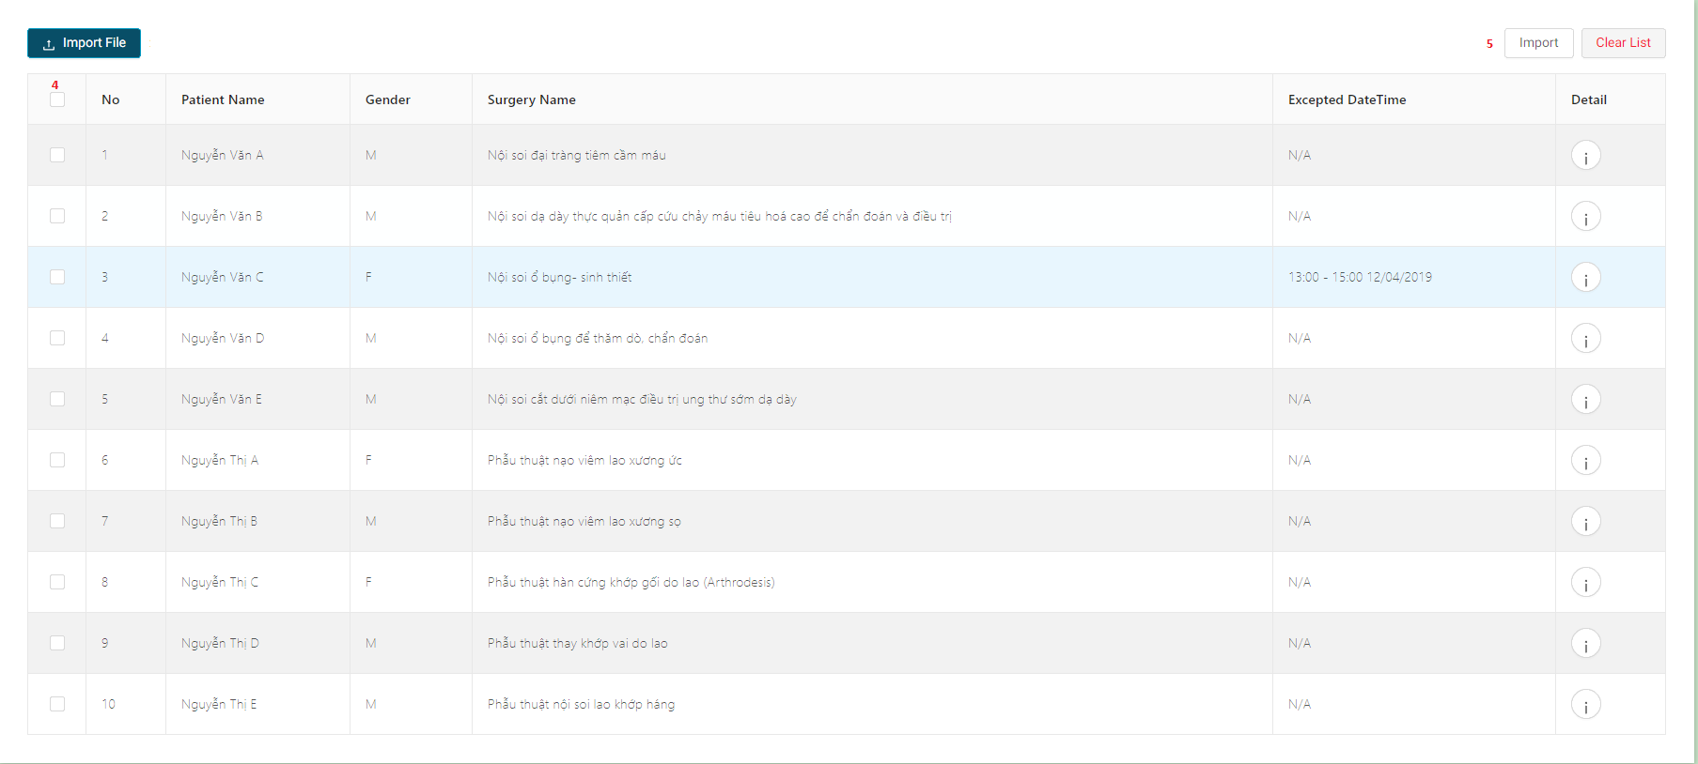

|  |  |
| --- | --- |
| **Step** | **Description** |
| Pre-condition | Login as Hospital staff |
| 1 | Click “Import File” button |
| 2 | Choose excel file to import |
| 3 | Click “Open” on Choose File window |
| 4 | Check profiles need importing |
| 5 | Click “Import” button |

* 1. **Confirm Medical Supply Request**

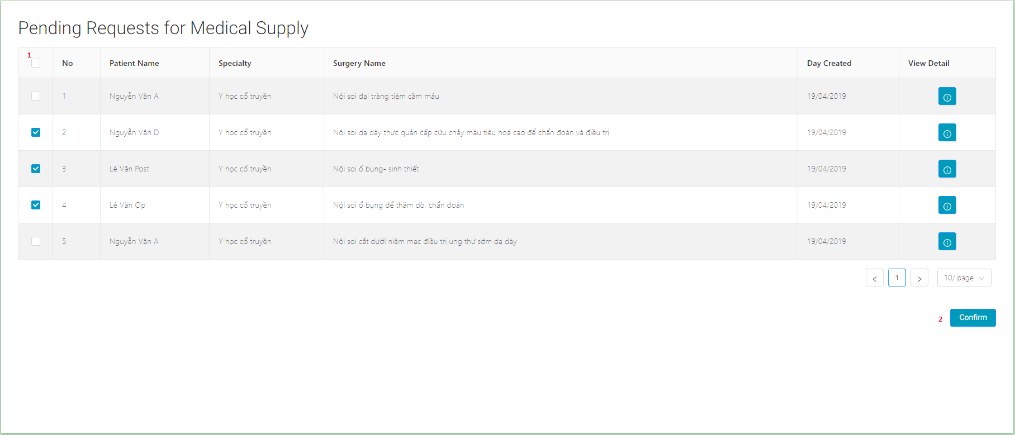

|  |  |
| --- | --- |
| **Step** | **Description** |
| Pre-condition | Login as Medical Supply staff |
| 1 | Check request for supplies want to confirm |
| 2 | Click “Confirm” button |

* 1. **Schedule** 
     1. **Get Surgery schedule by date**

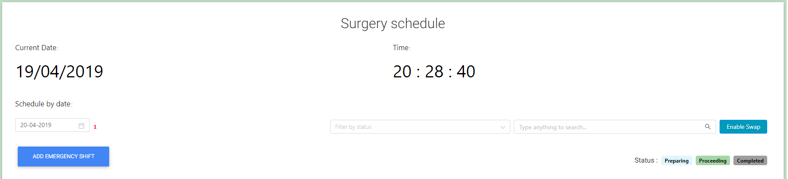

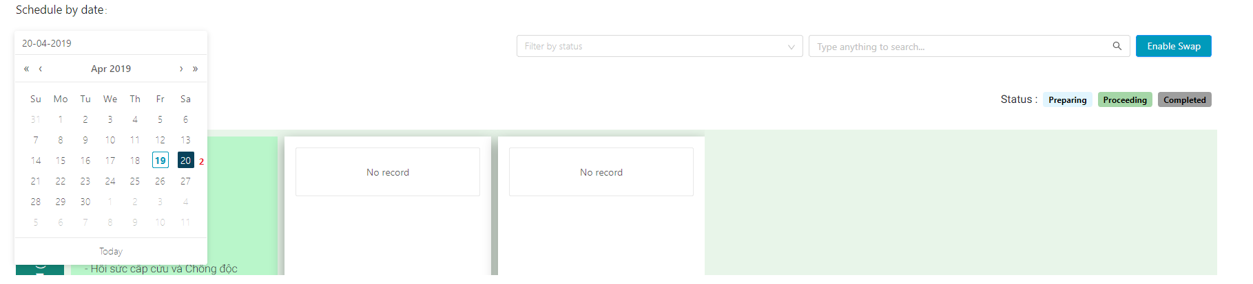

|  |  |
| --- | --- |
| **Step** | **Description** |
| Pre-condition | Login as Chief Nurse |
| 1 | Click “Schedule by date:” date box |
| 2 | Choose day want to get schedule on |

* + 1. **Update surgery schedule**

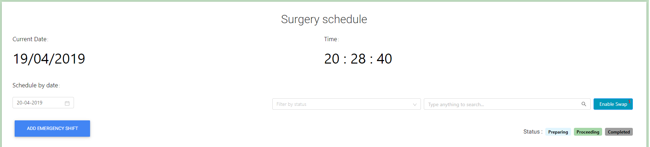

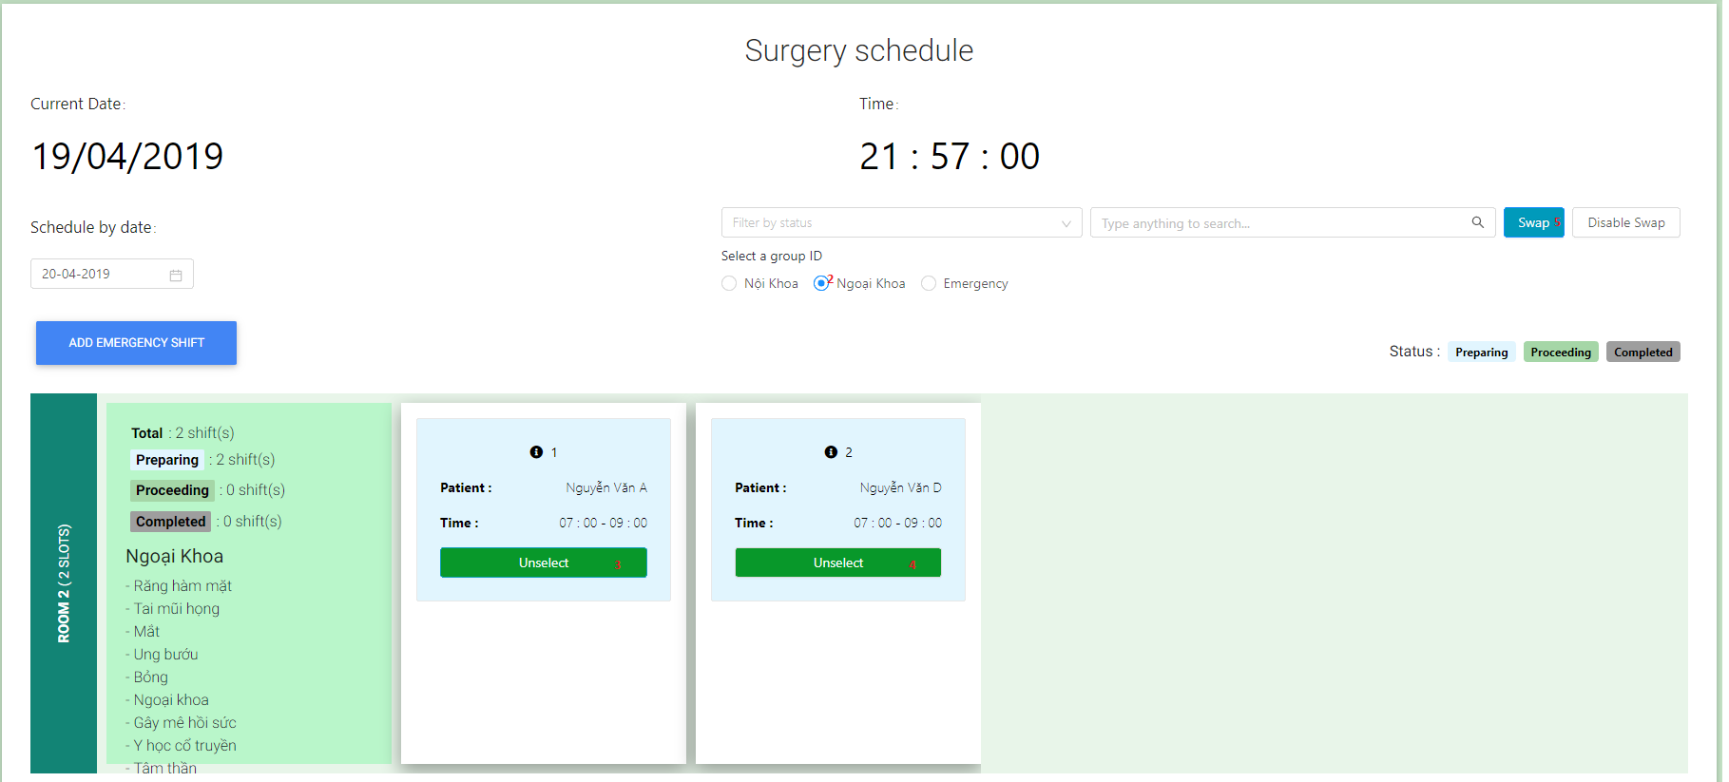

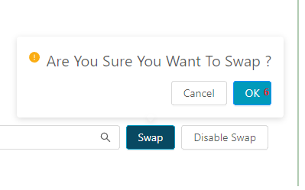

|  |  |
| --- | --- |
| **Step** | **Description** |
| Pre-condition | Login as Chief Nurse |
| 1 | Click “Schedule by date:” date box |
| 2 | Choose specialties group to swap |
| 3 | Choose first surgery shift to swap |
| 4 | Choose second surgery shift to swap |
| 5 | Click “Swap” button |
| 6 | Click “OK” button |

* + 1. **Add schedule for emergency surgery**

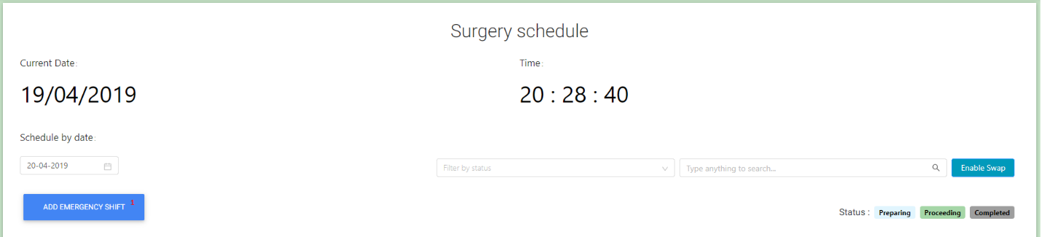

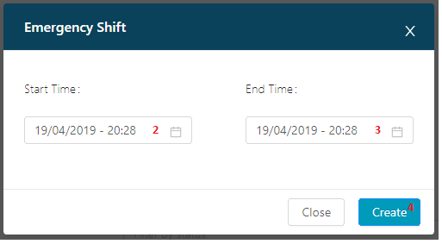

|  |  |
| --- | --- |
| **Step** | **Description** |
| Pre-condition | Login as Chief Nurse |
| 1 | Click “ADD EMERGENCY SHIFT” |
| 2 | Choose estimate start time of emergency surgery |
| 3 | Choose estimate end time of emergency surgery |
| 4 | Click “Create” button |

* + 1. **Change schedule time for a surgery shift**

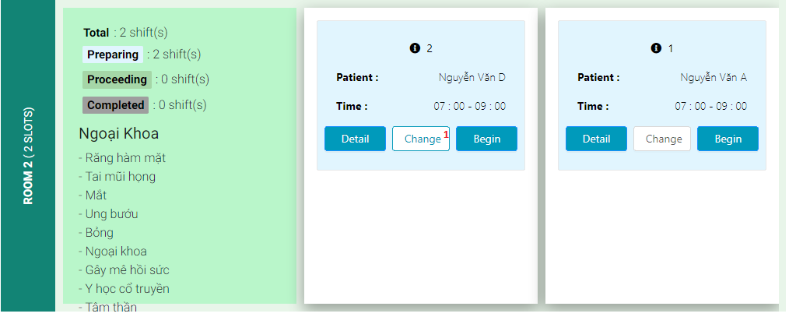

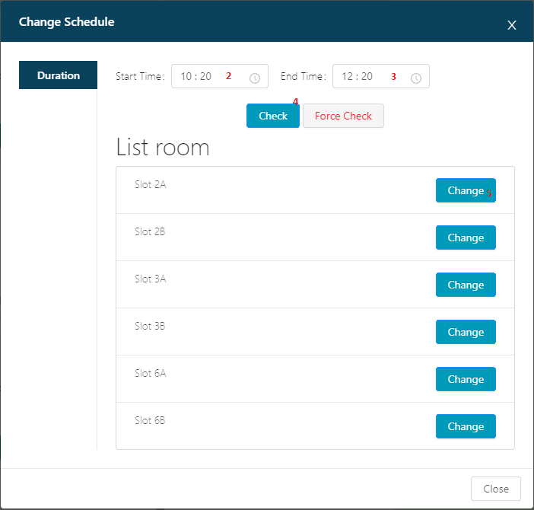

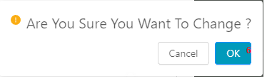

|  |  |
| --- | --- |
| **Step** | **Description** |
| Pre-condition | Login as Chief Nurse |
| 1 | Click “Change” button of a Surgery Shift |
| 2 | Choose estimate start time want to change |
| 3 | Choose estimate start time want to change |
| 4 | Click “Check” of “Force Check” button |
| 5 | Choose a slot want to change and click “Change” button |
| 6 | Click “OK” button |

* + 1. **Start a surgery schedule**

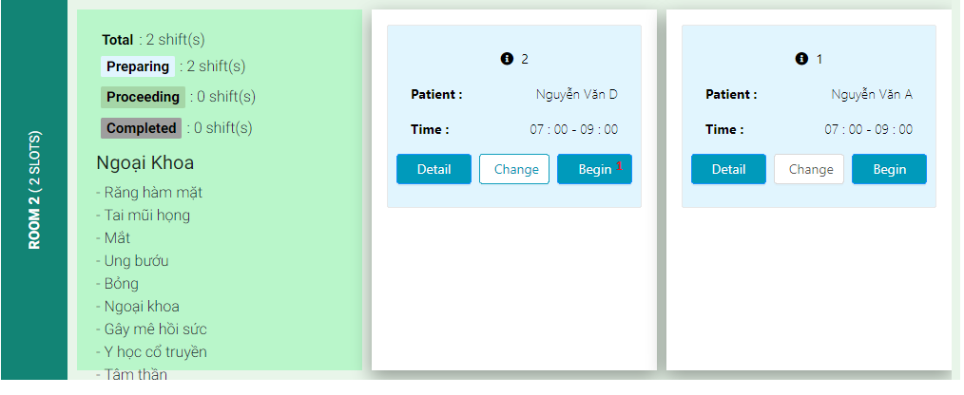

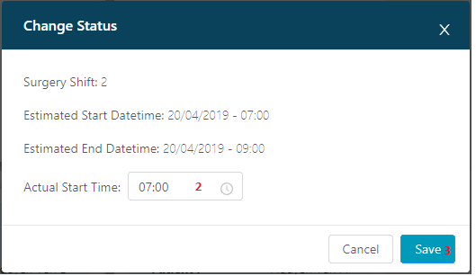

|  |  |
| --- | --- |
| **Step** | **Description** |
| Pre-condition | Login as Chief Nurse |
| 1 | Click “Begin” button |
| 2 | Choose Start time |
| 3 | Click “Save” button |

* + 1. **Complete a surgery schedule**

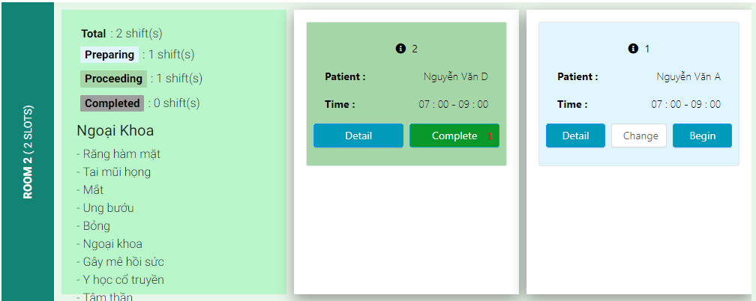

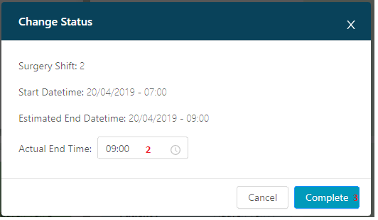

|  |  |
| --- | --- |
| **Step** | **Description** |
| Pre-condition | Login as Chief Nurse |
| 1 | Click “Complete” button |
| 2 | Choose End time |
| 3 | Click “Complete” button |

* + 1. **Create Treatment Report**

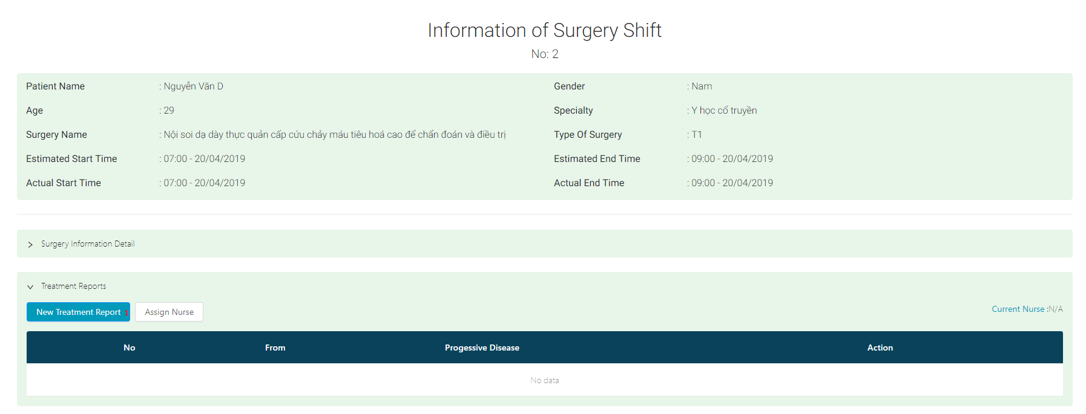

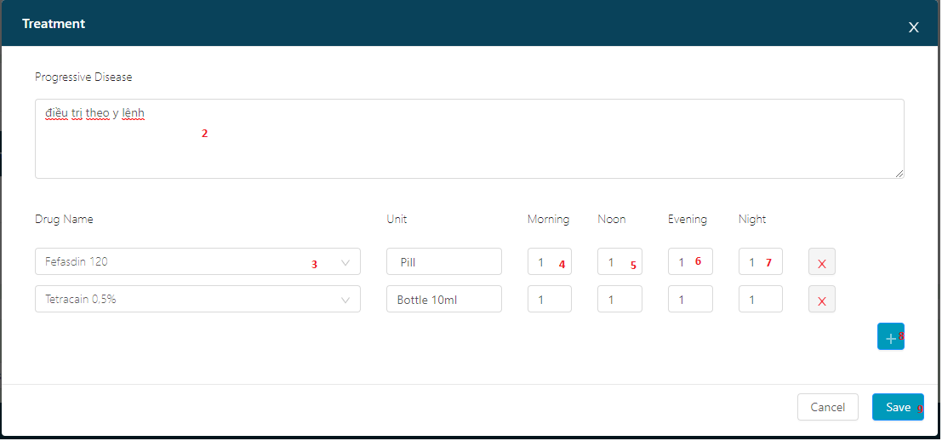

|  |  |
| --- | --- |
| **Step** | **Description** |
| Pre-condition | Login as Chief Nurse |
| 1 | Click “New Treatment Report” button |
| 2 | Enter Progressive Disease |
| 3 | Choose Drugs for patient |
| 4 | Choose quantity for Morning |
| 5 | Choose quantity for Noon |
| 6 | Choose quantity for Evening |
| 7 | Choose quantity for Night |
| 8 | Click “+” to add more and repeat step 3 |
| 9 | Click “Save” button |

* + 1. **Assign Nurse**

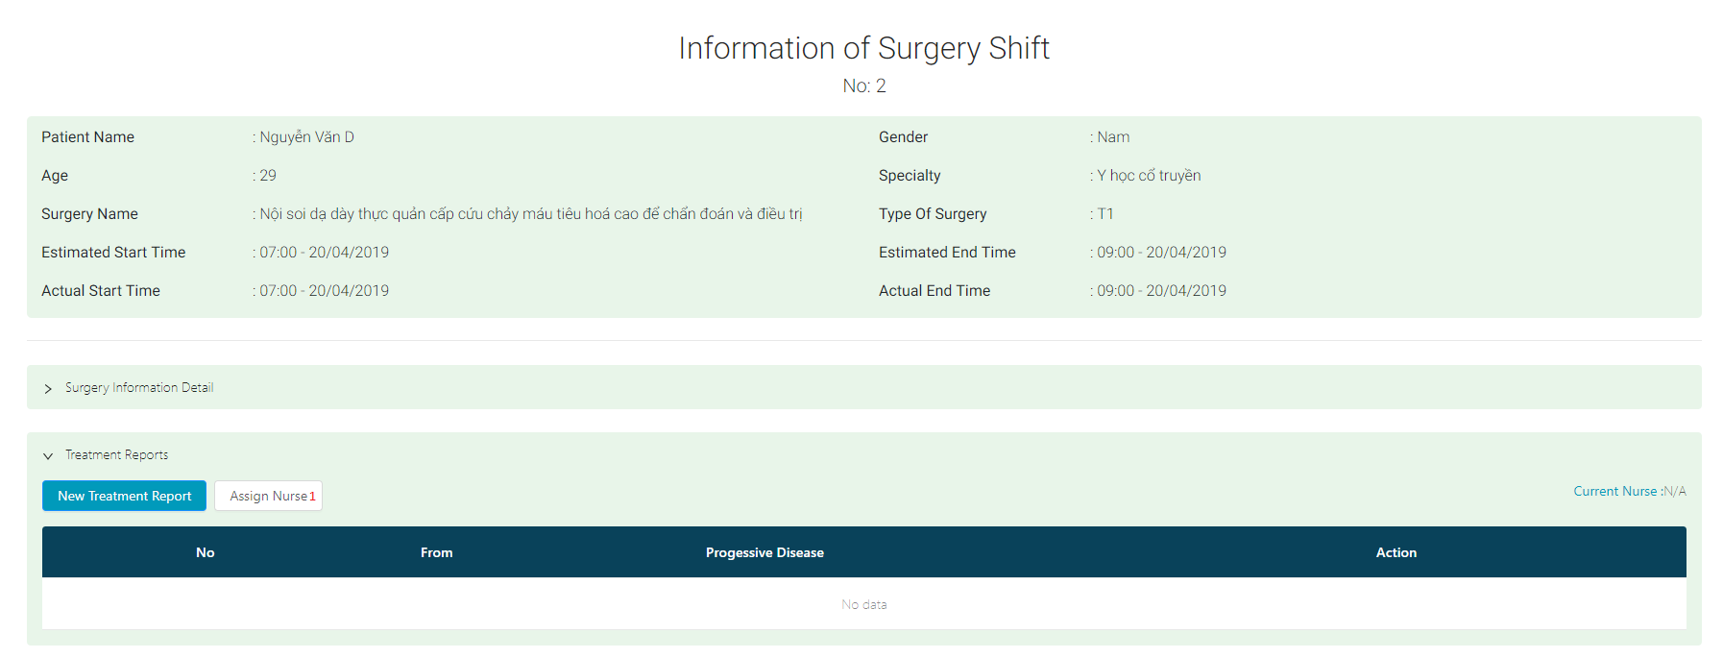

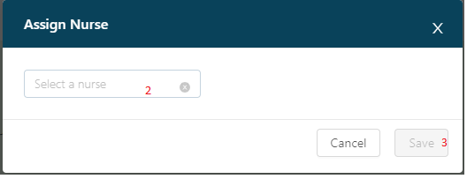

|  |  |
| --- | --- |
| **Step** | **Description** |
| Pre-condition | Login as Chief Nurse |
| 1 | Click “Assign Nurse” button |
| 2 | Choose a Nurse Name |
| 3 | Click “Save” button |

* + 1. **Move to Recovery**

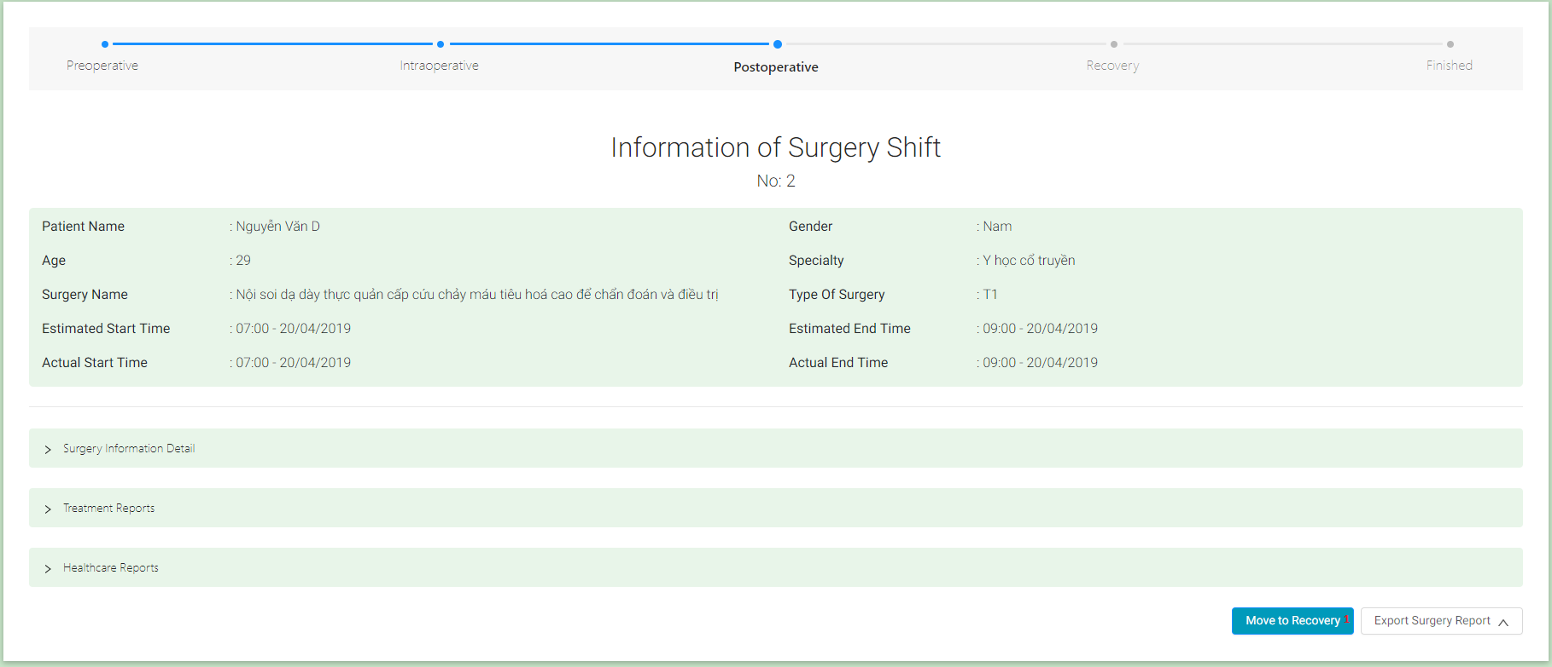

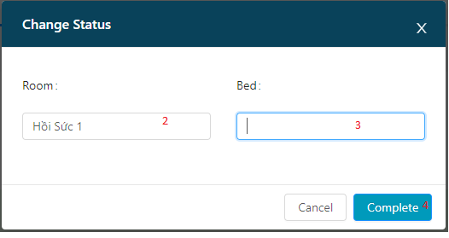

|  |  |
| --- | --- |
| **Step** | **Description** |
| Pre-condition | Login as Chief Nurse |
| 1 | Click “Move to Recovery” button |
| 2 | Enter Recovery Room name(optional) |
| 3 | Enter Recovery Bed number(optional) |
| 4 | Click “Complete” button |

* 1. **Mobile Interface Design**

1. **Appendix**